]\


CAPSTONE PROJECT REPORT
Report 3 – Software Requirement Specification

– Hanoi, Nov 2026 –
Table of Contents
Change Log 4
Definition and Acronyms 5
I. Overall Requirements 6
1. Context Diagram 6
2. Main Business Flow 9
2.1 User Onboarding & KYC (BF-01) 9
2.2 Plot & Listing Publication (BF-02) 10
2.3 Contract Signing & Activation (BF-03) 11
2.4 Milestone Delivery & Settlement (BF-04) 12
2.5 Breach & Force Majeure Resolution (BF-05) 13
2.6 Mutual Termination & Replacement (BF-06) 14
2.7 Emergency Security Lock (BF-07) 15
3. Conceptual Data Model 16
3.1 Entity Relationship Diagram 16
3.2 Entity Descriptions 17
3.3 Data Business Rules 23
4. User Requirements 25
4.1 Actors 25
4.2 Use Cases (UC) 26
4.3 Use Case Diagrams 29
4.4 Permission Matrix 36
5. System Functionalities 39
5.1 Screen Inventory 40
5.2 External API Inventory 44
5.3 Background Job Inventory 44
II. Use Case Specifications 46
1. Plot & Listing 46
1.1 Create Listing (UC14) 46
2. Contract 47
2.1 Create Contract Offer (UC20) 47
2.2 Negotiate Contract Terms (UC21) 48
2.3 Sign Contract (UC22) 48
2.4 Activate Contract (UC23) 49
2.5 Propose Mutual Termination (UC26) 50
2.6 Propose Contract Replacement (UC27) 50
3. Milestone & Delivery 51
3.1 Fund Milestone (UC30) 51
3.2 Record Seller Weighing (UC32) 52
3.3 Record Buyer Receipt (UC33) 52
3.4 Confirm Milestone Delivery (UC34) 53
3.5 Flag Delivery Issue (UC35) 54
3.6 Respond to Delivery Issue (UC36) 54
3.7 Submit Force Majeure Claim (UC37) 55
4. Dispute & Inspection 56
4.1 Report Breach (UC40) 56
4.2 Review and Resolve Breach Case (UC41) 56
4.3 Decide Force Majeure Claim (UC42) 57
4.4 Submit Inspection Result (UC44) 58
4.5 Commission External Inspection (UC45) 59
4.6 Review External Inspection Report (UC47) 59
4.7 Terminate Contract (UC54) 60
5. Audit & Security 61
5.1 Lock or Unlock Monetary Operations (UC52) 61
III. Functional Requirements 62
1. User Authentication & Account 62
1.1 Registration & Login 62
1.2 Profile & KYC 63
2. Account Administration 65
2.1 KYC Review 65
2.2 Reputation Governance 66
3. Plot & Listing 67
3.1 Plot Registry 67
3.2 Plot Risk Review 69
3.3 Product Management 70
3.4 Listing Management 70
3.5 Listing Marketplace 72
3.6 Listing Moderation 73
4. Market Prices 74
4.1 Reference Prices 74
5. Contract 75
5.1 Offer Creation 75
5.2 Contract Viewing and Negotiation 78
5.3 Contract Signing 80
5.4 Contract Replacement 81
5.5 Escrow Statement 82
6. Milestone & Delivery 82
6.1 Milestone Tracking 82
6.2 Delivery Recording 83
6.3 Delivery Issue Handling 84
6.4 Milestone Price Adjustment 85
7. Dispute & Inspection 86
7.1 Breach Reporting 86
7.2 Breach Case Management 87
7.3 Contract Termination 89
7.4 Force Majeure Review 90
7.5 Contract Operations 91
7.6 Level 1.5 Inspection 92
7.7 Level 2 Inspection Handling 94
8. Audit & Security 95
8.1 Audit Evidence 95
8.2 System Security 96
9. Analytics 97
9.1 Analytics Reports 97
10. Background Job Inventory 98
10.1 Transactional Outbox Relay (JOB-01) 98
10.2 Milestone Completion Sync (JOB-02) 98
10.3 Contract Settlement Reconciler (JOB-03) 98
10.4 Deposit Lock Retry (JOB-04) 99
10.5 Milestone Funding Lock Retry (JOB-05) 99
10.6 Funding Cure Window Expiry (JOB-06): 100
10.7 Buyer Confirmation Auto-Confirm (JOB-07):. 100
10.8 Seller Response Window Timeout (JOB-08):. 101
10.9 Buyer Receive Window Timeout (JOB-09):. 101
10.10 Seller Delivery Deadline Overdue (JOB-10):. 101
10.11 Level 2 Buffer and Provisional Settlement (JOB-11) 102
10.12 Level 2 Buffer Terminal Settlement (JOB-12) 102
10.13 Orphan Reservation Reaper (JOB-13) 102
10.14 Plot Geo-risk Check (JOB-14) 103
10.15 VNSAT Price Ingestion (JOB-15) 103
10.16 Email Intake Mailbox Poll (JOB-16) 104
10.17 File Parse and Malware Scan (JOB-17) 104
10.18 Orphan File Cleanup (JOB-18) 104
10.19 Retention and Legal Hold Deletion (JOB-19) 105
10.20 Audit Anchor Worker (JOB-20) 105
10.21 Weekly Audit Chain Verification (JOB-21) 106
10.22 Weekly Audit Digest (JOB-22) 106
10.23 Ledger and Audit Reconciliation (JOB-23) 106
10.24 Used Nonce Cleanup (JOB-24) 107
10.25 Analytics Monthly Aggregation (JOB-25) 107
10.26 AML Structuring Pattern Scan (JOB-26) 107
10.27 Elevated Risk Review Expiry (JOB-27) 108
10.28 Notification Delivery Retry (JOB-28) 108
10.29 Dead-Letter Queue Monitoring and Replay (JOB-29) 109
11. External API Inventory 109
11.1 Emergency Lock API (API-01) 109
11.2 Emergency Unlock API (API-02) 109
11.3 Audit Hash Query API (API-03) 110
11.4 Escrow Bank Commands (API-04) 110
11.5 Bank Command Results (API-05) 110
11.6 Outbound Email (API-06) 110
11.7 Inspection Report Intake (API-07) 110
11.8 Timestamp Anchoring (API-08) 111
11.9 Reference Price Ingestion (API-09) 111
11.10 Geo Dataset Lookup (API-10) 111
IV. Non-Functional Requirements 111
1. External Interfaces 111
2. Quality Attributes 112
2.1 Usability 112
2.2 Performance 113
2.3 Security 113
2.4 Reliability 114
2.5 Auditability and Compliance 115
V. Requirement Appendix 115
1. Business Rules 115
2. System Messages 124
3. Other Requirements 133

Change Log
Date | A*M, D | In charge | Change Description
25/09/2026 | A | Group 6 | First version: I.1 Context Diagram, I.2 Main Business Flow, I.3 Conceptual Data Model.
30/09/2026 | A, M | Group 6 | Added I.4 User Requirements (actors, use cases, use case diagrams, permission matrix) and I.5 System Functionalities.
02/10/2026 | A, M | Group 6 | Added II Use Case Specifications. Revised I.3.2 Entity Descriptions and I.3.3 Data Business Rules.
04/10/2026 | M | Group 6 | Revised I.5.1 Screen Inventory to 61 screens, I.5.2 External API Inventory and I.5.3 Background Job Inventory.
08/10/2026 | A, M | Group 6 | Added III Functional Requirements (61 screens, 29 background jobs, 10 external APIs), IV Non-Functional Requirements, V Requirement Appendix (business rules GB-01 to GB-48, system messages MSG01 to MSG112) and the Definition and Acronyms table.
12/10/2026 | A, M, D | Group 6 | Split the staff role into Admin, Operator and the new Arbitrator across actors, use cases, permission matrix, screens, business rules and messages; added I.4.3.8 UCs for Arbitrator. Redrew the context diagram, the seven business flows (UML activity diagrams), the ERD (crow's foot notation) and the screen flow. Removed the duplicated UC27 block from I.2.6. Added GB-49 to the appendix (moved out of the business constraints table) and GB-50 (2-business-day contest window for breach decisions, UC41, BF-05).
02/11/2026 | M, D | Group 6 | v1.7: aligned with the Phase 2 design. Scope narrowed to COFFEE only. Removed the objection procedure (UC55, JOB-31) that contradicted GB-50. Replaced the I.5.3 job list with JOB-01 to JOB-29 of Part III. Corrected entity lifecycles in I.3.2. Added UC54 to I.4.2. Added the contract-level exception and the party Contest action for GB-50. Fixed the Inspector re-login window (1800 s), the Level 2 commission actor and staff role wording.
10/11/2026 | M | Group 6 | Context diagram and BF-01..BF-07 redrawn in Visual Paradigm notation (editable .drawio in docs/reports/figures/srs); BF-03 follows D42/D43. Activation failure (D42): the parties ask to cancel, the Operator only retries the lock — UC29, role matrix, UC Activate Contract alternative flow and postconditions, screens 5.2.2 and 7.5.1, screen list and MSG94 updated
10/11/2026 | M | Group 6 | Use case diagrams 4.3.1-4.3.9 redrawn in Visual Paradigm notation (editable .drawio in docs/reports/figures/srs); 4.3.4 uses an abstract Contract Party actor with generalization from Buyer and Seller; 4.3.6 UC29 is the Operator's lock retry (D42)
10/11/2026 | M | Group 6 | ERD 3.1 redrawn in crow's foot notation (editable .drawio in docs/reports/figures/srs); the three parts now follow the split the 3.1 text names (a) identity, product and listing, (b) contract, milestone and money, (c) dispute, inspection, reputation and audit; entities, keys and cardinalities unchanged
*A - Added M - Modified D - Deleted

Definition and Acronyms
Acronym | Definition
AML | Anti-Money Laundering; the checks and records that detect and report suspicious transaction patterns.
API | Application Programming Interface; in this document also the identifier of an external interface, API-01 to API-10.
BF | Business Flow; the identifier of a main business flow described in Part I.
CDM | Conceptual Data Model; the model of the system's entities and their relationships.
DKIM | DomainKeys Identified Mail; an email signature result recorded as a trust signal for incoming inspection reports.
ERD | Entity Relationship Diagram; the diagram of entities, attributes and relationships.
ES256 | ECDSA using the P-256 curve and SHA-256; the signature algorithm required on External Verifier emergency lock and unlock requests.
EUDR | European Union Deforestation Regulation; requires proof that a commodity lot comes from plots with no deforestation after 31 December 2020.
FM | Force Majeure; an event outside the Seller's control that excuses non-performance after review.
GB | Guardrail Business rule; the identifier of a business rule listed in the Requirement Appendix.
GPS | Global Positioning System; the source of the coordinates used when a plot is pinned manually.
IdP | Identity Provider; the external component that holds credentials and issues authenticated sessions with roles.
IMAP | Internet Message Access Protocol; used to poll the platform intake mailbox for inspection reports.
JOB | Background job; the identifier of a scheduled or event-driven job, JOB-01 to JOB-29.
KML | Keyhole Markup Language; the file format used to import plot boundaries.
KYC | Know Your Customer; the identity and authority verification a Buyer, Seller or Inspector must pass before trading.
Level 1.5 inspection | A re-inspection performed by a platform Inspector when a milestone result is contested.
Level 2 inspection | An inspection commissioned from an external inspection organization, whose report arrives by email.
MSG | System message; the identifier of a message listed in the Requirement Appendix.
OTP | One-Time Password; the single-use code sent by email that a Buyer or Seller must enter to sign a contract.
OTS | OpenTimestamps; the public service that returns a timestamp proof for a submitted hash.
PDPL | Personal Data Protection law of Vietnam; the obligations applied to the processing of personal data.
SHA-256 | Secure Hash Algorithm with a 256-bit output; used for contract content hashes and audit record hashes.
SMTP | Simple Mail Transfer Protocol; used to send outbound email.
SPF | Sender Policy Framework; an email sender check recorded as a trust signal for incoming inspection reports.
SRS | Software Requirement Specification; this document.
UC | Use Case; the identifier of a use case specified in Part II.
UUID | Universally Unique Identifier; the identifier format used for contracts, milestones, plots and files.
VND | Vietnamese dong; the currency of every amount in the system.
VNSAT | The public Vietnamese agricultural market price source used for reference prices.
WGS84 | World Geodetic System 1984; the coordinate reference system of all plot geometries.

I. Overall Requirements

1. Context Diagram
AgriContract is a B2B platform for domestic forward trading contracts on coffee in Vietnam between Buyers (processing and trading enterprises) and Sellers (cooperatives and suppliers). Sellers declare their growing plots and publish listings; Buyers find a listing, make an offer and negotiate the terms; both parties sign the same version of the terms with an e-mail OTP.
A signed contract becomes active only when both deposits are locked at the custodian bank. It is then carried out milestone by milestone: the Buyer's payment for each milestone is locked in escrow before the Seller delivers, and it is released only when the delivered quantity and quality are confirmed by the Buyer or decided through inspection (Level 1.5 on the platform, Level 2 by an external organization). Breaches, force majeure claims and terminations are settled through recorded decisions, so no party is penalized on an allegation alone.
Every decision that moves money or changes a contract is written to a tamper-evident audit chain that is anchored externally, and an independent External Verifier can freeze all money movements in an emergency.
The context diagram below shows AgriContract as a single system. User actors are on the left and external systems on the right. A solid line is a request or action sent by the party that starts it; a dashed line is data returned or provided to that party. Internal infrastructure (identity provider, message broker, databases, object storage) lies inside the system boundary and is not shown.

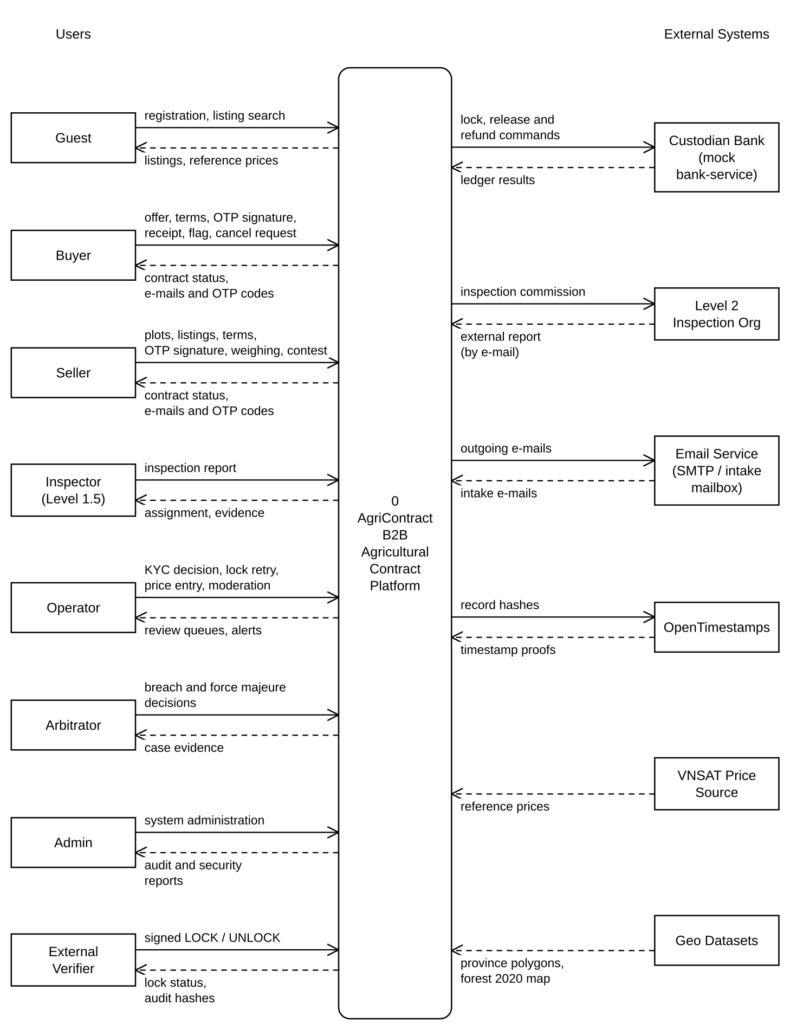

2. Main Business Flow

2.1 User Onboarding & KYC (BF-01)
Trigger: A Guest signs up for an account.
End condition: KYC status is VERIFIED and the result is e-mailed, or KYC is REJECTED with a reason.
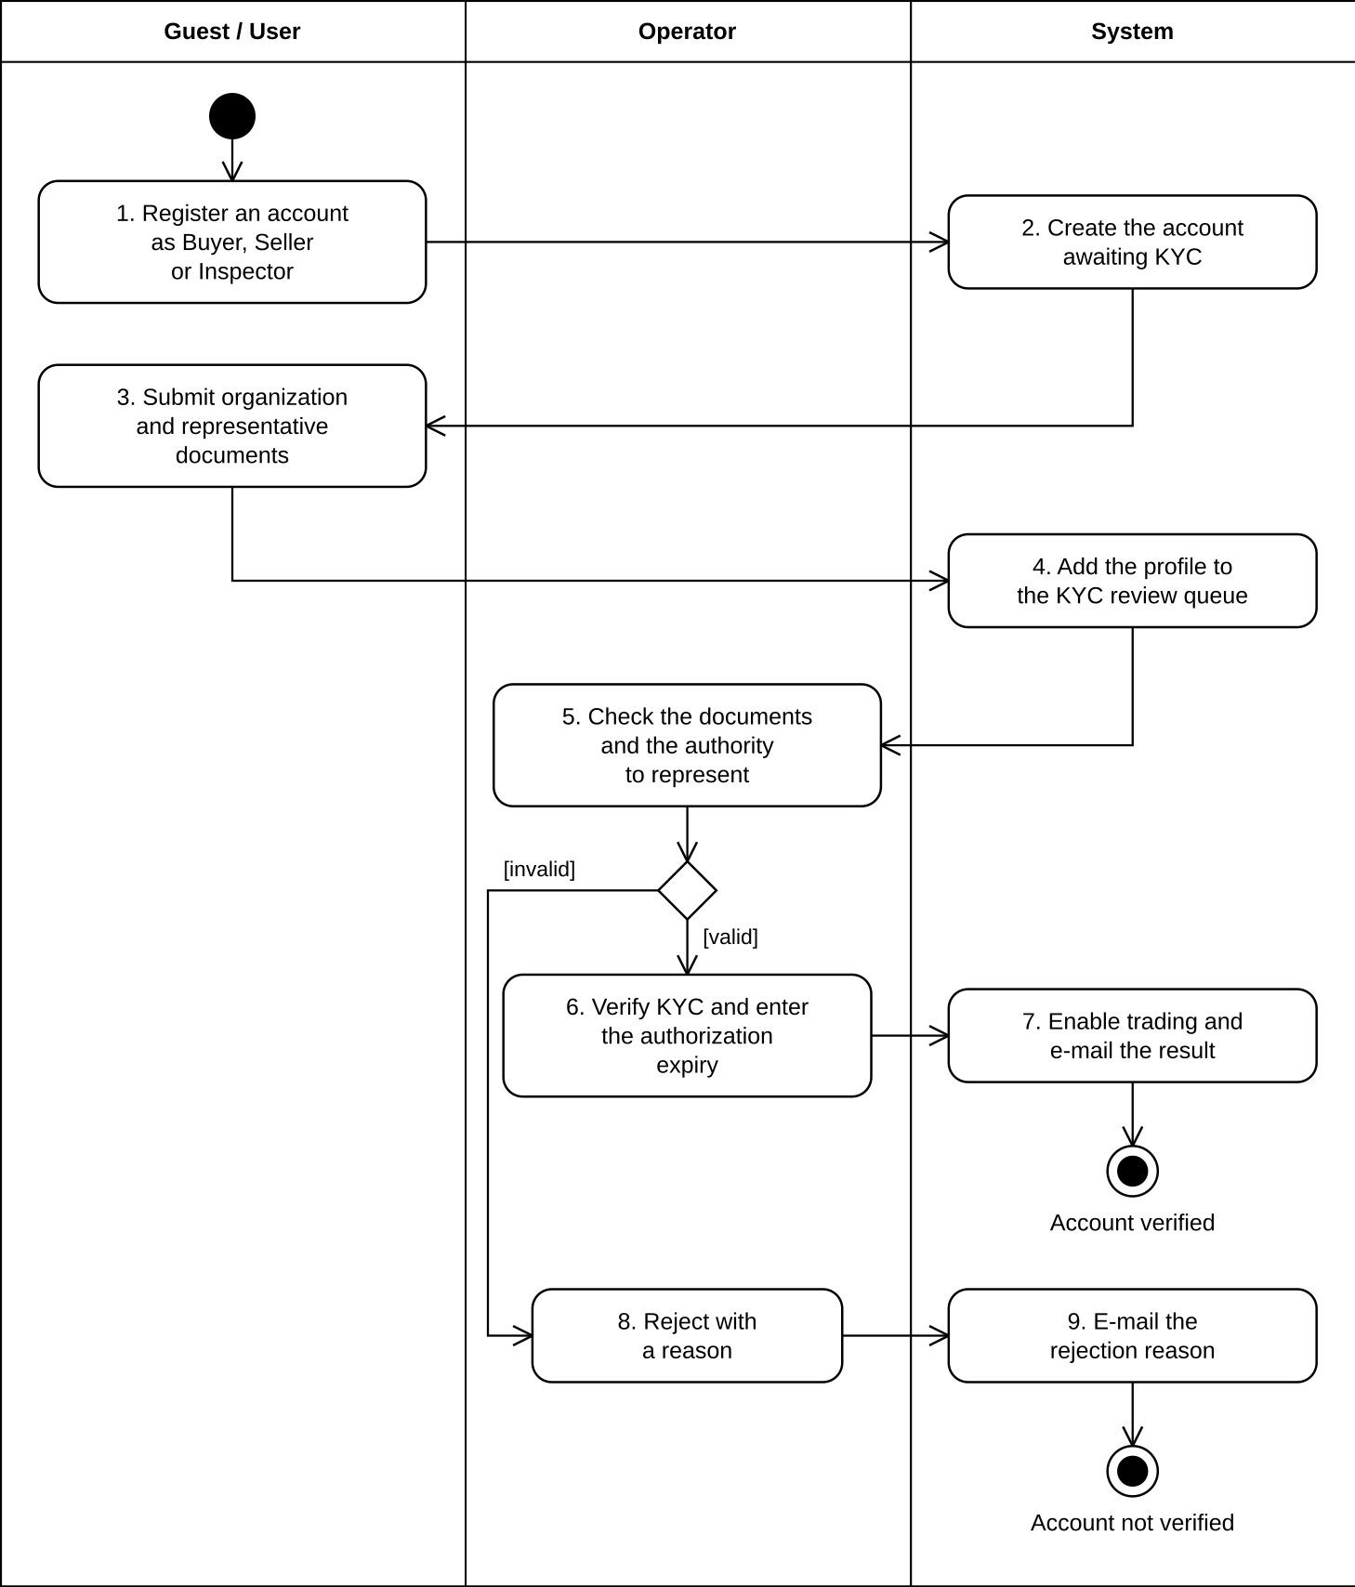

2.2 Plot & Listing Publication (BF-02)
Trigger: A VERIFIED Seller wants to sell a batch of goods.
End condition: The listing is AVAILABLE on the marketplace, or the listing is not published.
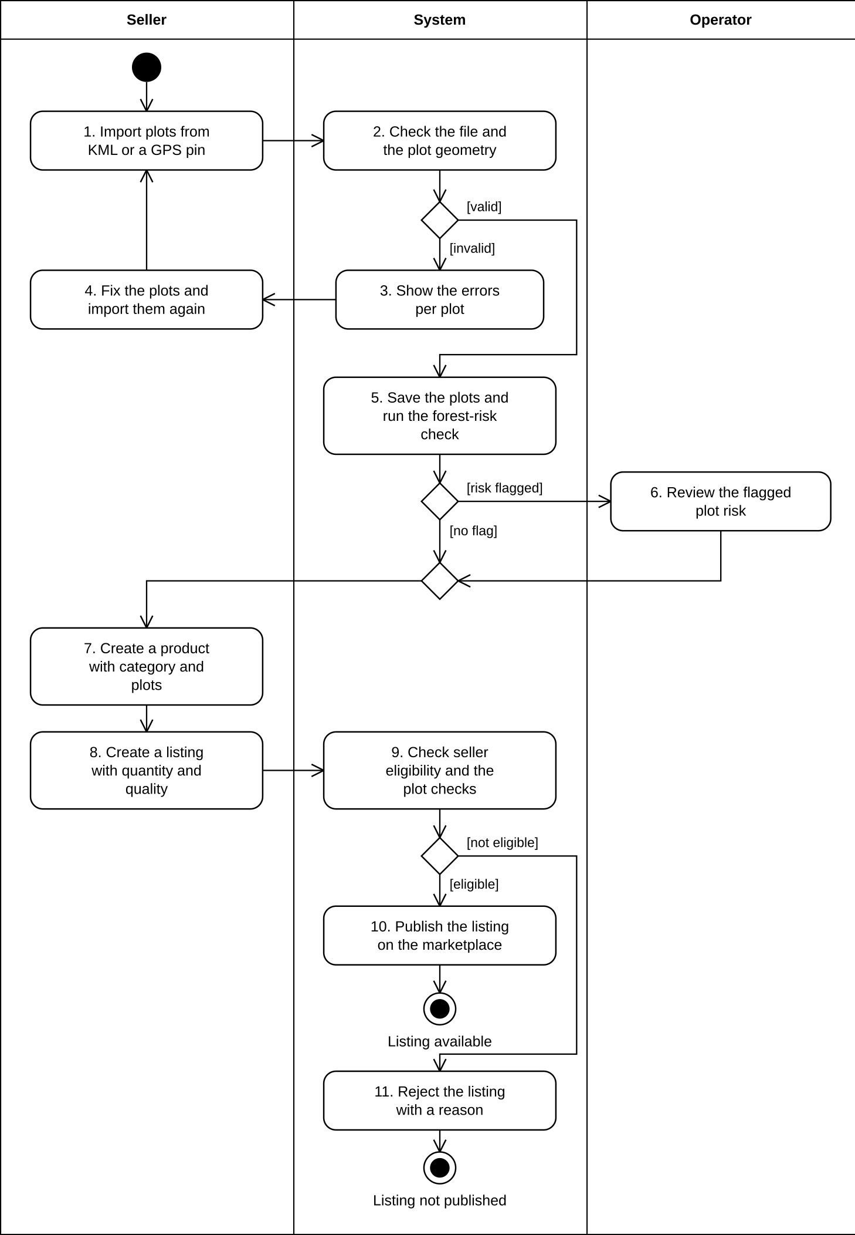

2.3 Contract Signing & Activation (BF-03)
Trigger: A Buyer creates an offer on an AVAILABLE listing.
End condition: The contract is ACTIVE, WITHDRAWN or ACTIVATION_FAILED.
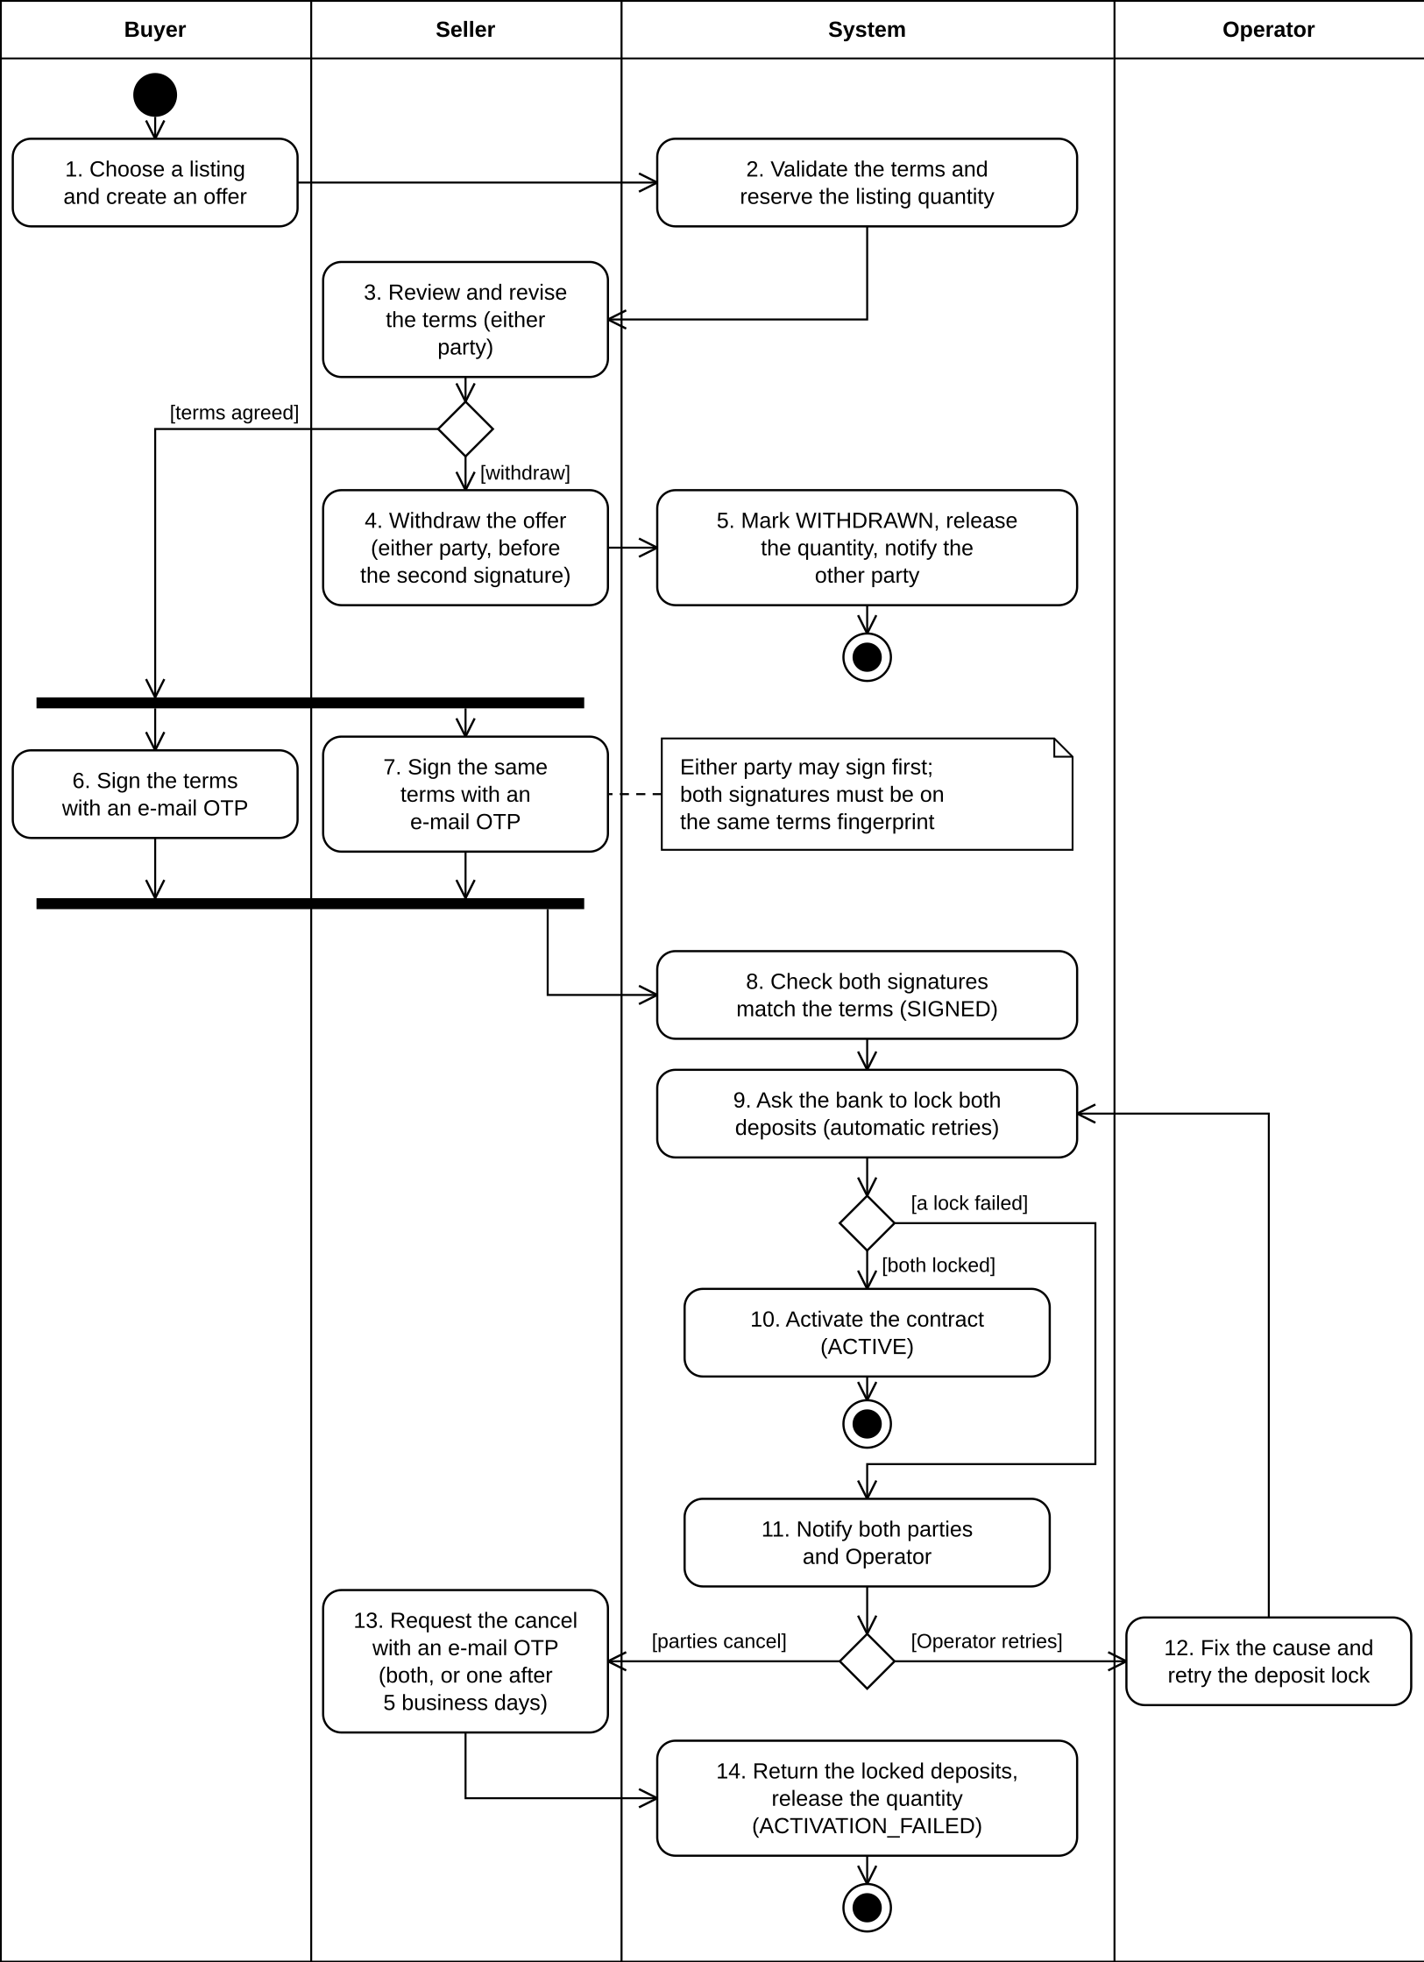

2.4 Milestone Delivery & Settlement (BF-04)
Trigger: A contract is ACTIVE and a milestone's funding is due.
End condition: The contract is SETTLED (a funding failure continues in BF-05).
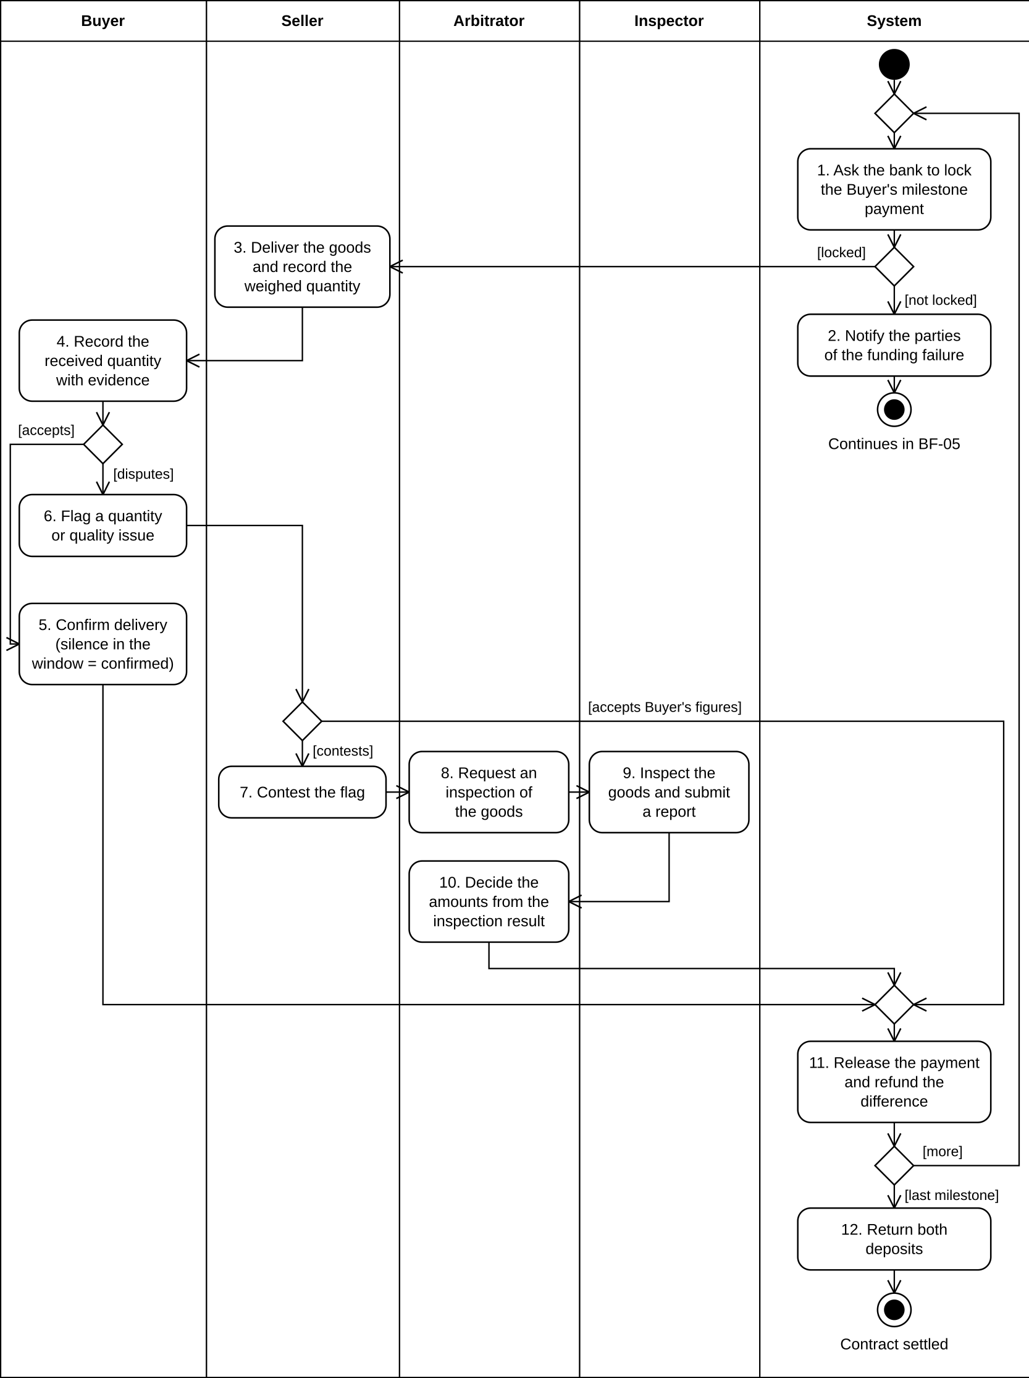

2.5 Breach & Force Majeure Resolution (BF-05)
Trigger: A breach is reported, force majeure is claimed, or the system detects an objective failure.
End condition: The contract is TERMINATED, or it stays ACTIVE.
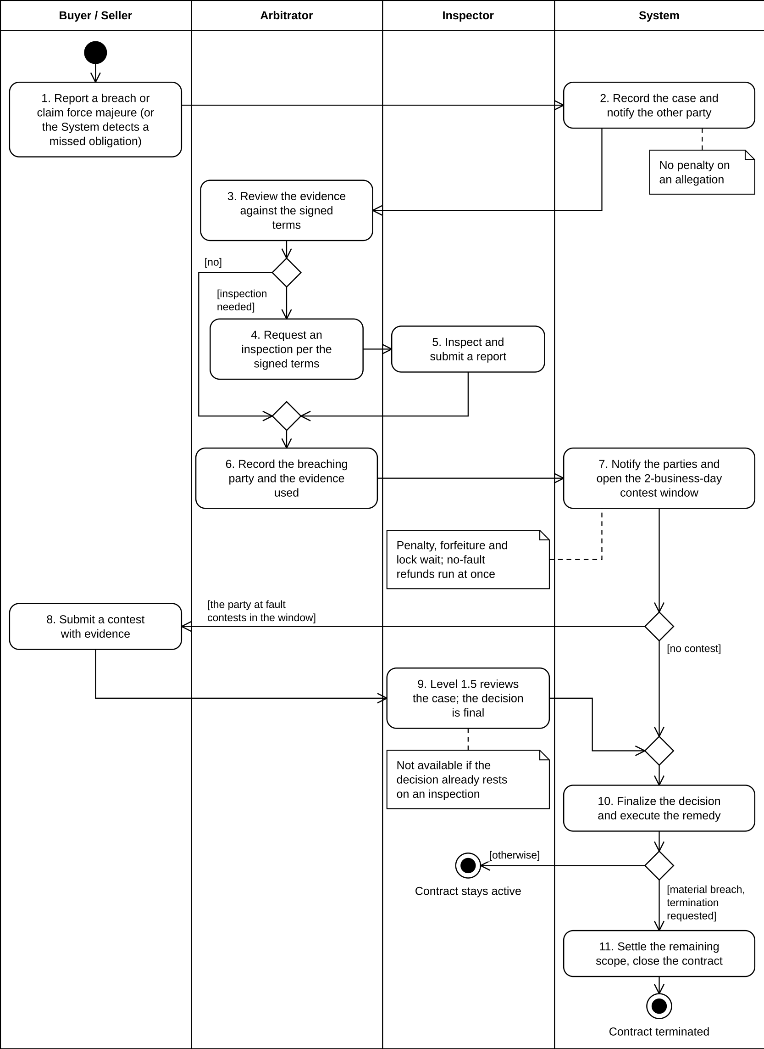

2.6 Mutual Termination & Replacement (BF-06)
Trigger: A party proposes a mutual termination or a replacement contract.
End condition: The contract is TERMINATED or SUPERSEDED, or it stays ACTIVE.

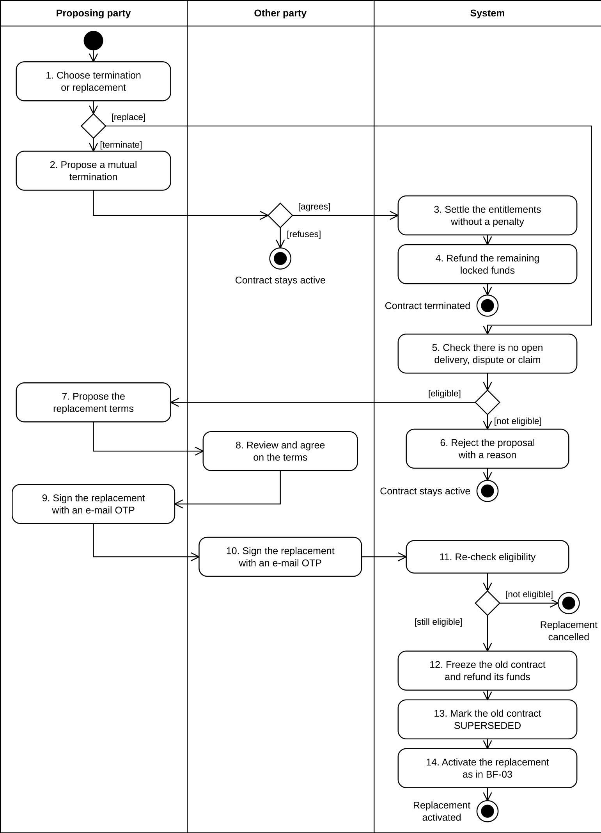

2.7 Emergency Security Lock (BF-07)
Trigger: The External Verifier detects an incident and sends a signed LOCK request.
End condition: The system lock is ACTIVE and every money movement is rejected until the External Verifier sends a signed UNLOCK; or the request is rejected and no lock is applied.

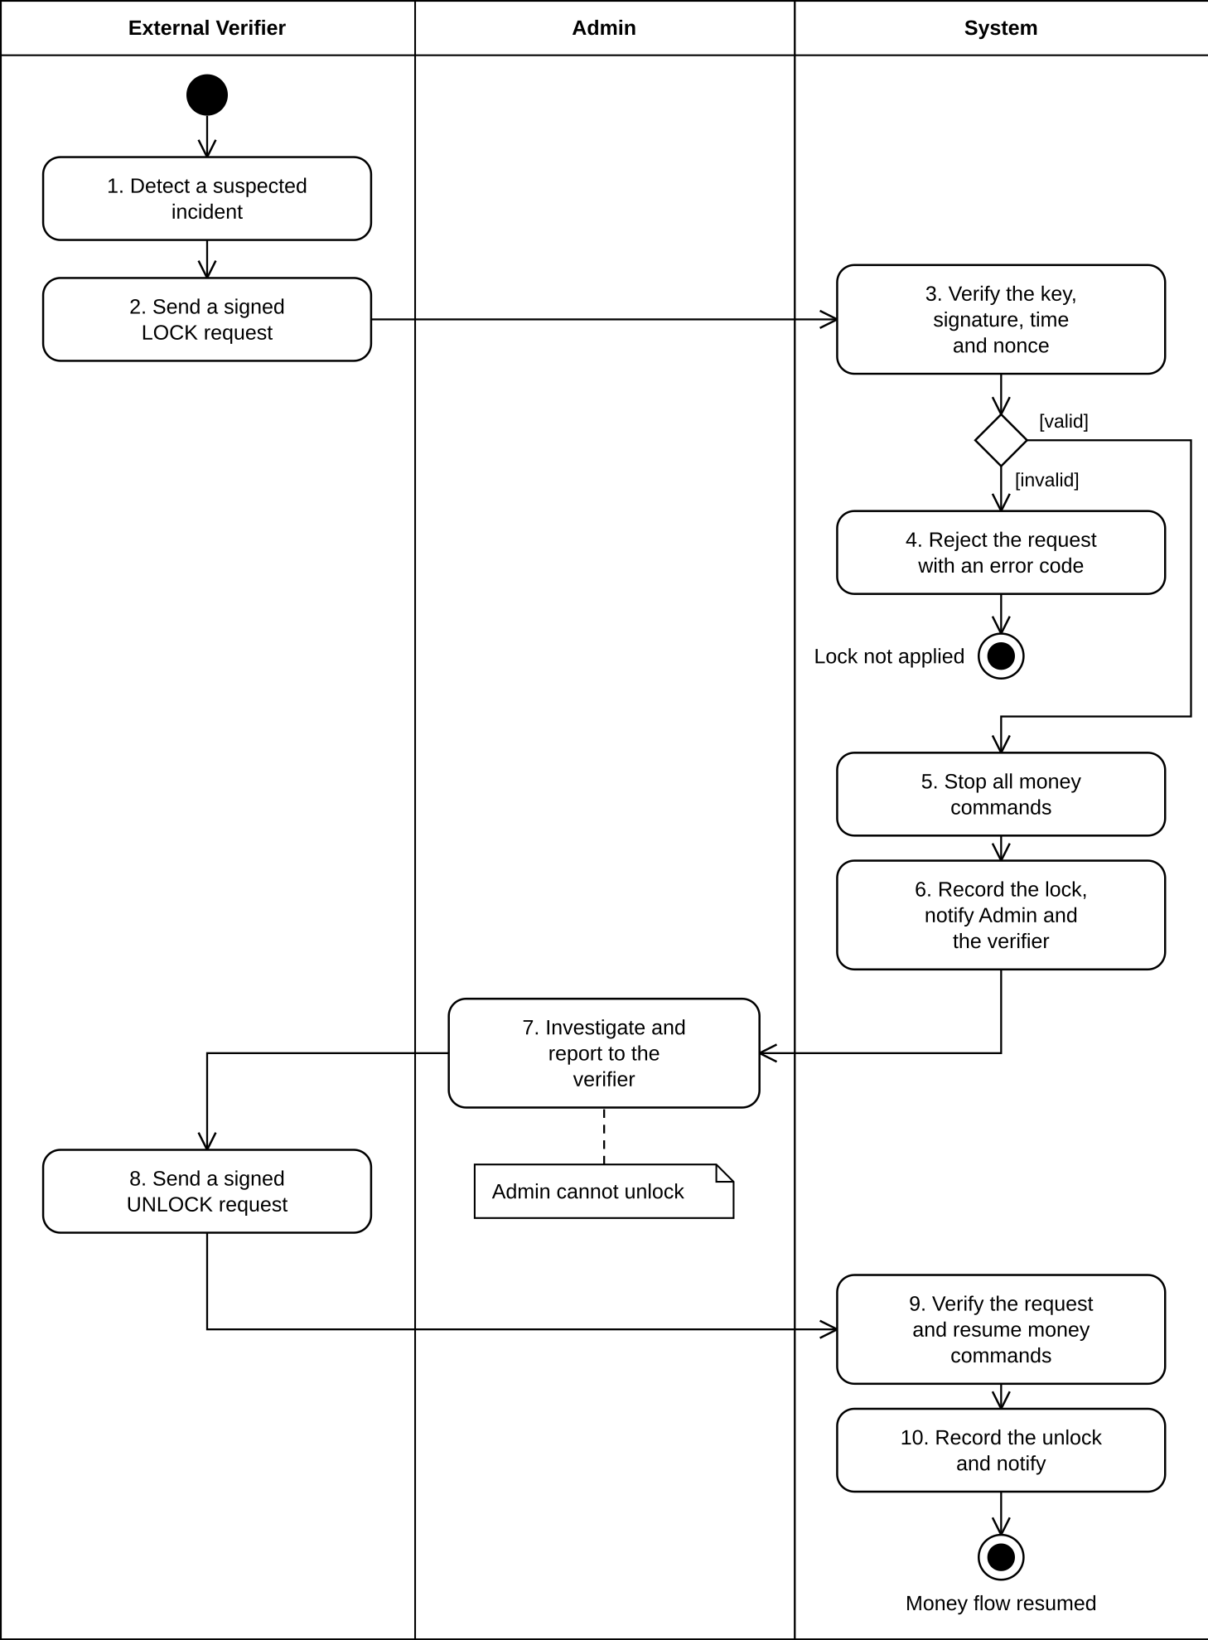

3. Conceptual Data Model

3.1 Entity Relationship Diagram
The conceptual data model of AgriContract is presented as an entity relationship diagram in three parts by domain: (a) identity, product and listing; (b) contract, milestone and money; (c) dispute, inspection, reputation and audit. An entity that belongs to another part is shown as a grey box with its name only. The diagram uses crow's foot (Information Engineering) notation. Each box is an entity; the first compartment holds its primary key (bold, underlined) and the second holds its foreign keys (italic); key business attributes are listed in 3.2. A line is a relationship, labelled with a verb read from the parent to the child, and the symbols at each end show the minimum and maximum cardinality: a bar is "one", a circle is "zero" and a crow's foot is "many". The many-to-many relationship between products and plots is resolved by the associative entity PRODUCT_PLOT. Data types, infrastructure tables and derived analytics data are not shown.
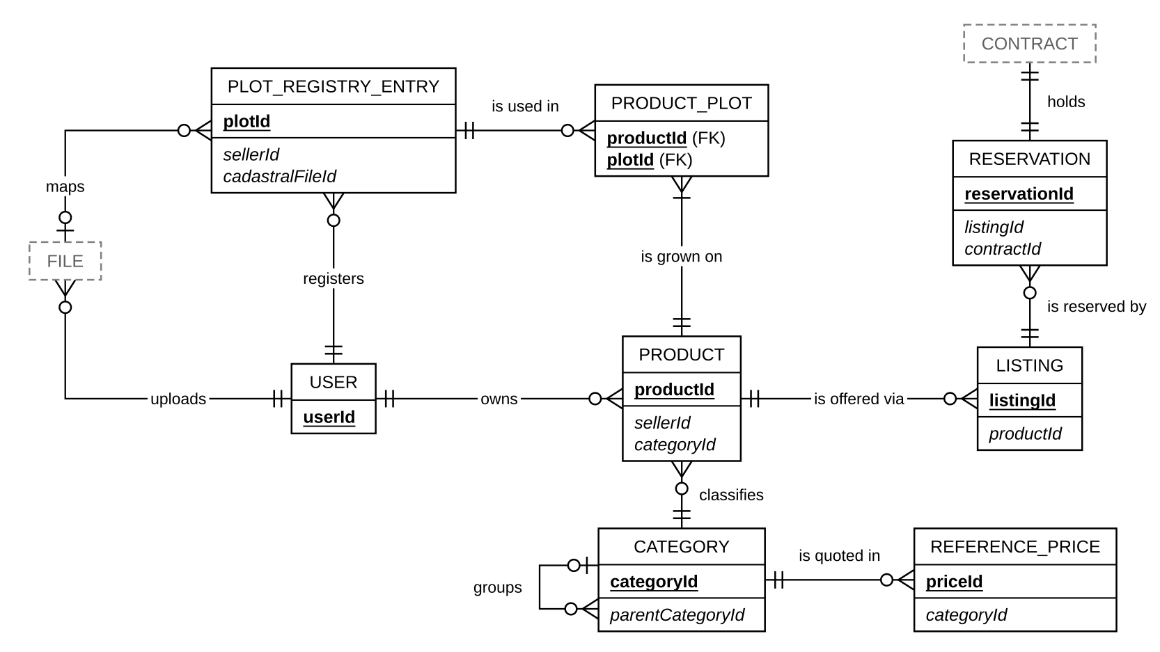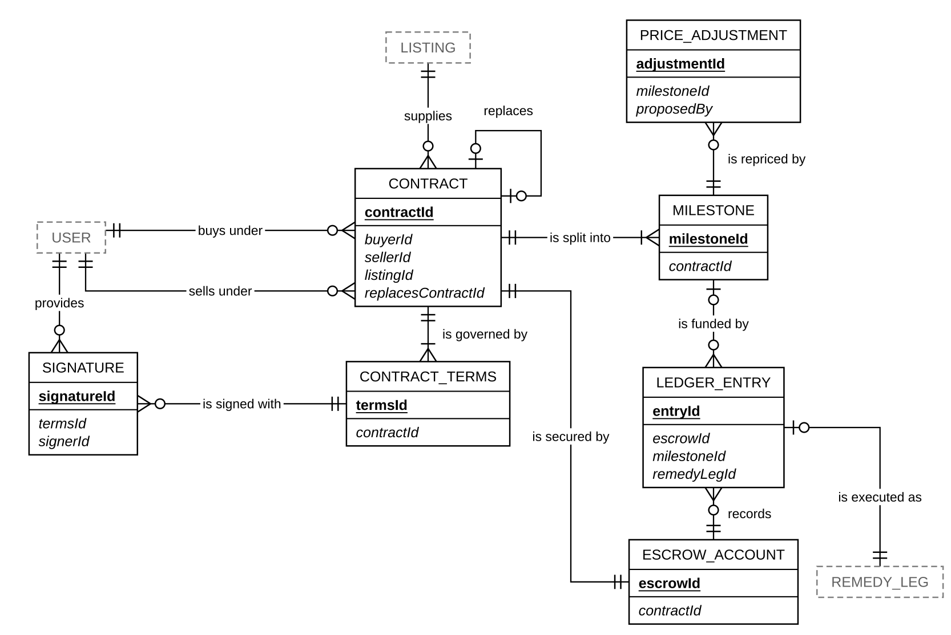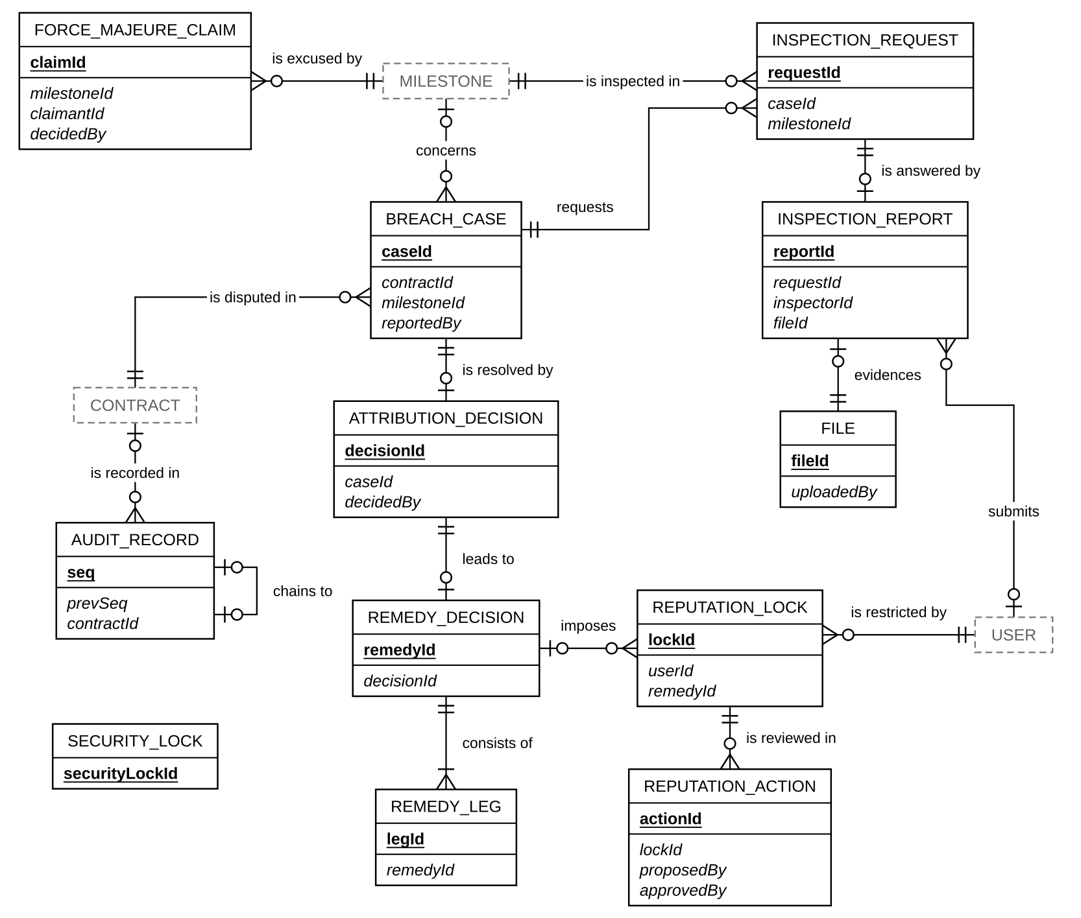

Notes
- SECURITY_LOCK has no relationship line because the emergency lock applies to the whole system rather than to any single record. REFERENCE_PRICE is linked to CATEGORY because reference prices are quoted per commodity, and AUDIT_RECORD is linked to CONTRACT because each contract has its own chain of audit records.

3.2 Entity Descriptions
Entity: USER
Field | Value
Purpose | An account on the platform. It is either an organization that trades (a cooperative selling as Seller, or a company buying as Buyer) or a staff member (Inspector, Operator, Arbitrator, Admin).
Key business attributes | organizationName, role, kycStatus, authorizationExpiresAt
Business identity | The login identity managed by the identity provider. One person or organization has one account.
Status / lifecycle | KYC moves from PENDING to VERIFIED or REJECTED. A VERIFIED user still cannot list or sign when the representative's authorization has expired or when the user has an active reputation lock.
Entity: PLOT_REGISTRY_ENTRY
Field | Value
Purpose | A farm plot of one member household. It belongs to a seller, can be reused across many products, and provides the geolocation that EUDR requires for coffee.
Key business attributes | householdLabel, geometryType, geometry, areaHectares, declaredProvince, verificationLevel, geoRiskLevel
Business identity | The pair (seller, householdLabel). Re-importing a KML file matches existing plots on this pair instead of creating duplicates.
Status / lifecycle | No business lifecycle. A plot can be updated by re-import. The satellite check moves from PENDING to CHECKED or UNVERIFIED. Products keep their own snapshot of the plot, so later edits do not change listings or contracts that already exist.
Entity: CATEGORY
Field | Value
Purpose | Classification of agricultural products by commodity. In Phase 2 the only supported commodity is COFFEE.
Key business attributes | commodity, name
Business identity | Unique category name within a commodity.
Status / lifecycle | PENDING → APPROVED or REJECTED. A Seller proposes a category and the Operator approves or rejects it.
Entity: PRODUCT
Field | Value
Purpose | An agricultural product definition owned by a seller, tied to category and plot registry entries.
Key business attributes | productName, varietyName, cropYear
Business identity | Pair of (seller, productName).
Status / lifecycle | Active product profiles offer goods via listings.
Entity: PRODUCT_PLOT
Field | Value
Purpose | The link between a product and a plot it is grown on. It resolves the many-to-many relationship between PRODUCT and PLOT_REGISTRY_ENTRY.
Key business attributes | plotSnapshot
Business identity | Pair of (product, plot).
Status / lifecycle | Created with the product. The plot snapshot is frozen when the link is created, so later edits to the plot do not change existing listings or contracts.
Entity: LISTING
Field | Value
Purpose | Public offering of a product for sale on the marketplace.
Key business attributes | offeredQuantity, quantityAvailable, minOrderQuantity, declaredQualitySpec, status
Business identity | System-generated listing identifier.
Status / lifecycle | DRAFT → AVAILABLE → PARTIALLY_COMMITTED → CLOSED. The Seller can pause a listing (PAUSED) and republish it.
Entity: RESERVATION
Field | Value
Purpose | Temporary quantity hold on a listing while a contract offer is negotiated or signed.
Key business attributes | quantity, status
Business identity | Unique reservation link between listing and pending contract.
Status / lifecycle | RESERVED → SIGNED_RELEASABLE → COMMITTED (on contract activation), or RELEASED (on withdrawal, activation failure, or no contract within 30 minutes).
Entity: REFERENCE_PRICE
Field | Value
Purpose | Market commodity prices published for reference by region.
Key business attributes | commodity, province, price, source, quotedAt
Business identity | Tuple of (commodity, province, quotedAt).
Status / lifecycle | Time-series pricing records; no state changes.
Entity: CONTRACT
Field | Value
Purpose | The forward contract agreement between a Buyer and a Seller.
Key business attributes | status, termsVersion, signedContentHash
Business identity | Unique contract identifier.
Status / lifecycle | OFFERED → NEGOTIATING → SIGNED → ACTIVE → SETTLED. Other terminal states: WITHDRAWN, TERMINATED, SUPERSEDED, ACTIVATION_FAILED.
Entity: CONTRACT_TERMS
Field | Value
Purpose | Detailed conditions and clauses governing a contract version.
Key business attributes | agreedPrice, priceBand, depositRates, qualityTerms, deliveryTerms, governingLaw, maxPenaltyRate, damagesPolicy, inspectionTerms, buyerConfirmWindowDays, forceMajeureReportWindowDays
Business identity | Pair of (contract, termsVersion).
Status / lifecycle | Frozen upon first party signature.
Entity: SIGNATURE
Field | Value
Purpose | Electronic verification signature (OTP-based) bound to a contract terms version.
Key business attributes | signerRole, termsHash, signedAt
Business identity | Tuple of (contract, termsVersion, signerRole).
Status / lifecycle | Immutable signature record once validated.
Entity: MILESTONE
Field | Value
Purpose | Delivery tranche within a contract specifying delivery schedules and amounts.
Key business attributes | milestoneIndex, committedQuantity, batchAmount, deliveryDeadline, deliveryStatus, fundingStatus
Business identity | Pair of (contract, milestoneIndex).
Status / lifecycle | CREATED → IN_PROGRESS → SELLER_WEIGHED → BUYER_RECEIVED → SETTLED, with the branches AWAITING_SELLER_RESPONSE → CONTESTED and FORCE_MAJEURE_PENDING_REVIEW.
Entity: PRICE_ADJUSTMENT
Field | Value
Purpose | Proposed price revision for a specific milestone based on market or quality changes.
Key business attributes | proposedPrice, proposedBy, status
Business identity | Unique price adjustment identifier per milestone.
Status / lifecycle | PENDING → ACCEPTED or REJECTED.
Entity: FORCE_MAJEURE_CLAIM
Field | Value
Purpose | Exemption request due to unforeseeable natural or severe events.
Key business attributes | eventDescription, eventKnownAt, status
Business identity | Unique force majeure claim identifier tied to a milestone.
Status / lifecycle | SUBMITTED → APPROVED or REJECTED.
Entity: BREACH_CASE
Field | Value
Purpose | Formal dispute record alleging non-performance or contract violation.
Key business attributes | allegedBreachingRole, breachReasonCode, severity, status
Business identity | Unique breach case identifier.
Status / lifecycle | REPORTED → UNDER_REVIEW → RESOLVED.
Entity: ATTRIBUTION_DECISION
Field | Value
Purpose | Recorded finding determining responsibility or fault for a breach or contract conclusion.
Key business attributes | finalBreachingRole, decisionSource, qualityDisposition
Business identity | Unique attribution decision identifier linked to contract or breach case.
Status / lifecycle | Finalized decision record driving remedy generation.
Entity: REMEDY_DECISION
Field | Value
Purpose | Financial and administrative corrective actions resulting from attribution decisions.
Key business attributes | penaltyEligible, reputationEligible, legalProfileSnapshot
Business identity | Unique remedy decision identifier.
Status / lifecycle | Executes remedy legs through bank/custodian commands.
Entity: REMEDY_LEG
Field | Value
Purpose | Specific monetary allocation leg (release, refund, penalty, damages) within a remedy decision.
Key business attributes | remedyType, fundType, role, amount
Business identity | Unique leg identifier per remedy decision.
Status / lifecycle | Translated directly into ledger entry execution.
Entity: ESCROW_ACCOUNT
Field | Value
Purpose | Bank/custodian escrow tracking deposits and milestone funding for a contract.
Key business attributes | buyerDepositState, sellerDepositState
Business identity | One-to-one relationship with Contract.
Status / lifecycle | Each deposit moves from DEPOSIT_LOCKED to DEPOSIT_RELEASED or DEPOSIT_SEIZED. The account is a projection of the bank ledger.
Entity: LEDGER_ENTRY
Field | Value
Purpose | Individual financial transaction entry recorded in escrow ledger.
Key business attributes | entryType, fundType, amount, recordedAt
Business identity | Unique ledger entry identifier.
Status / lifecycle | Immutable accounting record.
Entity: INSPECTION_REQUEST
Field | Value
Purpose | Commission of Level 2 external quality or quantity inspection.
Key business attributes | inspectionOrg, caseCode, status, requestedAt
Business identity | Unique caseCode.
Status / lifecycle | REQUESTED → CASE_ID_CONFIRMED.
Entity: INSPECTION_REPORT
Field | Value
Purpose | Inspection finding report submitted by internal inspector (Level 1.5) or external org (Level 2).
Key business attributes | tier, normalizedResult, reportHash, status, submittedAt
Business identity | Unique inspection report identifier.
Status / lifecycle | A Level 1.5 report is CONFIRMED at submission. A Level 2 report is PENDING_REVIEW until the Operator confirms it (CONFIRMED) or rejects it (REJECTED).
Entity: FILE
Field | Value
Purpose | Uploaded evidence document or image stored in object storage.
Key business attributes | ingestChannel, sha256, status, legalHold
Business identity | sha256 hash value.
Status / lifecycle | PROCESSING → READY or FAILED; a file under legal hold cannot be deleted.
Entity: REPUTATION_LOCK
Field | Value
Purpose | Restriction imposed on a user account preventing listing or contract signing after deliberate breach.
Key business attributes | lockedUntil, reasonCode
Business identity | Unique reputation lock identifier per user.
Status / lifecycle | ACTIVE → EXPIRED or EARLY_UNLOCKED.
Entity: REPUTATION_ACTION
Field | Value
Purpose | Maker-checker request to apply or remove a reputation lock.
Key business attributes | actionType, proposedBy, approvedBy, status
Business identity | Unique reputation action identifier.
Status / lifecycle | PROPOSED → APPROVED or REJECTED.
Entity: SECURITY_LOCK
Field | Value
Purpose | System-wide emergency lock triggered by External Verifier to freeze money movements.
Key business attributes | state, verifierOrg, activatedAt
Business identity | Singleton system emergency state entity.
Status / lifecycle | ACTIVE ↔ RELEASED. Only a signed External Verifier request changes it.
Entity: AUDIT_RECORD
Field | Value
Purpose | Tamper-evident audit event record linked sequentially in a hash chain.
Key business attributes | seq, sourceType, recordHash, prevHash
Business identity | Sequential integer seq.
Status / lifecycle | Immutable record anchored via external timestamping.

3.3 Data Business Rules
Rule | Description | Enforced On
Money format | Money is a positive decimal with exactly 2 fractional digits, rounded HALF_UP. Floating-point values are never used. Only the contract side rounds; the bank never rounds again. | Contract creation, milestone funding, remedy calculation, ledger posting
Units and time | Quantities are stored in kilograms. Timestamps are stored in UTC. Deadlines end at the end of the day in Vietnam time (ICT), and working days are Monday to Friday excluding Vietnamese public holidays. | Listing creation, contract creation, deadline checks
Unique household plot | A seller cannot have two plots with the same householdLabel. Re-importing a KML file updates the plot with the same (seller, householdLabel) instead of creating a new one. | Plot import and re-import
Plot geometry | Geometry is stored in WGS84 coordinates. A plot created by manual pin can only be a POINT. A POLYGON must come from a KML import. | Plot import and manual pin
Plot required for EUDR commodities | A coffee product must reference at least one plot before it can be listed. | Listing creation
Category commodity | Every approved category is mapped to exactly one commodity; in Phase 2 the only accepted commodity is COFFEE. Category names are unique. | Category approval and category creation
Snapshot, not live reference | Plot data is copied into the product when a listing is created. Product, category, plot and listing data are copied into the contract terms when the contract is created. Later edits or deletion of the source never change a snapshot or its hash. | Listing creation and contract creation
Available quantity | quantityAvailable starts equal to offeredQuantity, is never negative and is changed only by reservations. A reservation is accepted only if the requested quantity is at least minOrderQuantity and at most quantityAvailable. | Listing creation, reservation and reservation release
Terms frozen at first signature | Contract terms can change only before the first signature. The first signature freezes the terms and their SHA-256 hash (signedContentHash), which covers the full terms and the legal profile. | Contract terms update and contract signing
Two matching signatures | A contract has at most one signature per side. The second signature must carry the same terms hash as the first. | Contract signing
Contract value is derived | totalContractValue equals agreedPrice multiplied by the sum of milestone committed quantities. It is calculated by the system and never entered by a user. | Contract creation and terms update
Deposit rate band | The buyer's deposit rate must be between 3% and 10% of the total contract value, with 5% as the default. | Contract creation and terms update
Terminal contracts are final | A contract in SETTLED, TERMINATED, SUPERSEDED, ACTIVATION_FAILED or WITHDRAWN cannot change and must hold no locked money. | Contract settlement, termination, replacement and activation failure
Settled milestone is final | A SETTLED milestone cannot be changed. | Milestone settlement
Price adjustment limits | The effective price of an adjustment must be inside the signed price band and accepted before the milestone's funding request. It never changes the signed terms or their hash. | Price adjustment proposal and acceptance
Penalty cap | A contractual penalty cannot exceed the legal profile's maxContractualPenaltyRate (8% under the Vietnamese commercial profile), calculated on the breached obligation. | Remedy calculation
No-fault means no punishment | When finalBreachingRole is empty, the remedy has penaltyEligible = false and reputationEligible = false, and contains no deposit forfeiture, penalty or damages legs. | Remedy calculation
Decisions are final | Attribution and remedy decisions cannot be changed once created. | Attribution and remedy decision
Remedy leg identity | Every remedy leg has a unique remedyLegId, which the bank uses so that a leg is never executed twice. Legs with a zero amount are not created. | Remedy execution at the bank
Ledger is append-only | Ledger entries can only be inserted and read, never updated or deleted. Each entry has a unique source event, so the same event is never recorded twice. | Ledger posting
Ledger is the source of truth | The escrow account is a projection of the bank ledger. When they disagree, the ledger wins. | Escrow projection update and reconciliation
Reputation locks are append-only | A lock is never updated. Expiry and early unlock are derived from lockedUntil and approved actions. When a user has several active locks, the latest lockedUntil applies. | Reputation lock creation and early unlock
Unique inspection case code | A case code is unique within its inspection organization. | Inspection case code confirmation
Report hash frozen | An inspection report's hash, covering the file, result, time and actor, is fixed at submission, before any review. | Inspection report submission
Evidence files | Only a file in READY state can be attached as evidence. A file under legal hold cannot be deleted. A file not attached to any business record is deleted after one week. | Evidence attachment, file deletion and orphan file cleanup
Audit chain is append-only | Audit records are never updated or deleted, and each source event produces exactly one record. Records hold IDs, amounts and hashes only, with no personal data. Deleting a file never deletes its audit record. | Audit record creation
Single-use nonce | Each security lock or unlock request carries a nonce that can be used only once. | Security lock and unlock request
Reference only | Reference prices are never used to calculate any contract or settlement amount. | Contract creation and settlement calculation
Retention | Contracts, signatures, snapshots and settlement evidence are kept for 10 years after the contract closes. Ledger entries are kept for 10 years and archived, never deleted. KYC documents are kept for 5 years after the relationship ends. Audit records are kept permanently. | Archiving and data deletion
Replacement freeze | While a contract is REPLACEMENT_PENDING or SUPERSEDE_REFUND_PENDING, trading and milestone actions on it are blocked and its delivery and funding timers have no business effect. Refunds, reconciliation, security locks, notifications and read access continue. Eligibility is rechecked before the replacement is committed (GB-49). | Contract replacement

4. User Requirements

4.1 Actors
# | Actor | Description
1 | Guest | A visitor who has not logged in. A Guest can browse published listings and reference prices, and can register an account as a Buyer, Seller or Inspector.
2 | Buyer | A trading company that buys agricultural goods. After its KYC is verified, the Buyer creates offers from listings, negotiates and signs contracts with an OTP, funds each milestone through escrow, confirms or flags each delivery, and can report a breach or propose termination. A Buyer acts only on contracts it is a party to.
3 | Seller | A cooperative, a group of linked farming households, or a supplier that sells goods. After its KYC is verified, the Seller registers plots, manages products and listings, signs contracts, records the weighed quantity of each delivery, responds to the Buyer's flags and can claim force majeure. The Seller is paid milestone by milestone.
4 | Inspector (Level 1.5) | An independent inspector registered on the platform. The Inspector sees only the cases assigned to them, together with the quality terms committed in the contract, and submits measurements and a report that the system hashes on submission.
5 | Operator | Platform staff who handle daily, reversible operations: reviewing KYC, reviewing plot risk, moderating categories and listings, entering manual prices, proposing reputation actions, retrying a failed deposit or funding lock, and handling the paperwork of Level 2 inspections (tracking commissions, matching and confirming received reports, manual upload and intake failures). The Operator does not decide disputes; retrying a bank command re-sends the same command and never changes an amount.
6 | Admin | Platform staff who administer the system: creating staff accounts and assigning roles, monitoring audit chain integrity and the security lock status, exporting contract evidence and viewing analytics reports. The Admin has no business decision rights on contracts, disputes or money; its only money-related action is approving the technical replay of a failed money, security or evidence message proposed by the Operator (GB-48). No Admin can edit ledger entries, signed contracts or audit records, or trigger the emergency lock.
7 | Arbitrator | Platform staff who decide disputes: reviewing and resolving breach cases and routing contested decisions to Level 1.5 (GB-50), deciding force majeure claims, requesting Level 1.5 or Level 2 inspections, executing a termination after a final decision, and approving or rejecting reputation actions proposed by another user. Every decision is recorded with its evidence and cannot be edited afterwards.
8 | External Verifier | An independent organization outside the platform team. It queries contract audit hashes to check integrity, receives the weekly audit digest, and is the only party that can trigger or release the emergency security lock, using a digitally signed (ES256) request.
9 | Level 2 Inspection Organization | An accredited inspection body named in the contract terms. It receives a commission letter with a case ID by email and sends its inspection report back by email. It has no account on the platform.
10 | Custodian Bank | The bank that holds escrow funds, simulated by the mock bank-service. It executes lock, release, refund and seize commands and returns command results and ledger entries.
11 | Email Service | The SMTP service that delivers OTP codes, notifications and evidence attachments. Its intake mailbox also receives Level 2 inspection reports.
12 | OpenTimestamps | A public timestamping service. It receives the audit digest and returns a timestamp proof.
13 | VNSAT Price Source | The external source of coffee reference prices by province, read on a schedule.
14 | Geo Datasets | Province boundary polygons and the 2020 forest baseline, used to check plot location and deforestation risk.

4.2 Use Cases (UC)
ID | Use Case | Feature | Use Case Description
UC01 | Register Account | User Authentication & Account | The Guest creates an account as a Buyer, Seller or Inspector with organization details. The account starts with KYC status PENDING.
UC02 | Log In and Log Out | User Authentication & Account | A registered user (Buyer, Seller, Inspector, Operator, Arbitrator or Admin) signs in once and sees only the functions of their role, and logs out to end the session.
UC03 | Manage Profile and KYC | User Authentication & Account | The Buyer, Seller or Inspector updates organization details, submits KYC documents and the representative's authorization, and sees the KYC status, the authorization expiry date and any active lock.
UC04 | View Partner Profile | User Authentication & Account | The Buyer or Seller views another party's public profile, reputation and lock history before trading. Private contact data is never shown.
UC05 | Review KYC Application | Account Administration | The Operator verifies a pending account, entering the authorization expiry date from the real documents, or rejects it with a reason.
UC06 | Propose Reputation Action | Account Administration | The Operator proposes an early unlock or the clearing of an elevated-risk flag for a user, with a reason. The proposal waits for an Arbitrator's decision.
UC07 | Approve Reputation Action | Account Administration | The Arbitrator approves or rejects a reputation action proposed by another person. The system blocks an Arbitrator from approving their own proposal.
UC08 | Manage Accounts and Roles | Account Administration | The Admin creates staff accounts, assigns roles and deactivates accounts through the identity provider.
UC09 | Register Plots | Plot & Listing | The Seller imports plots from a KML file, or adds a plot by GPS pin when no KML is available. The system checks the geometry and province of each placemark and reports errors per placemark.
UC10 | Upload Cadastral Extract | Plot & Listing | The Seller attaches a cadastral map extract to a plot to raise the plot's confidence level.
UC11 | Request Geo-risk Re-evaluation | Plot & Listing | The Seller sends field photos for a plot flagged with high deforestation risk and asks for the plot to be re-evaluated.
UC12 | Review Plot Risk | Plot & Listing | The Operator reviews plots flagged for overlapping another seller's plot or for deforestation risk, and accepts or rejects them instead of the system rejecting them automatically.
UC13 | Manage Products | Plot & Listing | The Seller creates and updates products with category, variety, crop year, self-declared certifications and linked plots. Coffee products must link at least one plot.
UC14 | Create Listing | Plot & Listing | The Seller creates a listing for a product with the offered quantity, minimum order quantity, declared quality and linked plots. The system checks the product and plots and saves a snapshot of them.
UC15 | Pause or Close Listing | Plot & Listing | The Seller pauses, republishes or closes a listing and sees the remaining quantity after each contract.
UC16 | Browse Listings | Plot & Listing | The Guest, Buyer or Seller searches listings by commodity, region, quality and seller reputation, and opens a listing's details.
UC17 | Moderate Categories and Listings | Plot & Listing | The Operator approves or rejects categories proposed by sellers, assigning the commodity on approval, and moderates products and listings that break platform rules.
UC18 | View Reference Prices | Market Prices | Any user, including a Guest, views reference prices by commodity and province. Reference prices are never used to calculate contract amounts.
UC19 | Enter Manual Prices | Market Prices | The Operator enters a coffee reference price by hand, with its province, source and reason, when the VNSAT source is interrupted or needs a controlled correction.
UC20 | Create Contract Offer | Contract | The Buyer creates an offer from a listing with quantity, price band, milestone schedule, quality, delivery and inspection terms and deposit rates. The quantity is reserved on the listing while the contract is negotiated.
UC21 | Negotiate Contract Terms | Contract | The Buyer or Seller edits the contract terms until both sides agree. Terms can no longer change after the first signature.
UC22 | Sign Contract | Contract | The Buyer or Seller signs the contract with an OTP sent by email. The second signature must cover the same terms as the first.
UC23 | Activate Contract | Contract | After the second signature, the system locks the Buyer's deposit, and the Seller's deposit when one was agreed, at the bank. The contract becomes ACTIVE only when every deposit is locked.
UC24 | Withdraw Offer | Contract | The Buyer or Seller withdraws the offer before both signatures exist, without any penalty. The reserved quantity returns to the listing.
UC25 | View Contracts | Contract | The Buyer or Seller views their contracts with the status of each milestone, the deposits, payments made and the decision history.
UC26 | Propose Mutual Termination | Contract | The Buyer or Seller proposes to end the contract by agreement. When the other party confirms, the remaining obligations end with no penalty and no reputation impact, and locked funds return to their owners.
UC27 | Propose Contract Replacement | Contract | The Buyer or Seller proposes a new contract to replace the current one when terms must change after signing. When the new contract is signed, the old one becomes SUPERSEDED.
UC28 | Export Escrow Statement | Contract | The Buyer or Seller exports their own ledger entries for a contract to reconcile with their accounting.
UC29 | Handle Activation Failure | Contract | After a deposit lock failed, the Operator retries the lock once the cause is fixed; the Buyer and Seller decide to stop: when both ask to cancel, or one asks after 5 business days, the system refunds the locked deposits and releases the reserved quantity. The Operator cannot cancel a contract.
UC30 | Fund Milestone | Milestone & Delivery | The Buyer funds the batch amount of the next milestone before its funding deadline. The Seller's delivery clock starts only when the funding is locked.
UC31 | Adjust Milestone Price | Milestone & Delivery | The Buyer or Seller proposes a new price for one milestone, inside the signed price band, before that milestone is funded. The other party accepts or rejects it.
UC32 | Record Seller Weighing | Milestone & Delivery | The Seller records the weighed quantity of a milestone delivery and attaches the weighing slip or delivery documents.
UC33 | Record Buyer Receipt | Milestone & Delivery | The Buyer records the quantity actually received so the system can compare it with the Seller's weighing.
UC34 | Confirm Milestone Delivery | Milestone & Delivery | The Buyer confirms that the milestone is acceptable, so the payment is released to the Seller. If the Buyer does not respond in time, the system confirms automatically.
UC35 | Flag Delivery Issue | Milestone & Delivery | The Buyer flags a short quantity or a quality problem with evidence, so the payment is held instead of released.
UC36 | Respond to Delivery Issue | Milestone & Delivery | The Seller accepts or contests a flag raised by the Buyer within the response window. A contested flag goes to dispute handling.
UC37 | Submit Force Majeure Claim | Milestone & Delivery | The Seller declares force majeure with evidence within the deadline set in the contract.
UC38 | Upload Evidence File | Milestone & Delivery | The Buyer or Seller uploads a file such as a weighing slip, photo or document. The system scans the file, and only a file in READY state can be attached as evidence.
UC39 | Retry Milestone Funding | Milestone & Delivery | The Operator retries the funding lock of a milestone after the Buyer confirms funds are available or after a bank or system outage is resolved.
UC40 | Report Breach | Dispute & Inspection | The Buyer or Seller reports a breach by the other party with evidence, and follows the case until the final decision.
UC41 | Review and Resolve Breach Case | Dispute & Inspection | The Arbitrator reviews a breach case with its evidence and inspection results, requests a Level 1.5 or Level 2 inspection when needed, and records who is at fault. A milestone-level decision that brings a penalty, deposit forfeiture or reputation lock takes effect only after the 2-business-day contest window (GB-50).
UC42 | Decide Force Majeure Claim | Dispute & Inspection | The Arbitrator accepts or rejects a force majeure claim after reviewing its evidence.
UC43 | View Assigned Cases | Dispute & Inspection | The Inspector views the cases assigned to them and the quality terms committed in each contract.
UC44 | Submit Inspection Result | Dispute & Inspection | The Inspector submits the measured values and the report file. The system hashes the report so it cannot be changed after submission.
UC45 | Commission External Inspection | Dispute & Inspection | The Arbitrator creates a Level 2 inspection commission for a case. The system emails the organization named in the signed terms with the case ID and the intake address.
UC46 | Send External Inspection Report | Dispute & Inspection | The Level 2 Inspection Organization emails its report to the platform intake mailbox, quoting the case ID. The system matches the report to the case and queues it for review.
UC47 | Review External Inspection Report | Dispute & Inspection | The Operator reviews a Level 2 report waiting for review, confirms or rejects it and links it to the correct case. The Operator also handles intake failures and uploads a report manually when email intake fails.
UC48 | Export Contract Evidence | Audit & Security | The Admin verifies the audit chain of one contract and exports its evidence package, or the EUDR evidence package, for arbitration or court.
UC49 | Monitor Audit Integrity | Audit & Security | The Admin views the result of the weekly audit chain verification, the latest OpenTimestamps anchor and ledger–audit reconciliation alerts.
UC50 | View Security Lock Status | Audit & Security | The Admin views whether the emergency security lock is active, the lock history and the used nonces. The Admin cannot lock or unlock.
UC51 | Query Audit Hash | Audit & Security | The External Verifier queries the audit hash of a contract to check its integrity independently of the platform team.
UC52 | Lock or Unlock Monetary Operations | Audit & Security | The External Verifier sends a signed request to stop all money movements when an incident is suspected, and later sends a signed request to release the lock. Only the External Verifier can release it.
UC53 | View Analytics Reports | Analytics | The Admin views the termination report by commodity, the escrow effectiveness report and force majeure trends.
UC54 | Terminate Contract | Dispute & Inspection | The aggrieved Buyer or Seller, or the Arbitrator, ends the contract after a final decision: a MATERIAL breach resolved against a party, a breach recorded by the system, or an approved force majeure claim. The money is settled according to that decision.

4.3 Use Case Diagrams
Each diagram covers one human actor, except 4.3.4, which covers the contract workflow shared by Buyer and Seller. External systems appear on the right as secondary actors.
Notation (UML 2.5): a solid line joins an actor to a use case the actor starts. A dashed «include» arrow goes from a base use case to a use case it always performs. A dashed «extend» arrow goes from an optional use case to the base use case it extends, and the extension runs only under its condition. In 4.3.4 a solid line with a hollow triangle (generalization) goes from Buyer and from Seller to the abstract Contract Party actor: both start every use case of Contract Party.

Relationship | Meaning
UC04 View Partner Profile «extend» UC16 Browse Listings | The user may open the seller's profile from a listing.
UC20 Create Contract Offer «extend» UC16 Browse Listings | The Buyer may create an offer from a listing's details.
UC10 Upload Cadastral Extract «extend» UC09 Register Plots | The Seller may attach a cadastral extract to a registered plot.
UC11 Request Geo-risk Re-evaluation «extend» UC09 Register Plots | Only when the plot is flagged with high deforestation risk.
UC34 Confirm Milestone Delivery «extend» UC33 Record Buyer Receipt | When the received batch is acceptable.
UC35 Flag Delivery Issue «extend» UC33 Record Buyer Receipt | When the batch is short or below the committed quality.
UC23 Activate Contract «extend» UC22 Sign Contract | Only on the second signature.
UC24, UC26, UC27, UC28 «extend» UC25 View Contracts | Actions started from a contract's details when its status allows them.
UC44 Submit Inspection Result «extend» UC43 View Assigned Cases | When the Inspector has the measurements for a case.
UC45 Commission External Inspection «extend» UC41 Review and Resolve Breach Case | When the case needs a Level 2 inspection.
UC32, UC35, UC37, UC40 «include» UC38 Upload Evidence File | These use cases always attach evidence.

4.3.1 UCs for Guest
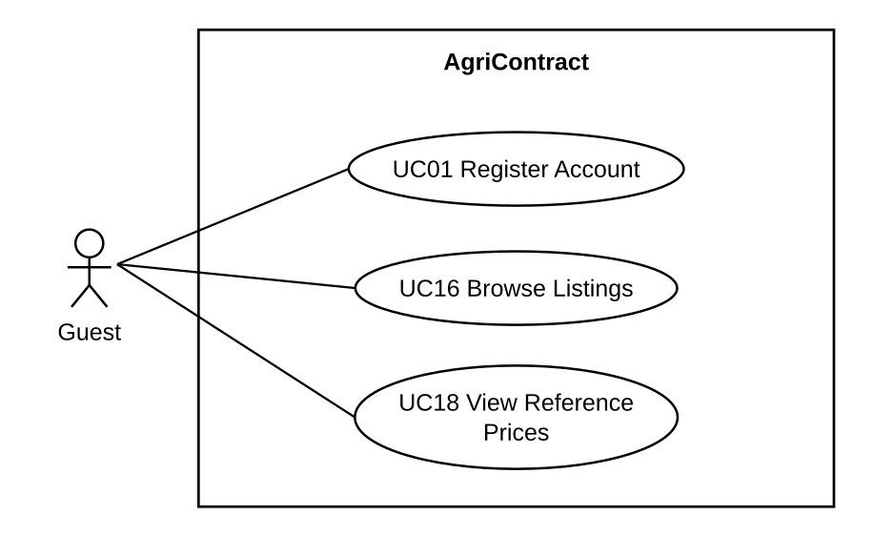

4.3.2 UCs for Buyer
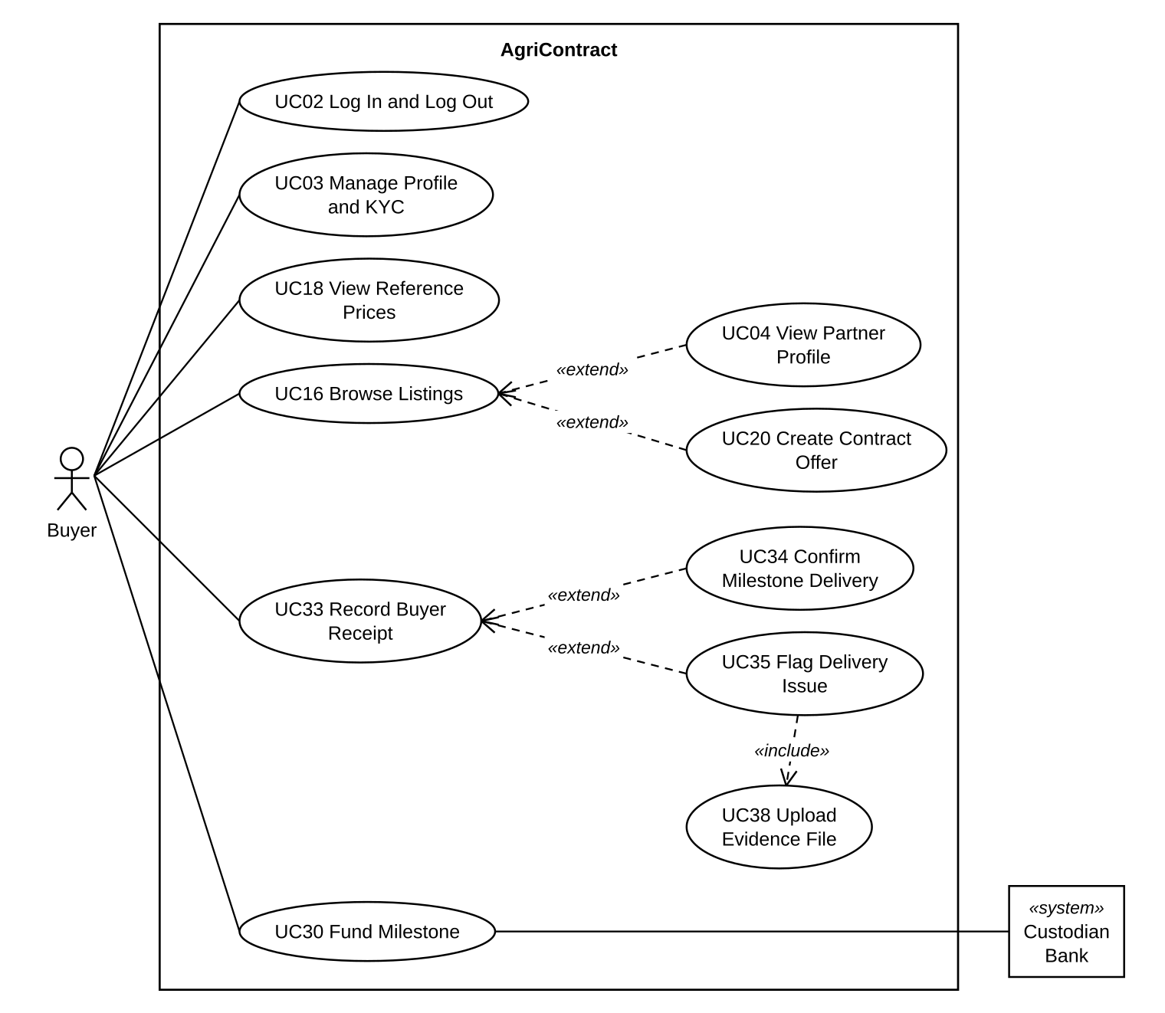

4.3.3 UCs for Seller
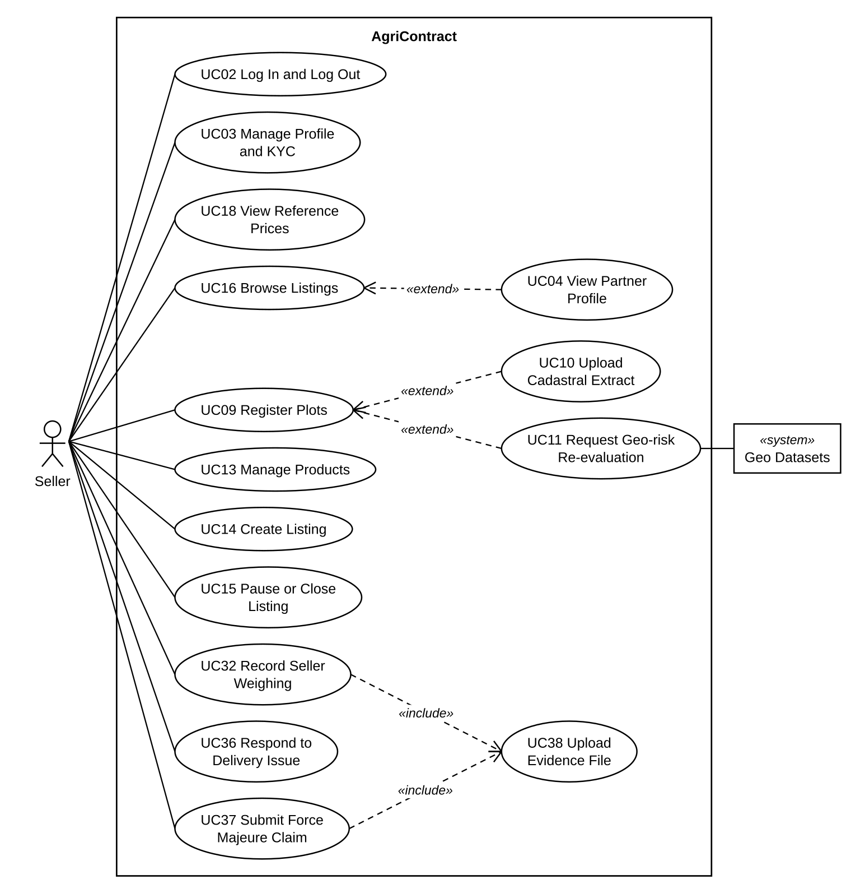

4.3.4 UCs for Contract Parties (Buyer and Seller)
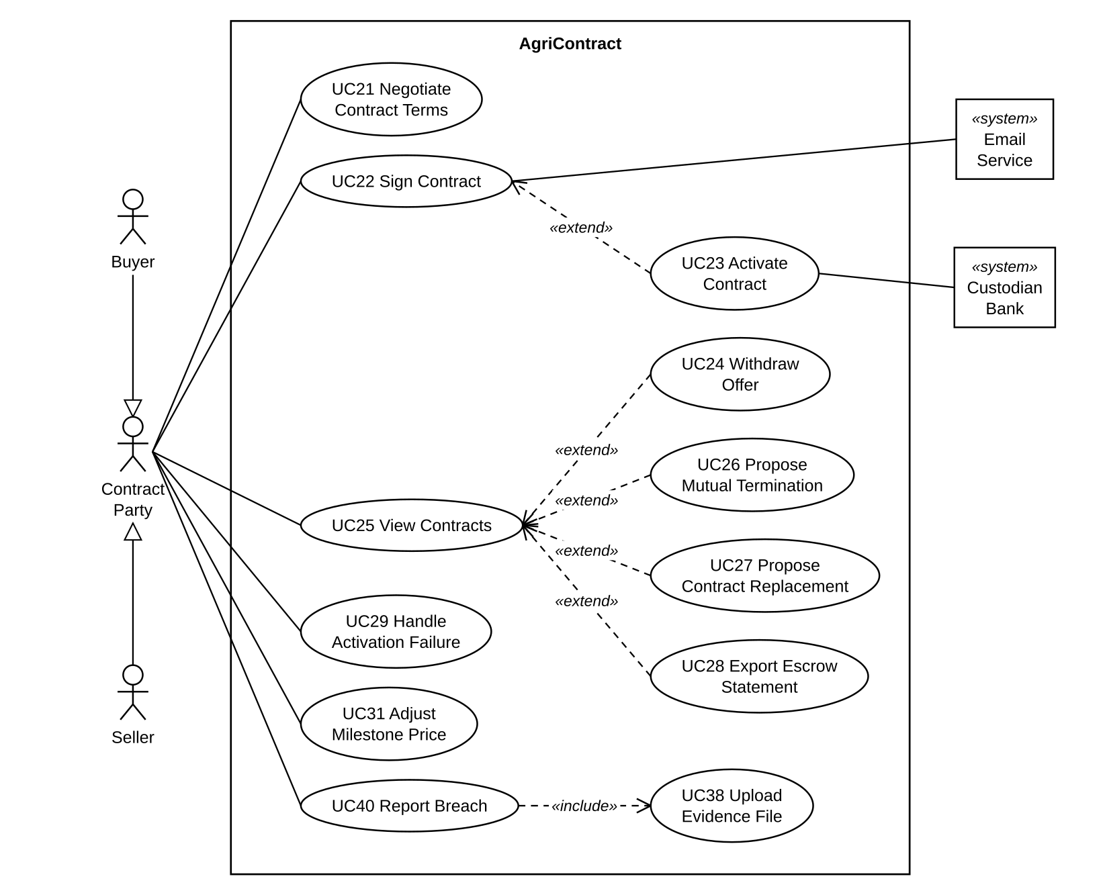

4.3.5 UCs for Inspector
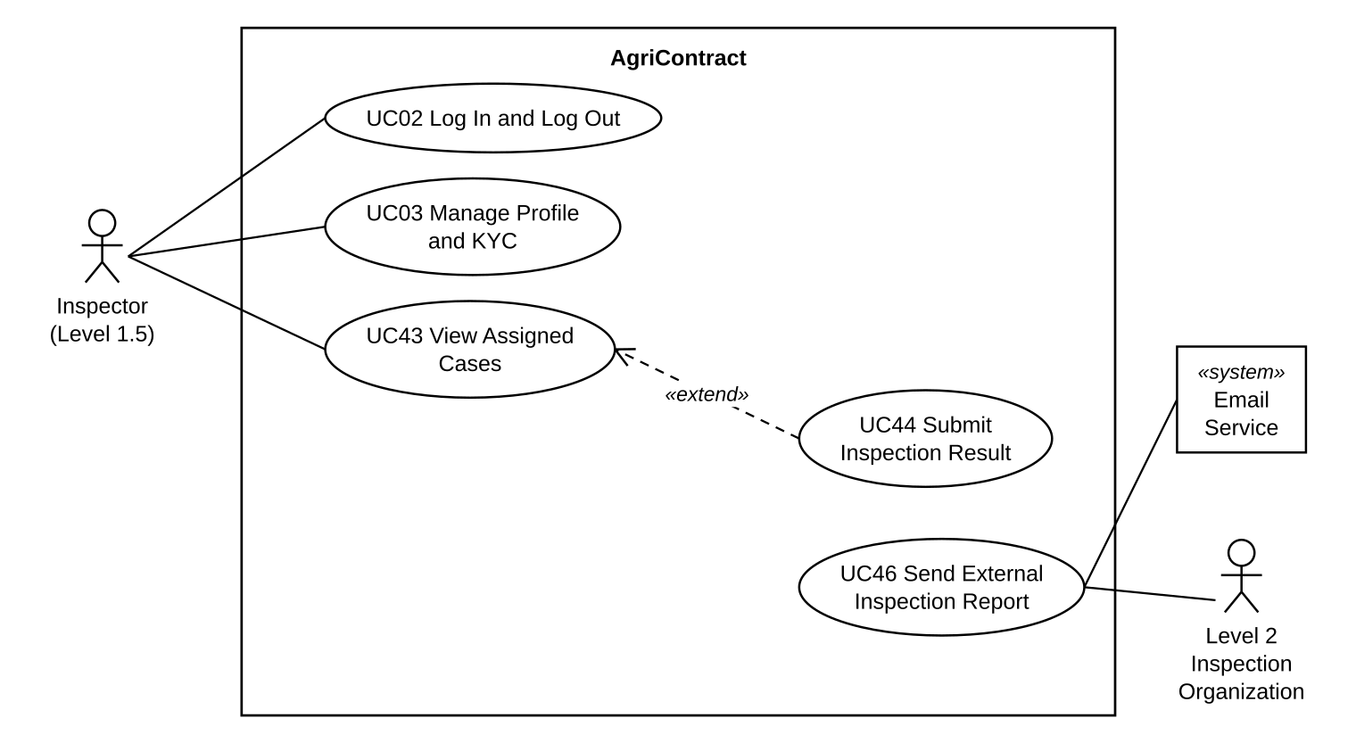

4.3.6 UCs for Operator
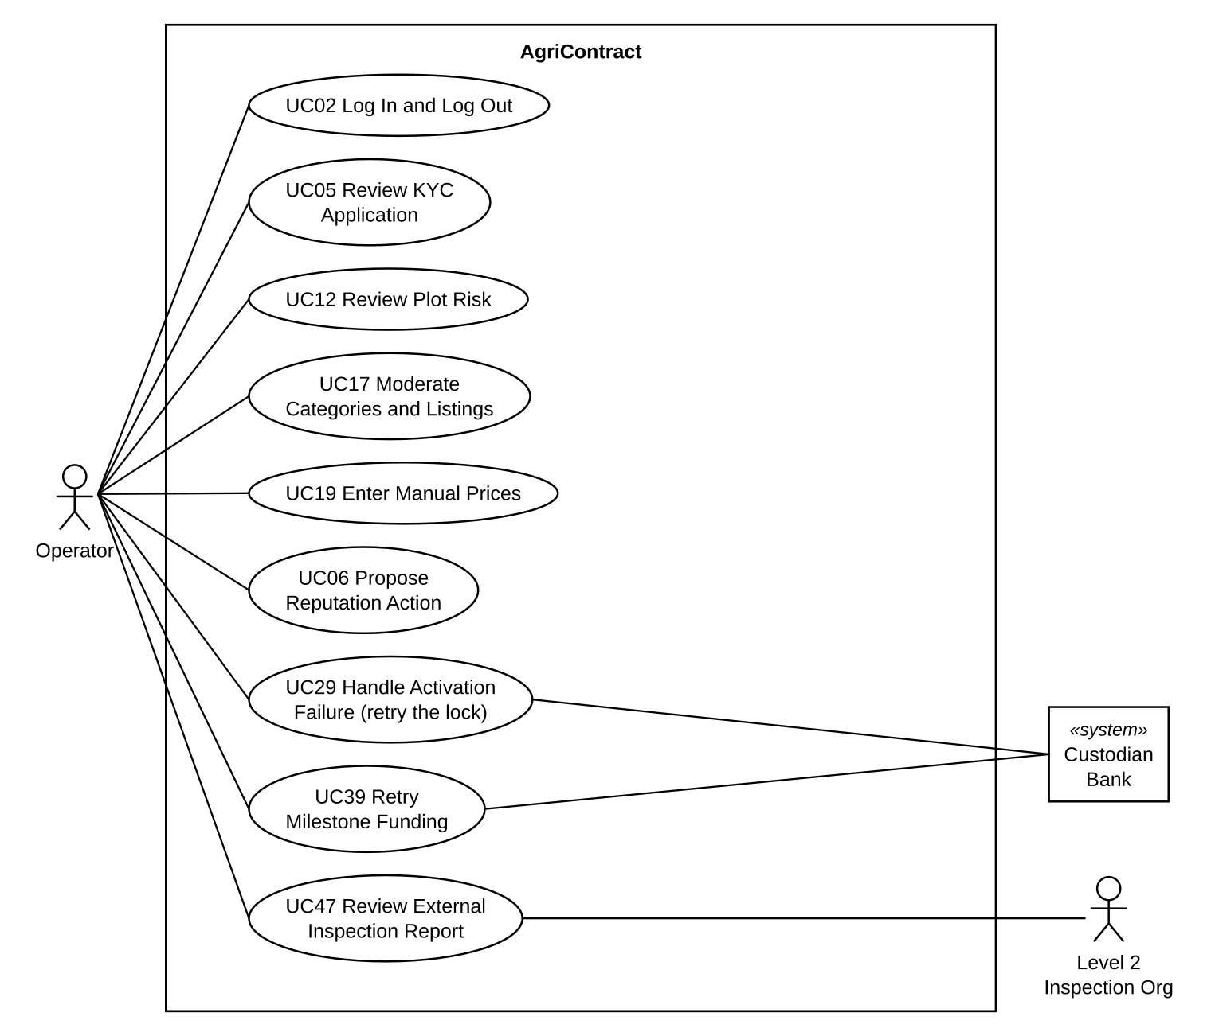

4.3.7 UCs for Admin
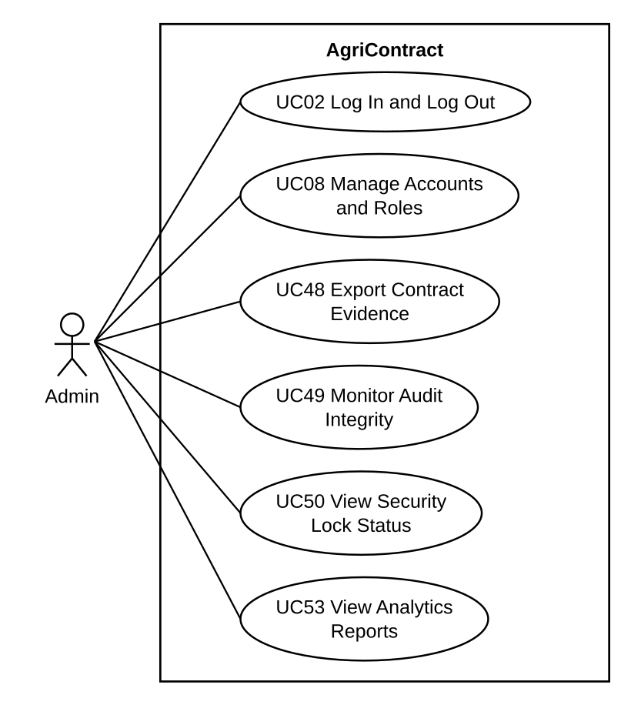

4.3.8 UCs for Arbitrator
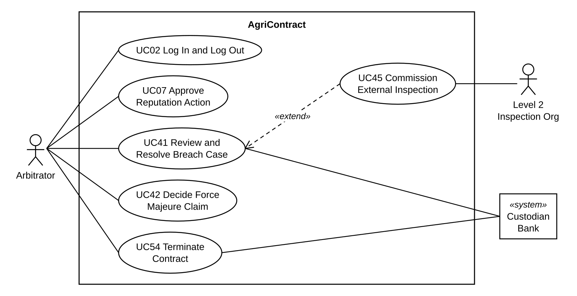

4.3.9 UCs for External Verifier
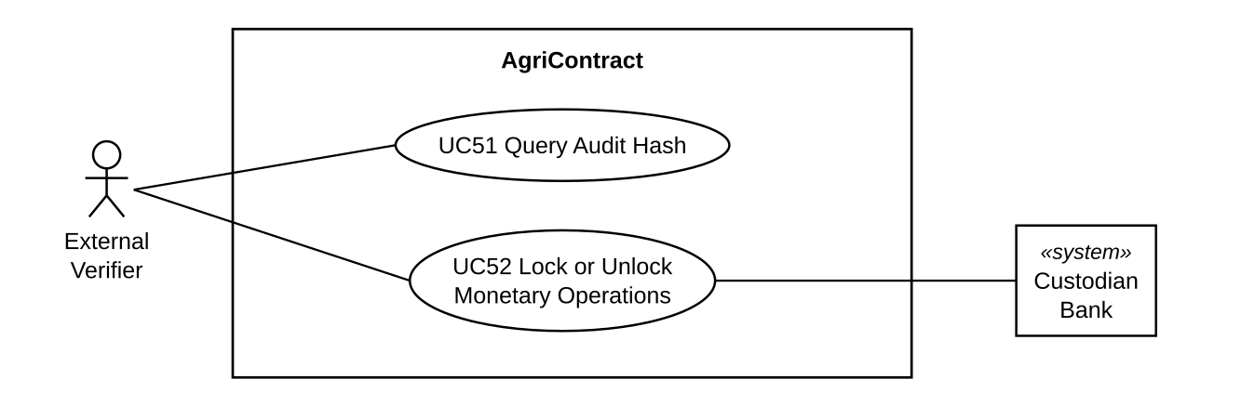

4.4 Permission Matrix
Full = unrestricted · Restricted = conditions apply (see footnotes) · No = denied
Entity | Action | Admin | Operator | Arbitrator | Inspector | Buyer | Seller | Guest | External Verifier
User account | Register | No | No | No | No | No | No | Full | No
User account | Edit own profile / Submit KYC | No | No | No | Full | Full | Full | No | No
User account | Verify / Reject KYC | No | Full | No | No | No | No | No | No
User account | Create staff account / Assign role / Deactivate | Full | No | No | No | No | No | No | No
User account | View public profile and reputation | Full | Full | Full | Full | Full | Full | No | No
Plot | Import / Add / Update | No | No | No | No | No | Restricted ¹ | No | No
Plot | Review risk (accept / reject) | No | Full | No | No | No | No | No | No
Category | Propose | No | No | No | No | No | Full | No | No
Category | Approve / Reject | No | Full | No | No | No | No | No | No
Product | Create / Edit | No | No | No | No | No | Restricted ¹ | No | No
Listing | Create / Publish / Pause / Close | No | No | No | No | No | Restricted ¹ ² | No | No
Listing | View (published only) | Full | Full | Full | Full | Full | Full | Full | No
Product / Listing | Moderate | No | Full | No | No | No | No | No | No
Reference price | View | Full | Full | Full | Full | Full | Full | Full | No
Reference price | Enter manually | No | Full | No | No | No | No | No | No
Contract | Create offer | No | No | No | No | Restricted ² | No | No | No
Contract | Edit terms (before first signature) | No | No | No | No | Restricted ³ | Restricted ³ | No | No
Contract | Sign with OTP | No | No | No | No | Restricted ² ³ | Restricted ² ³ | No | No
Contract | Withdraw offer | No | No | No | No | Restricted ³ | Restricted ³ | No | No
Contract | View | Full | Full | Full | Restricted ⁴ | Restricted ³ | Restricted ³ | No | No
Contract | Propose / Accept mutual termination | No | No | No | No | Restricted ³ | Restricted ³ | No | No
Contract | Propose replacement | No | No | No | No | Restricted ³ | Restricted ³ | No | No
Contract | Retry deposit lock | No | Full | No | No | No | No | No | No
Contract | Request / withdraw activation cancel | No | No | No | No | Restricted ³ | Restricted ³ | No | No
Contract (signed) | Edit / Delete | No | No | No | No | No | No | No | No
Milestone | Fund | No | No | No | No | Restricted ³ | No | No | No
Milestone | Propose / Accept price adjustment | No | No | No | No | Restricted ³ | Restricted ³ | No | No
Milestone | Record weighing | No | No | No | No | No | Restricted ³ | No | No
Milestone | Record receipt / Confirm delivery / Flag issue | No | No | No | No | Restricted ³ | No | No | No
Milestone | Respond to flag | No | No | No | No | No | Restricted ³ | No | No
Milestone | Retry funding | No | Full | No | No | No | No | No | No
Force majeure claim | Submit | No | No | No | No | No | Restricted ³ | No | No
Force majeure claim | Accept / Reject | No | No | Full | No | No | No | No | No
Breach case | Report | No | No | No | No | Restricted ³ | Restricted ³ | No | No
Breach case | View | No | No | Full | No | Restricted ³ | Restricted ³ | No | No
Breach case | Resolve (attribution and remedy) | No | No | Full | No | No | No | No | No
Inspection request | Request Level 1.5 | No | No | Full | No | No | No | No | No
Inspection request | Commission Level 2 | No | No | Full | No | No | No | No | No
Inspection report | Submit Level 1.5 result | No | No | No | Restricted ⁴ | No | No | No | No
Inspection report | Review Level 2 report | No | Full | No | No | No | No | No | No
File | Upload / Attach as evidence | No | No | No | Restricted ⁴ | Restricted ³ | Restricted ³ | No | No
Ledger entry | Export own statement | No | No | No | No | Restricted ³ | Restricted ³ | No | No
Ledger entry | Edit / Delete | No | No | No | No | No | No | No | No
Reputation action | Propose (early unlock / clear elevated risk) | No | Full | No | No | No | No | No | No
Reputation action | Approve / Reject | No | No | Restricted ⁵ | No | No | No | No | No
Audit record | View verification status / Export evidence | Full | No | No | No | No | No | No | No
Audit record | Query contract audit hash | No | No | No | No | No | No | No | Full
Audit record | Edit / Delete | No | No | No | No | No | No | No | No
Security lock | View status and history | Full | No | No | No | No | No | No | No
Security lock | Trigger / Release | No | No | No | No | No | No | No | Restricted ⁶
Analytics report | View | Full | No | No | No | No | No | No | No

¹ Only the Seller's own plots, products and listings.
² The user's KYC must be VERIFIED, the representative's authorization must not be expired, and the user must have no active reputation lock.
³ Only contracts in which the user is the Buyer or the Seller. Each action is also limited to the contract or milestone state in which it is allowed (for example, terms can be edited only before the first signature).
⁴ Only cases assigned to this Inspector, and only the contract's committed quality terms.
⁵ The Arbitrator cannot approve or reject a proposal they created themselves.
⁶ Only through a request signed with the Verifier's ES256 key and carrying a single-use nonce.
Each staff role holds only the actions of its own function; no staff role acts as a fallback for another.

5. System Functionalities
AgriContract is delivered as a web application for the platform's human users and a small set of machine interfaces for external parties. Buyers and Sellers use the trading screens to manage their profile and KYC, register plots, publish listings, negotiate and sign contracts, and carry out each milestone. The Inspector, Operator, Arbitrator and Admin each have their own work queues for inspection, review and dispute handling. The External Verifier has no screen and uses three signed or keyed APIs. Time-based rules, such as response windows, retries, price ingestion and audit verification, run as background jobs without a user action. Sections 5.1 to 5.3 list these three kinds of functionality, and Part III describes each one in detail.

5.1 Screen Inventory

a. Screen Flow
The screen flow below groups the screens by the users who open them. After Login, each user sees a main menu that depends on their role. Bold boxes are main menu items; the other screens are opened from a screen, as the arrows show. Dialogs opened from a screen are written in italics inside its box. Staff accounts and roles (UC08) are managed in the identity provider's administration console, so they have no screen in AgriContract.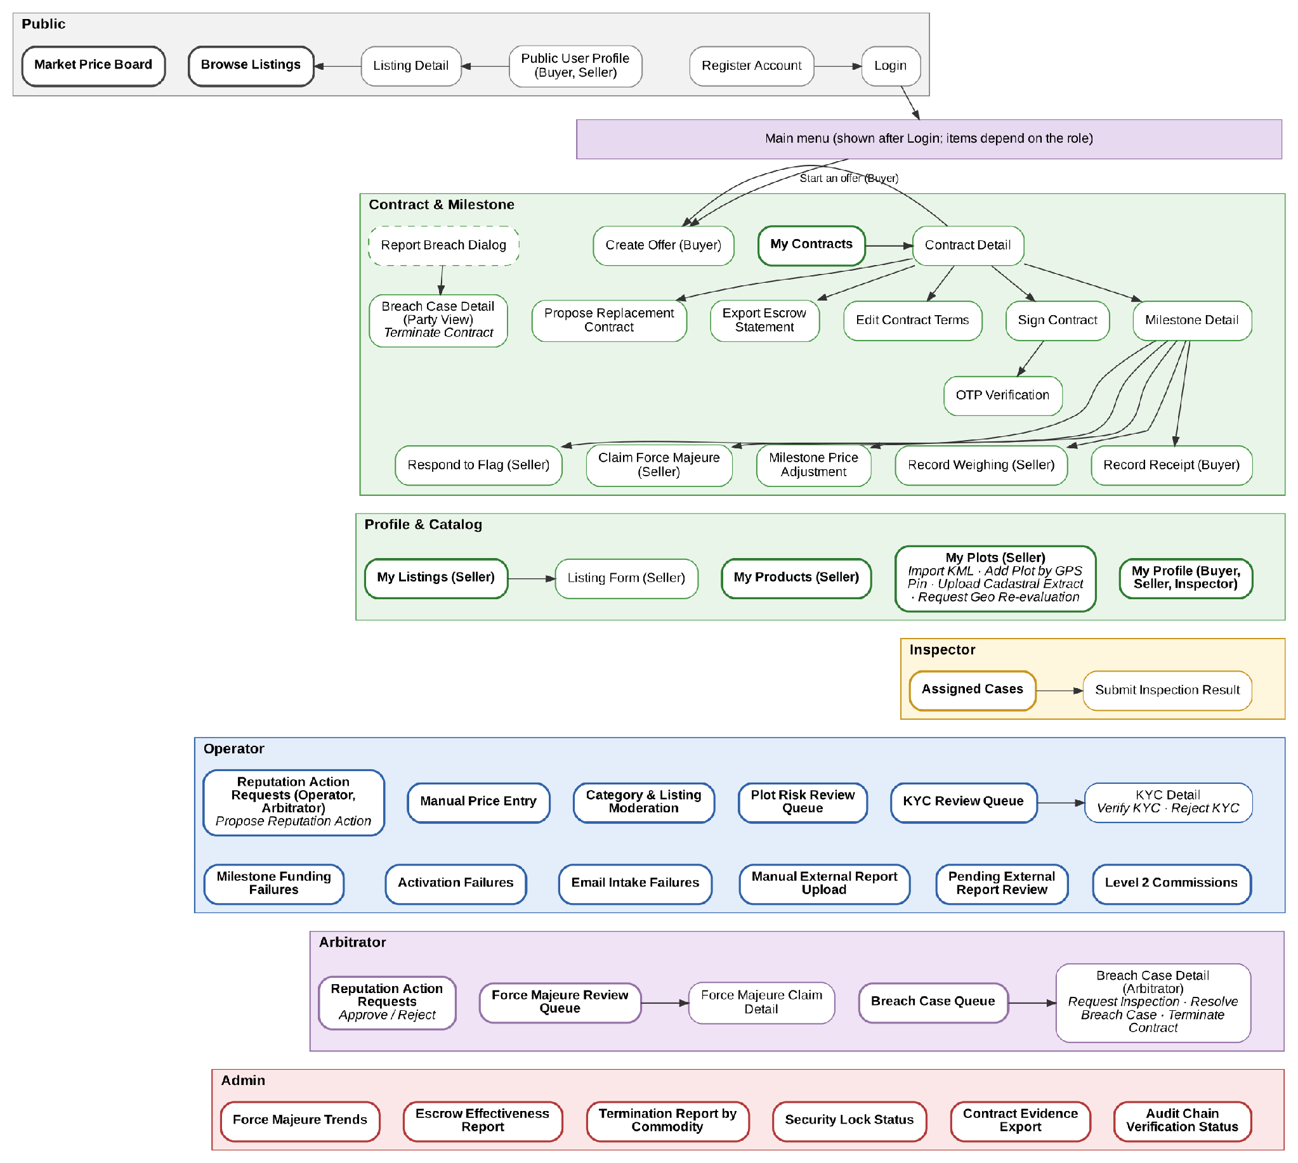

b. Screen List

# | Screen Name | Feature | Description
1 | Register Account | User Authentication & Account | Allows a Guest to create a Buyer, Seller or Inspector account with organization details; the account starts with KYC status PENDING
2 | Login | User Authentication & Account | Allows any registered user to sign in and reach the main menu of their role; the header user menu also lets them log out
3 | My Profile | User Authentication & Account | Allows a Buyer, Seller or Inspector to update organization and representative details, upload authority documents, submit KYC and see their eligibility and lock status
4 | Public User Profile | User Authentication & Account | Allows a Buyer or Seller to view another party's verification status, reputation score and lock history, without private contact data
5 | KYC Review Queue | Account Administration | Allows the Operator to list, filter and open user profiles waiting for KYC review
6 | KYC Detail | Account Administration | Allows the Operator to review a profile's information and documents, verify or reject it, and see its decision history
7 | Verify KYC Dialog | Account Administration | Allows the Operator to confirm verification and enter the authorization expiry date taken from the real documents
8 | Reject KYC Dialog | Account Administration | Allows the Operator to reject a profile with a reason that is shown to the user
9 | Reputation Action Requests | Account Administration | Allows the Operator and Arbitrator to view reputation action proposals; the Arbitrator approves or rejects proposals created by another person
10 | Propose Reputation Action Dialog | Account Administration | Allows the Operator to propose an early unlock or the clearing of an elevated-risk flag, with a reason
11 | My Plots | Plot & Listing | Allows the Seller to view registered plots with their confidence and geo-risk level, and to start plot registration actions
12 | Import KML Dialog | Plot & Listing | Allows the Seller to upload a KML file, review the result for each placemark and enter missing area values
13 | Add Plot by GPS Pin Dialog | Plot & Listing | Allows the Seller to save the current position as a point plot when no KML file is available, with a warning when accuracy is low
14 | Upload Cadastral Extract Dialog | Plot & Listing | Allows the Seller to attach a cadastral map extract to a plot to raise the plot's confidence level
15 | Request Geo Re-evaluation Dialog | Plot & Listing | Allows the Seller to send field photos for a plot flagged with high deforestation risk and ask for re-evaluation
16 | Plot Risk Review Queue | Plot & Listing | Allows the Operator to review plots flagged for overlap or deforestation risk, accept or reject them, or ask for more evidence
17 | My Products | Plot & Listing | Allows the Seller to create and edit products with category, variety, crop year, certifications and linked plots, and to propose a new category
18 | My Listings | Plot & Listing | Allows the Seller to see their listings with the remaining quantity, and to pause, republish or close a listing
19 | Listing Form | Plot & Listing | Allows the Seller to enter listing details, link plots, see the reference price and publish the listing
20 | Browse Listings | Plot & Listing | Allows a Guest, Buyer or Seller to search and filter published listings by commodity, region, quality and seller reputation
21 | Listing Detail | Plot & Listing | Allows a user to view a listing, the seller's profile and the reference price; a Buyer can start an offer from here
22 | Category & Listing Moderation | Plot & Listing | Allows the Operator to approve or reject categories proposed by Sellers and to moderate products and listings that break platform rules
23 | Market Price Board | Market Prices | Allows any user, including a Guest, to view reference prices by commodity and province with their capture date
24 | Manual Price Entry | Market Prices | Allows the Operator to enter a coffee reference price by hand when the VNSAT source is interrupted, and see the entry history
25 | Create Offer | Contract | Allows the Buyer to create an offer from a listing with quantity, price band, milestone schedule, quality, delivery and inspection terms and deposit rates, with a preview of the money amounts
26 | My Contracts | Contract | Allows the Buyer or Seller to list their contracts and filter them by status
27 | Contract Detail | Contract | Allows the Buyer or Seller to view the terms, milestones, deposits and decision history, and to start the actions allowed in the contract's current status
28 | Edit Contract Terms | Contract | Allows the Buyer or Seller to change the contract terms before the first signature
29 | Sign Contract | Contract | Allows the Buyer or Seller to review the hash of the terms being signed, re-authenticate and request a signing OTP
30 | OTP Verification | Contract | Allows the Buyer or Seller to enter the OTP sent by email to sign the contract, or to request a new OTP
31 | Propose Replacement Contract | Contract | Allows the Buyer or Seller to propose or confirm a new contract that replaces the current one  Screen Behavior & Rules: The system rejects contract replacement proposals if there are unresolved deliveries, returns, disputes, pending inspections, or force majeure claims. Preconditions and eligibility are rechecked before accepting the second signature and committing the replacement. During negotiation and signing, the old contract remains ACTIVE; it transitions to REPLACEMENT_PENDING only after both parties sign the replacement contract. The replacement contract activates only after all refunds on the old contract are confirmed and the old contract reaches SUPERSEDED.
32 | Export Escrow Statement | Contract | Allows the Buyer or Seller to export their own ledger entries for a contract over a chosen period
33 | Milestone Detail | Milestone & Delivery | Allows the Buyer or Seller to track a milestone's funding and delivery; the Buyer funds the milestone here, and both parties start delivery actions
34 | Record Weighing | Milestone & Delivery | Allows the Seller to record the weighed quantity of a delivery and attach the weighing slip
35 | Record Receipt | Milestone & Delivery | Allows the Buyer to record the received quantity, then confirm the milestone or flag an issue
36 | Respond to Flag | Milestone & Delivery | Allows the Seller to accept or contest the Buyer's flag before the response deadline
37 | Claim Force Majeure | Milestone & Delivery | Allows the Seller to declare force majeure for a milestone with evidence
38 | Milestone Price Adjustment | Milestone & Delivery | Allows the Buyer or Seller to propose or accept a new milestone price inside the signed price band
39 | Report Breach Dialog | Dispute & Inspection | Allows the Buyer or Seller to report a breach by the other party and attach evidence files
40 | Breach Case Detail (Party View) | Dispute & Inspection | Allows the Buyer or Seller to follow a breach case, download its evidence, see the final outcome, contest a milestone-level decision before its deadline and, after a material breach is resolved, request termination
41 | Breach Case Queue | Dispute & Inspection | Allows the Arbitrator to browse, filter and open breach cases that are not yet resolved
42 | Breach Case Detail (Arbitrator) | Dispute & Inspection | Allows the Arbitrator to review a case's evidence and inspection results, request an inspection and resolve the case
43 | Request Inspection Dialog | Dispute & Inspection | Allows the Arbitrator to request a Level 1.5 inspection or commission a Level 2 inspection for a case
44 | Resolve Breach Case Dialog | Dispute & Inspection | Allows the Arbitrator to record the final breaching party, the decision source and the supporting evidence
45 | Terminate Contract Dialog | Dispute & Inspection | Allows the Buyer, Seller or Arbitrator to execute the final termination of a contract after a breach or force majeure decision; the system then calculates the remedy and returns, releases or seizes the locked funds
46 | Force Majeure Review Queue | Dispute & Inspection | Allows the Arbitrator to list force majeure claims waiting for a decision
47 | Force Majeure Claim Detail | Dispute & Inspection | Allows the Arbitrator to review a claim's evidence and reporting window, then approve or reject it
48 | Activation Failures | Dispute & Inspection | Allows the Operator to retry the deposit lock of a contract whose activation failed, see the parties' cancel requests and track the refunds
49 | Milestone Funding Failures | Dispute & Inspection | Allows the Operator to retry a failed milestone funding lock and watch the cure deadline
50 | Assigned Cases | Dispute & Inspection | Allows the Inspector to view their assigned cases, the quality terms to measure and the due dates
51 | Submit Inspection Result | Dispute & Inspection | Allows the Inspector to enter measurements or mark the case inconclusive, upload the report file and submit after re-authentication
52 | Level 2 Commissions | Dispute & Inspection | Allows the Operator to track Level 2 commissions and confirm the case ID of a received report
53 | Pending External Report Review | Dispute & Inspection | Allows the Operator to review a received Level 2 report, match it to a commission, record the normalised result and approve or reject it
54 | Manual External Report Upload | Dispute & Inspection | Allows the Operator to upload a Level 2 report that did not arrive by email and confirm its result
55 | Email Intake Failures | Dispute & Inspection | Allows the Operator to view intake emails that could not be processed and mark them as reviewed
56 | Audit Chain Verification Status | Audit & Security | Allows the Admin to view the weekly audit chain verification result, failure details, the latest OpenTimestamps anchor and reconciliation alerts
57 | Contract Evidence Export | Audit & Security | Allows the Admin to verify one contract's audit chain and export its evidence package or EUDR evidence package
58 | Security Lock Status | Audit & Security | Allows the Admin to view whether the emergency lock is active, its history and the used nonces; the Admin cannot lock or unlock
59 | Termination Report by Commodity | Analytics | Allows the Admin to view contract terminations by commodity for a chosen year
60 | Escrow Effectiveness Report | Analytics | Allows the Admin to view how escrow protected settlements for a chosen month
61 | Force Majeure Trends | Analytics | Allows the Admin to view force majeure incidents by commodity over a chosen year

5.2 External API Inventory
# | API Name | Calling Path | Description
1 | Emergency Lock API | External Verifier → AgriContract | Allows the External Verifier to freeze all money movements with a request signed by its ES256 key and carrying a single-use nonce
2 | Emergency Unlock API | External Verifier → AgriContract | Allows the External Verifier to release the emergency lock; this is the only way to unlock
3 | Audit Hash Query API | External Verifier → AgriContract | Allows the External Verifier to read the current audit hash of a contract and compare it with the hash it holds
4 | Escrow bank commands | AgriContract → Custodian Bank | Sends lock, release, refund and seize commands for deposits and milestone payments
5 | Bank command results | Custodian Bank → AgriContract | Returns the result of each bank command and the ledger entries used for statements and reconciliation
6 | Outbound email | AgriContract → Email Service | Sends signing OTPs, notifications, Level 2 commission letters, the weekly audit digest and evidence attachments
7 | Inspection report intake | AgriContract → Email Service (intake mailbox) | Reads the intake mailbox every 5 minutes to receive Level 2 inspection reports that quote a case ID
8 | Timestamp anchoring | AgriContract → OpenTimestamps | Submits important audit hashes and the weekly chain head, and receives the timestamp proofs
9 | Reference price ingestion | AgriContract → VNSAT Price Source | Reads coffee reference prices by province once a day
10 | Geo dataset lookup | AgriContract → Geo Datasets | Checks a plot's location against province boundaries and the 2020 forest baseline to set its geo-risk level

5.3 Background Job Inventory
# | Job Name | Group | Description
1 | Transactional Outbox Relay (JOB-01) | Scheduled | Publish domain events and notification commands that were saved together with a business change, so no event is lost if the service stops right after the change
2 | Milestone Completion Sync (JOB-02) | Scheduled | Detect that the last milestone of a contract is SETTLED and start normal contract completion
3 | Contract Settlement Reconciler (JOB-03) | Scheduled | Move a contract to SETTLED only after the bank ledger shows that every deposit return succeeded and nothing remains locked (GB-22)
4 | Deposit Lock Retry (JOB-04) | Event-driven | Absorb temporary bank or network failures when locking the Buyer and Seller deposits of a newly signed contract (GB-44)
5 | Milestone Funding Lock Retry (JOB-05) | Event-driven | Lock the next milestone's batch amount while tolerating temporary failures (GB-25)
6 | Funding Cure Window Expiry (JOB-06) | Scheduled | Record a Buyer funding breach when the Buyer did not cure the funding failure in time (GB-37)
7 | Buyer Confirmation Auto-Confirm (JOB-07) | Scheduled | Settle a milestone as clean when the Buyer neither confirms nor flags in time (GB-29)
8 | Seller Response Window Timeout (JOB-08) | Scheduled | Treat Seller silence after a Buyer flag as acceptance of the Buyer's figures (GB-31)
9 | Buyer Receive Window Timeout (JOB-09) | Scheduled | Prevent a milestone from staying in SELLER_WEIGHED forever when the Buyer never records receipt, without ever settling on the Seller's weight alone (GB-45)
10 | Seller Delivery Deadline Overdue (JOB-10) | Scheduled | Detect milestones not delivered by the effective delivery deadline, so the Buyer can report a late-delivery breach while the Seller can still claim force majeure
11 | Level 2 Buffer and Provisional Settlement (JOB-11) | Scheduled | Avoid locking the Seller's money indefinitely while a Level 2 report is awaited (GB-26)
12 | Level 2 Buffer Terminal Settlement (JOB-12) | Scheduled | Make the Level 1.5 ruling final and release the held buffer (GB-26)
13 | Orphan Reservation Reaper (JOB-13) | Scheduled | Return listing quantity held by a reservation whose contract was never created (GB-15)
14 | Plot Geo-risk Check (JOB-14) | Event-driven | Check the plot against the province boundaries and the 2020 forest baseline and set its geo-risk level (GB-07)
15 | VNSAT Price Ingestion (JOB-15) | Scheduled | Read coffee reference prices by province from VNSAT (GB-14)
16 | Email Intake Mailbox Poll (JOB-16) | Scheduled | Receive Level 2 inspection reports and acknowledgements sent by email (UC46)
17 | File Parse and Malware Scan (JOB-17) | Event-driven | Make every file pass format checks and malware scanning before it can be used as evidence (GB-03)
18 | Orphan File Cleanup (JOB-18) | Scheduled | Delete files that no business record claimed within one week
19 | Retention and Legal Hold Deletion (JOB-19) | Scheduled | Delete or anonymise data whose retention period has ended, for example KYC files 5 years after the relationship ends, OTP records 90 days after expiry and ordinary notification logs after 2 years (GB-46)
20 | Audit Anchor Worker (JOB-20) | Event-driven | Anchor the hash of important audit records with OpenTimestamps and email the proof at milestone settlement (API-08)
21 | Weekly Audit Chain Verification (JOB-21) | Scheduled | Detect tampering in the audit chain and create the weekly anchor (GB-40)
22 | Weekly Audit Digest (JOB-22) | Scheduled | Email the current chain head hash to the External Verifier (GB-40)
23 | Ledger and Audit Reconciliation (JOB-23) | Scheduled | Check that money moved in the ledger matches the settlement amounts recorded in the audit chain (GB-41)
24 | Used Nonce Cleanup (JOB-24) | Scheduled | Remove External Verifier nonces older than the 300-second timestamp window (GB-42)
25 | Analytics Monthly Aggregation (JOB-25) | Scheduled | Recompute monthly statistics by commodity (settled counts, breaches by party, mutual and no-fault exits, breach rates, force majeure incidents, escrow efficiency) (GB-43)
26 | AML Structuring Pattern Scan (JOB-26) | Scheduled | Detect Buyer–Seller pairs with repeated contracts just below the 500 million VND reporting threshold (GB-47)
27 | Elevated Risk Review Expiry (JOB-27) | Scheduled | Return a Buyer–Seller pair to NORMAL when 6 months pass after detection without a repeat, so a false positive does not stay flagged forever (GB-47)
28 | Notification Delivery Retry (JOB-28) | Event-driven | Send each template email exactly once per event, recipient and notification type (API-06)
29 | Dead-Letter Queue Monitoring and Replay (JOB-29) | Event-driven | Recover messages that exhausted their retries without creating duplicate business effects (GB-48)

II. Use Case Specifications

1. Plot & Listing

1.1 Create Listing (UC14)
Primary Actors | Seller | Secondary Actors | None
Description | As a seller, I want to publish a listing for one of my products so that buyers can find the goods and make an offer.
Preconditions | The Seller is logged in. The Seller's KYC is VERIFIED, the representative's authorization has not expired and the Seller has no active reputation lock. The Seller has at least one product (UC13). The Seller has at least one registered plot whose geo check is finished (UC09).
Normal Flow | Create Listing  1. Seller opens My Listings and selects New Listing.  2. Seller selects the product. System shows the declared-quality fields for the product's commodity.  3. Seller enters the offered quantity and the minimum order quantity in kg.  4. Seller enters the declared quality of the goods.  5. Seller selects the linked plots from the plot registry. At least one plot is required.  6. System shows the current reference price for the commodity and province as information only.  7. Seller selects Publish.  8. System checks the Seller's eligibility, the quantities and the linked plots.  9. System saves a snapshot of the product and the linked plots with the listing.  10. System sets quantityAvailable equal to the offered quantity and publishes the listing as AVAILABLE.
Alternative Flows | Save as Draft  Seller selects Save Draft instead of Publish. System saves the listing as DRAFT and it is not shown to buyers.  Invalid Quantity or Quality  System shows which fields are invalid (for example a minimum order quantity larger than the offered quantity) and does not publish the listing.  Missing Plot  System does not publish the listing and asks the Seller to link at least one plot.  Plot Geo Check Still Pending  System does not allow the Seller to select a plot whose geo check is still PENDING.  Seller Not Eligible  If the KYC is not VERIFIED, the authorization has expired, the Seller is locked, or eligibility cannot be confirmed, System refuses to publish and shows the reason.  Yield Anomaly  If the offered quantity is unusually high for the linked plots' area, System adds a review flag for the Operator but still publishes the listing.
Postconditions | The listing is AVAILABLE on the marketplace with its full quantity available. The product and plot data are saved as a snapshot, so later edits to the product or plots do not change this listing.

2. Contract

2.1 Create Contract Offer (UC20)
Primary Actors | Buyer | Secondary Actors | Seller
Description | As a buyer, I want to create a contract offer from a listing so that I can propose the full contract terms to the seller.
Preconditions | The Buyer is logged in. The Buyer's KYC is VERIFIED, the representative's authorization has not expired and the Buyer has no active reputation lock. The listing is AVAILABLE or PARTIALLY_COMMITTED.
Normal Flow | Create Contract Offer  1. Buyer opens a listing's details and selects Create Offer.  2. System shows the listing summary and an offer form for the listing's commodity.  3. Buyer enters the agreed unit price and the price band (minimum and maximum unit price).  4. Buyer builds the milestone schedule: the committed quantity, expected delivery date and grace days of each milestone.  5. Buyer enters the quality terms (committed specification and deviation policy), delivery terms, inspection terms, deposit and penalty rates, time windows and legal profile.  6. System calculates the total contract value and the deposit amounts and shows them in the summary.  7. Buyer submits the offer.  8. System checks the terms, the Buyer's eligibility, the listing version and that the total quantity is between the listing's minimum order quantity and its quantityAvailable.  9. System reserves the total quantity on the listing.  10. System creates the contract in status OFFERED and saves a snapshot of the listing, product and plots with the contract terms.  11. System notifies the Seller of the new offer.
Alternative Flows | Listing Changed  If the listing was changed after the Buyer opened it, System rejects the offer and asks the Buyer to reload the listing and review the form.  Insufficient Quantity  If the total quantity is below the minimum order quantity or above quantityAvailable, System rejects the offer and shows the quantity available.  Invalid Terms  If a value is missing or outside its allowed range (for example an agreed price outside the price band, or a buyer deposit rate outside 3–10%), System shows the invalid fields and does not create the offer.  Listing Not Available  If the listing is PAUSED, CLOSED or no longer published, System does not create the offer.  Contract Creation Fails  If the contract cannot be created after the quantity has been reserved, System releases the reserved quantity and informs the Buyer.
Postconditions | A contract offer is created in status OFFERED with the proposed terms. The requested quantity is reserved on the listing, and the listing and product information used for the offer are saved with the contract. The Seller is notified of the offer.

2.2 Negotiate Contract Terms (UC21)
Primary Actors | Buyer, Seller | Secondary Actors | None
Description | As a buyer or seller, I want to change the proposed contract terms until both sides agree so that the contract we sign reflects what we negotiated.
Preconditions | The user is logged in and is the Buyer or the Seller of the contract. The contract is OFFERED or NEGOTIATING. Neither party has signed the contract yet.
Normal Flow | Negotiate Contract Terms  1. User opens the contract from My Contracts.  2. User selects Edit Terms.  3. System shows the current terms: price and price band, milestone schedule, quality terms, delivery terms, inspection terms, deposit and penalty rates, time windows and legal profile.  4. User changes one or more terms.  5. System recalculates the total contract value and the deposit amounts.  6. User saves the terms.  7. System checks the required fields and the allowed ranges of prices, rates and windows.  8. System saves the new terms and moves the contract to NEGOTIATING.  9. System notifies the other party that the terms have changed.  10. The other party reviews the terms and either changes them again (back to step 2) or signs the contract (UC22).
Alternative Flows | Invalid Terms  1. System detects a missing value or a value outside its allowed range.  2. System shows which fields are invalid and does not save the changes.  3. User corrects the terms and saves again.  Contract Already Signed by One Party  1. System detects that one party has already signed.  2. System does not allow the change and informs the user that the terms are frozen after the first signature.  3. The user can withdraw the offer instead (UC24) while the second signature is still missing.  Terms Changed by the Other Party  If the other party saved newer terms in the meantime, System rejects the save, reloads the latest terms and asks the user to review them again.
Postconditions | The contract holds the latest proposed terms and is in status NEGOTIATING. Any OTP issued for the previous terms can no longer be used to sign.

2.3 Sign Contract (UC22)
Primary Actors | Buyer, Seller | Secondary Actors | Email Service
Description | As a buyer or seller, I want to sign the contract with a one-time code sent to my email so that my signature is bound to the exact terms I agreed to.
Preconditions | The user is logged in and is the Buyer or the Seller of the contract. The contract is not yet SIGNED and the user has not signed it yet. The user's KYC is VERIFIED, the representative's authorization has not expired, and the user has no active reputation lock.
Normal Flow | Sign Contract  1. User opens the contract and selects Sign.  2. System shows a summary of the key terms and the signed content hash (SHA-256) of the terms.  3. System asks the user to log in again.  4. User logs in again.  5. User requests an OTP within 5 minutes of logging in again.  6. System sends a 6-digit OTP to the user's email. The OTP is bound to the user, the contract and the terms hash, and the email shows the same hash.  7. User enters the OTP within 5 minutes.  8. System checks the OTP, the time of the last login, the user's eligibility and that the terms hash still matches the current terms.  9. System records the signature with the signer role, the time and the terms hash.  10. If this is the first signature, System freezes the terms and notifies the other party to sign.  11. If this is the second signature and both signatures cover the same hash, System moves the contract to SIGNED and starts Activate Contract (UC23).
Alternative Flows | Wrong OTP  1. System rejects the code and shows the number of attempts left.  2. After 5 wrong attempts, System locks the current OTP and the user must request a new one.  OTP Expired or Not Received  1. User selects Resend OTP after the 60-second cooldown.  2. System sends a new OTP and the previous one becomes invalid immediately.  Login Too Old  If more than 5 minutes have passed since the user logged in again, System rejects the signing and asks the user to log in again.  Terms Changed  If the terms hash no longer matches the current terms, System rejects the signature and asks the user to review the new terms and request a new OTP.  User Not Eligible  If the KYC is not VERIFIED, the authorization has expired or the user is locked, System blocks the signing and shows the reason.
Postconditions | The user's signature is recorded against the terms hash. After the first signature the terms can no longer be edited. After the second signature the contract is SIGNED.

2.4 Activate Contract (UC23)
Primary Actors | Buyer, Seller (the party giving the second signature) | Secondary Actors | Custodian Bank
Description | As a buyer or seller, I want the contract to become active only when the agreed deposits are locked at the bank so that both sides know the money behind the contract is secured.
Preconditions | The contract has just become SIGNED, with two signatures on the same terms hash.
Normal Flow | Activate Contract  1. System calculates the Buyer deposit from the buyer deposit rate and the total contract value.  2. System sends a lock request for the Buyer deposit to the Custodian Bank.  3. If the seller deposit rate is greater than 0, System also sends a lock request for the Seller deposit.  4. The Custodian Bank locks each deposit and returns the result.  5. When every required deposit is locked, System moves the contract to ACTIVE.  6. System starts funding the first milestone (UC30).  7. System notifies the Buyer and the Seller that the contract is active.
Alternative Flows | Temporary Bank Failure  System retries the failed lock after 5 minutes, 30 minutes and 2 hours. Only the deposit that failed is retried; a deposit already locked is not locked again.  Deposit Lock Fails After All Retries  1. The contract stays SIGNED, because the signatures remain valid.  2. System notifies the Buyer, the Seller and the Operator.  3. No penalty or reputation effect applies to either party.  4. The failure is handled under UC29: the Operator retries the lock for the missing deposit after fixing the cause, or the parties ask to cancel. When both ask, or one asks after 5 business days from the first failure, System refunds every locked deposit and the contract becomes ACTIVATION_FAILED only after all refunds are confirmed. A successful lock before that makes the contract ACTIVE and the cancel requests lapse.  Monetary Operations Locked  While the External Verifier's emergency lock is active, the bank rejects every lock request. This is handled as a deposit lock failure with no fault on either party.
Postconditions | The contract is ACTIVE with the deposits locked and the first milestone funding started; or the contract stays SIGNED until a retried lock succeeds or the parties' cancel request ends it as ACTIVATION_FAILED.

2.5 Propose Mutual Termination (UC26)
Primary Actors | Buyer, Seller | Secondary Actors | Custodian Bank
Description | As a buyer or seller, I want to end the contract by agreement with the other party so that the remaining obligations stop without a penalty for either side.
Preconditions | The user is logged in and is the Buyer or the Seller of the contract. The contract is ACTIVE.
Normal Flow | Propose Mutual Termination  1. User opens the contract and selects Propose Mutual Termination.  2. System shows the effect: every milestone not yet settled ends, settled milestones stay as they are, deposits and locked milestone funds return to their owners, and there is no penalty or reputation effect.  3. User confirms the proposal.  4. System records the proposal and notifies the other party.  5. The other party opens the contract and selects Confirm Mutual Termination.  6. System records a decision with no breaching party.  7. System sends refund commands to the Custodian Bank for the Buyer deposit, the Seller deposit and any locked milestone amount.  8. The Custodian Bank confirms each refund.  9. When nothing remains locked for the contract, System moves the contract to TERMINATED and notifies both parties.
Alternative Flows | Other Party Does Not Confirm  The contract stays ACTIVE and continues normally.  Proposer Tries to Confirm  System does not allow the party who proposed the termination to confirm it.  Refund Fails  System does not close the contract until every refund is confirmed and alerts the Operator.
Postconditions | The contract is TERMINATED by mutual agreement. All locked money has been returned to its owners, and no penalty or reputation lock is applied.

2.6 Propose Contract Replacement (UC27)
Primary Actors | Buyer, Seller | Secondary Actors | Custodian Bank, Email Service
Description | As a buyer or seller, I want to replace the current contract with a new one when the terms must change after signing so that we can renegotiate without either side being treated as breaching the contract.
Preconditions | The user is logged in and is the Buyer or the Seller of the contract. The contract is ACTIVE.
Normal Flow | Propose Contract Replacement  1. User opens the contract and selects Propose Replacement.  2. System opens the offer form pre-filled with the current terms and informs the user that settled milestones are not carried over.  3. User changes the terms and submits the proposal.  4. System creates a replacement draft linked to the current contract and notifies the other party.  5. The other party reviews the draft and selects Confirm Replacement.  6. Both parties sign the new contract (UC22).  7. When the new contract is SIGNED, System moves the old contract to REPLACEMENT_PENDING.  8. System refunds all money locked on the old contract (deposits and any locked milestone amount) and moves it to SUPERSEDE_REFUND_PENDING.  9. When every refund is confirmed, System moves the old contract to SUPERSEDED and links it to the new contract.  10. System activates the new contract (UC23), which locks its own deposits from zero.
Alternative Flows | Replacement Not Agreed or Not Signed  The draft is cancelled. The old contract stays ACTIVE and no money moves.  Refund Fails  The old contract stays in SUPERSEDE_REFUND_PENDING and System alerts the Operator.  New Contract Activation Fails  The new contract follows the normal activation failure path (UC29). The replacement of the old contract is not reversed.
Postconditions | The old contract is SUPERSEDED with no penalty. The new contract is signed and holds its own deposits.

3. Milestone & Delivery

3.1 Fund Milestone (UC30)
Primary Actors | Buyer | Secondary Actors | Custodian Bank, Seller
Description | As a buyer, I want the payment for each milestone locked in escrow before the seller delivers so that the seller is sure of being paid and starts the delivery.
Preconditions | The contract is ACTIVE. The milestone is the next one to fund: the first milestone right after activation, or a later milestone once the previous milestone is SETTLED.
Normal Flow | Fund Milestone  1. System calculates the batch amount: committed quantity × effective unit price (the accepted adjusted price if there is one, otherwise the agreed price).  2. System sets the milestone funding to FUNDING_PENDING and notifies the Buyer.  3. System sends a lock request for the batch amount from the Buyer's account to the Custodian Bank.  4. The Custodian Bank locks the amount and returns the result.  5. System sets the milestone funding to LOCKED. The Seller's delivery clock starts from this moment.  6. System notifies the Buyer and the Seller that the milestone is funded.
Alternative Flows | Temporary Bank Failure  System retries the lock after 5 minutes, 30 minutes and 2 hours.  Funding Fails After All Retries  1. System sets the milestone funding to FUNDING_FAILED and notifies the Buyer, the Seller and the Operator.  2. Nothing is seized yet. The Seller does not have to deliver while the milestone is not funded, and the delivery deadline is extended by the funding delay.  3. When the Buyer confirms that the funds are available, the Operator retries the funding (UC39) and the milestone returns to FUNDING_PENDING.  Cure Window Expires  If the funding is still FUNDING_FAILED 3 business days after the failure, System records a Buyer funding breach automatically and applies the contract's remedy.  Failure Caused by the System  A failure caused by a bank or system outage, or by the emergency lock, is not counted against the Buyer. The Operator retries the funding after the cause is fixed.
Postconditions | The batch amount is locked in escrow and the milestone is in progress with its effective delivery deadline.

3.2 Record Seller Weighing (UC32)
Primary Actors | Seller | Secondary Actors | Buyer
Description | As a seller, I want to record the weight of the batch before loading, with evidence, so that the quantity I deliver is documented.
Preconditions | The Seller is logged in and is the Seller of the contract. The milestone is IN_PROGRESS and its funding is LOCKED.
Normal Flow | Record Seller Weighing  1. Seller opens the milestone and selects Record Weighing.  2. System shows the committed quantity of the milestone.  3. Seller enters the weighed quantity in kg.  4. Seller uploads the weighing slip or photo, and optionally a delivery certificate (UC38).  5. System scans each file. Only a file that passes the scan can be attached.  6. Seller submits the weighing.  7. System checks that the weight is greater than 0 and that the weighing evidence is attached.  8. System records the declared weight, moves the milestone to SELLER_WEIGHED and notifies the Buyer.
Alternative Flows | Invalid Weight  System shows an error and the Seller corrects the weight.  File Rejected  If a file fails the scan, System marks it as rejected and the Seller uploads another file.  Shortfall Caused by Force Majeure  If the Seller cannot deliver the committed quantity because of a force majeure event, the Seller submits a force majeure claim (UC37).
Postconditions | The milestone is SELLER_WEIGHED with the declared weight and its evidence.

3.3 Record Buyer Receipt (UC33)
Primary Actors | Buyer | Secondary Actors | Seller
Description | As a buyer, I want to record the weight I actually received so that the system can compare it with the seller's weighing.
Preconditions | The Buyer is logged in and is the Buyer of the contract. The milestone is SELLER_WEIGHED.
Normal Flow | Record Buyer Receipt  1. Buyer opens the milestone and selects Record Receipt.  2. System shows the Seller's declared weight and evidence.  3. Buyer enters the weight received at unloading in kg.  4. Buyer uploads the receiving evidence, and optionally a delivery certificate (UC38).  5. System scans each file. Only a file that passes the scan can be attached.  6. Buyer submits the receipt.  7. System records the received weight and moves the milestone to BUYER_RECEIVED.  8. System starts the buyer confirmation window (2 to 10 business days, as agreed in the contract).  9. Buyer continues with Confirm Milestone Delivery (UC34) or Flag Delivery Issue (UC35).
Alternative Flows | Buyer Does Not Record the Receipt in Time  1. If the Buyer has not recorded the receipt 2 business days after the Seller's weighing, System notifies the Buyer.  2. If the Buyer still does not act, System passes the milestone to the Arbitrator to decide on the existing evidence.  3. The milestone is never settled on the Seller's declared weight alone.  File Rejected  If a file fails the scan, System marks it as rejected and the Buyer uploads another file.
Postconditions | The milestone is BUYER_RECEIVED with both the Seller's and the Buyer's weights recorded.

3.4 Confirm Milestone Delivery (UC34)
Primary Actors | Buyer | Secondary Actors | Seller, Custodian Bank
Description | As a buyer, I want to confirm that a delivered batch is acceptable so that the seller is paid for that milestone.
Preconditions | The milestone is BUYER_RECEIVED and no inspection is pending for it.
Normal Flow | Confirm Milestone Delivery  1. Buyer reviews both weights and selects Confirm Clean.  2. System calculates the amount due to the Seller from the two weights, applying the contract's transit loss tolerance.  3. System sends a release command to the Custodian Bank to pay the Seller. Any part of the locked amount that is not payable is returned to the Buyer.  4. The Custodian Bank confirms the payment.  5. System moves the milestone to SETTLED, records it in the audit chain and notifies both parties.  6. If another milestone follows, System starts funding it (UC30).  7. If this was the last milestone, System returns the deposits and moves the contract to SETTLED once the bank ledger shows nothing remains locked.
Alternative Flows | Buyer Does Not Respond in Time  If the Buyer neither confirms nor flags an issue within the confirmation window, System confirms the milestone as clean automatically, provided the milestone is still BUYER_RECEIVED and no inspection is pending.  Inspection Required Before Settlement  If the contract requires an inspection before settlement, System does not settle the milestone until the inspection report is confirmed.  Short Quantity Beyond the Threshold  If the delivered quantity is short by more than the threshold in the contract, System opens a breach case for review (UC41) instead of applying a penalty automatically. Payment for the quantity actually delivered is still released.
Postconditions | The milestone is SETTLED and the Seller has been paid for it.

3.5 Flag Delivery Issue (UC35)
Primary Actors | Buyer | Secondary Actors | Seller
Description | As a buyer, I want to flag a short quantity or a quality problem with evidence so that the payment is held instead of released.
Preconditions | The Buyer is logged in and is the Buyer of the contract. The milestone is BUYER_RECEIVED and the buyer confirmation window has not ended.
Normal Flow | Flag Delivery Issue  1. Buyer opens the milestone on the Record Receipt screen and selects Flag Issue.  2. Buyer selects the type of issue: short quantity or quality below the committed terms.  3. Buyer enters the figures the Buyer claims (the received quantity, or the quality problem found).  4. Buyer uploads the supporting evidence (UC38). System scans each file.  5. Buyer submits the flag.  6. System holds the milestone payment and moves the milestone to AWAITING_SELLER_RESPONSE.  7. System sets the Seller's response deadline (2 business days, ending 23:59:59 ICT) and notifies the Seller.  8. For a quality issue, System also opens a breach case so the quality can be decided from the signed quality terms (UC41).
Alternative Flows | Confirmation Window Has Ended  The milestone has already been confirmed automatically, so the Buyer can no longer flag it. The Buyer can still report a breach (UC40).  Missing Evidence  System does not accept the flag without at least one evidence file.  File Rejected  If a file fails the scan, it cannot be attached and the Buyer uploads another file.
Postconditions | The milestone is AWAITING_SELLER_RESPONSE and its payment is held. The flag alone does not decide that the Seller is at fault.

3.6 Respond to Delivery Issue (UC36)
Primary Actors | Seller | Secondary Actors | Buyer, Inspector (Level 1.5), Level 2 Inspection Organization
Description | As a seller, I want to accept or contest the buyer's flag before the response deadline so that the milestone is settled on figures I agree with or decided by inspection.
Preconditions | The Seller is logged in and is the Seller of the contract. The milestone is AWAITING_SELLER_RESPONSE and the response deadline has not passed.
Normal Flow | Respond to Delivery Issue  1. Seller opens the milestone and selects Respond to Flag.  2. System shows the Buyer's figures and evidence, the Seller's own declared weight and the response deadline.  3. Seller selects Accept Buyer's Figures.  4. System settles the milestone on the Buyer's figures, releases the payment due to the Seller and returns the rest to the Buyer.  5. System moves the milestone to SETTLED and notifies both parties.
Alternative Flows | Seller Contests the Flag  1. Seller selects Contest.  2. System moves the milestone to CONTESTED and keeps the payment held.  3. The dispute is routed to inspection according to the contract's inspection terms and value: a Level 1.5 inspection (UC44) or a Level 2 inspection (UC45).  4. When the inspection result is confirmed, the Arbitrator resolves the case (UC41) and the milestone is settled according to that decision.  5. If the decision favours the Seller, the result counts toward the Buyer's flag-and-lose rate in the reputation record.  Seller Does Not Respond in Time  If the Seller does not respond within 2 business days, System treats the silence as acceptance of the Buyer's figures and settles the milestone on those figures.
Postconditions | The milestone is SETTLED on the Buyer's figures, or it is CONTESTED and waits for the inspection and the Arbitrator's decision.

3.7 Submit Force Majeure Claim (UC37)
Primary Actors | Seller | Secondary Actors | Arbitrator, Buyer
Description | As a seller, I want to declare a force majeure event with evidence so that a shortfall caused by the event is not treated as my breach.
Preconditions | The Seller is logged in and is the Seller of the contract. The milestone has started and is not yet SETTLED.
Normal Flow | Submit Force Majeure Claim  1. Seller opens the milestone and selects Claim Force Majeure.  2. System reminds the Seller that the claim must be made within the report window in the contract (3 days by default), counted from when the Seller became aware of the event.  3. Seller describes the event and the date the Seller became aware of it.  4. Seller uploads the evidence, such as a confirmation from the local authority, photos or news reports (UC38).  5. System scans each file. Only a file that passes the scan can be attached.  6. Seller submits the claim.  7. System records the claim and moves the milestone to FORCE_MAJEURE_PENDING_REVIEW.  8. System notifies the Arbitrator and the Buyer.
Alternative Flows | Missing Evidence  System does not accept a claim without at least one evidence file.  Late Claim  A claim filed after the report window is still recorded, and the Arbitrator takes the delay into account when deciding the claim (UC42).
Postconditions | The force majeure claim is waiting for the Arbitrator's decision. No penalty is applied to the milestone while the claim is pending.

4. Dispute & Inspection

4.1 Report Breach (UC40)
Primary Actors | Buyer, Seller | Secondary Actors | Arbitrator
Description | As a buyer or seller, I want to report that the other party breached the contract, with evidence, so that the case is reviewed and decided fairly.
Preconditions | The user is logged in and is the Buyer or the Seller of the contract. The contract is ACTIVE.
Normal Flow | Report Breach  1. User opens the contract and selects Report Breach.  2. User selects the milestone concerned, or leaves it empty for a breach of the whole contract.  3. User selects the party alleged to be in breach.  4. User selects the breach reason. The list depends on the alleged party (for example non-delivery, shortfall, late delivery or quality below the committed level for a Seller; funding failure, late payment, failure to receive or wrongful rejection for a Buyer).  5. User selects the severity: MINOR or MATERIAL.  6. User uploads at least one evidence file (UC38). System scans each file.  7. User submits the report.  8. System creates a breach case in status REPORTED and records it in the audit chain.  9. System notifies the other party and the Arbitrator.  10. User follows the case on the Breach Case Detail screen until it is resolved.
Alternative Flows | Invalid Report  If a required field is missing or the reason does not match the alleged party, System shows an error and does not create the case.  File Rejected  If a file fails the scan, it cannot be attached and the user uploads another file.  Case Opened by the System  System also opens a breach case automatically, for example when a delivered quantity is short by more than the contract threshold.
Postconditions | A breach case is REPORTED. No penalty, deposit forfeiture or reputation lock is applied until the case is resolved. Payment for goods already delivered continues as normal.

4.2 Review and Resolve Breach Case (UC41)
Primary Actors | Arbitrator | Secondary Actors | Inspector (Level 1.5), Level 2 Inspection Organization, Buyer, Seller
Description | As an arbitrator, I want to review a breach case with its evidence and inspection results and record who is at fault so that the remedy is applied only after a clear decision.
Preconditions | The Arbitrator is logged in. The breach case is REPORTED or UNDER_REVIEW.
Normal Flow | Review and Resolve Breach Case  1. Arbitrator opens the Breach Case Queue and selects a case.  2. Arbitrator selects Start Review. System moves the case to UNDER_REVIEW.  3. System shows the evidence, the signed terms and their hash, the milestone weights and the inspection status.  4. If the case needs an inspection, Arbitrator requests one. System selects the tier from the contract's inspection terms and value thresholds: a Level 1.5 inspection is assigned to a registered Inspector, and a Level 2 inspection is commissioned from the organization named in the contract (UC45).  5. The Inspector submits the result (UC44), or the Level 2 report is confirmed (UC47).  6. For a quality case, System calculates the quality disposition and the Seller's final entitlement from the signed quality terms. The Arbitrator confirms this result but cannot change the thresholds.  7. Arbitrator selects Resolve and records the final breaching party (Buyer, Seller or no fault), the decision source and the evidence the decision relies on.  8. System moves the case to RESOLVED and records the decision in the audit chain.  9. When a party is at fault and the remedy includes a penalty, deposit forfeiture or reputation lock, System first waits for the contest window to close, for a milestone-level case only (GB-50). System then calculates the remedy from the contract's legal profile, sends the money commands to the Custodian Bank and, when a party is at fault, applies the reputation lock.  10. System notifies both parties of the outcome.
Alternative Flows | Inspection Result Inconclusive  System does not allow the case to be resolved until a new inspection or a Level 2 inspection gives a conclusive result.  No Fault  If the Arbitrator decides that no party is at fault, no penalty, deposit forfeiture, damages or reputation lock is applied.  Material Breach  If the case is resolved as a MATERIAL breach, the aggrieved party may then terminate the contract (UC54).  Decision Contested  The party found at fault may contest the decision once, within 2 business days of being notified. If the decision did not already rest on a Level 1.5 or Level 2 inspection result, the case is sent to a Level 1.5 inspection whose decision is final and replaces the Arbitrator's decision. If it did, the contest is refused and the party may still go to commercial arbitration or court outside the platform. A breach case for the whole contract (no milestone) cannot be contested on the platform; its decision takes effect at once. Refunds and payments that involve no fault are not delayed by the contest window (GB-50).  Level 2 Report Delayed  If no confirmed Level 2 report arrives within 10 business days, System settles provisionally on a Level 1.5 result and keeps part of the amount until the Level 2 report arrives or the 30-day limit passes.
Postconditions | The breach case is RESOLVED with a final decision on who is at fault, and the resulting remedy has been applied.

4.3 Decide Force Majeure Claim (UC42)
Primary Actors | Arbitrator | Secondary Actors | Seller, Buyer, Inspector (Level 1.5)
Description | As an arbitrator, I want to accept or reject a force majeure claim after checking its evidence so that a genuine event is not penalized and a false claim is not accepted.
Preconditions | The Arbitrator is logged in. The milestone is FORCE_MAJEURE_PENDING_REVIEW.
Normal Flow | Decide Force Majeure Claim  1. Arbitrator opens the Force Majeure Review Queue and selects a claim.  2. System shows the claim, the evidence, the report window and the committed, declared and received quantities.  3. Arbitrator checks that the event was objective, unforeseeable and unavoidable, and that the claim was made within the report window.  4. Arbitrator selects APPROVED or REJECTED and submits the decision.  5. If the claim is approved, the shortfall on this milestone is exempt from penalty, the milestone continues with the quantity actually delivered, and neither party compensates the other.  6. If the claim is rejected, the shortfall is handled as a normal shortfall.  7. System records the decision in the audit chain and notifies both parties.
Alternative Flows | Decision Contested  The Buyer may contest an approval and the Seller may contest a rejection. The claim is then sent to a Level 1.5 inspection, whose decision is final. A Level 2 inspection is not used for force majeure.  Insufficient Evidence  The Arbitrator rejects the claim. The system never approves a claim automatically.
Postconditions | The force majeure claim is APPROVED or REJECTED and the milestone continues accordingly.

4.4 Submit Inspection Result (UC44)
Primary Actors | Inspector | Secondary Actors | Arbitrator
Description | As an inspector, I want to submit my measurements and report file for an assigned case so that the case can be decided on a result that cannot be changed afterwards.
Preconditions | The Inspector is logged in. The case is assigned to this Inspector (UC43) and its report is not yet submitted.
Normal Flow | Submit Inspection Result  1. Inspector opens Assigned Cases and selects a case.  2. System shows the contract, the milestone, the commodity and the committed quality terms. Other contract data is not shown.  3. Inspector enters the measured quantity and the accepted quantity.  4. Inspector enters the measured quality metrics for the commodity.  5. Inspector uploads the signed report file. System scans the file.  6. Inspector selects Submit Report.  7. If the last login is older than 30 minutes, System asks the Inspector to enter the password again.  8. System checks the required fields and that the accepted quantity is not greater than the measured quantity.  9. System calculates the report hash over the file, the result, the time and the Inspector, and stores the report as CONFIRMED.  10. System records the report in the audit chain and notifies the Arbitrator.
Alternative Flows | Inconclusive Inspection  Inspector sets the measurement status to INCONCLUSIVE and enters at least one reason. The report is saved, but the case cannot be resolved on it; a new inspection or a Level 2 inspection is needed.  Missing or Invalid Data  System shows the invalid fields and does not submit the report.  File Rejected  If the report file fails the scan, System does not accept it and the Inspector uploads another file.  Case Not Assigned to the Inspector  System does not show the case and rejects any submission for it.  Report Already Submitted  System does not allow any change. The report hash was fixed at submission.
Postconditions | The inspection report is CONFIRMED with a fixed hash and is available as evidence for the breach case (UC41).

4.5 Commission External Inspection (UC45)
Primary Actors | Arbitrator | Secondary Actors | Level 2 Inspection Organization, Email Service
Description | As an arbitrator, I want to commission the Level 2 inspection organization named in the contract so that an accredited body inspects the disputed goods.
Preconditions | The Arbitrator is logged in. A breach case or contested milestone needs a Level 2 inspection, and the signed contract terms name a Level 2 inspection organization.
Normal Flow | Commission External Inspection  1. Arbitrator opens the breach case and selects Request Inspection with tier Level 2.  2. System takes the inspection organization from the signed contract terms. It cannot be changed.  3. System creates a commission in status REQUESTED.  4. System emails a commission letter to the organization with the commission ID, the case information and the platform intake address.  5. The organization replies with its own case code.  6. System reads the reply from the intake mailbox and shows the case code as a suggested match.  7. Operator opens Level 2 Commissions and confirms the organization's case code.  8. System checks that the case code is unique for that organization and moves the commission to CASE_ID_CONFIRMED.
Alternative Flows | No Level 2 Organization in the Contract  System does not create the commission. The case uses a Level 1.5 inspection instead.  No Acknowledgement Received  The commission stays REQUESTED. Operator enters the case code by hand after contacting the organization.  Case Code Already Used  System rejects a case code that is already used for the same organization.  Level 2 Report Delayed  If no confirmed Level 2 report arrives within 10 business days, System commissions a Level 1.5 fallback and settles provisionally (see UC41).
Postconditions | The commission is CASE_ID_CONFIRMED, so the organization's report can be matched to it when it arrives by email (UC46, UC47).

4.6 Review External Inspection Report (UC47)
Primary Actors | Operator | Secondary Actors | Level 2 Inspection Organization, Arbitrator
Description | As an operator, I want to review a Level 2 report received by email and confirm or reject it so that only a checked report is used as evidence for the dispute.
Preconditions | The Operator is logged in. A Level 2 commission exists, and a report has been received at the platform intake mailbox (UC46) and is waiting for review.
Normal Flow | Review External Inspection Report  1. Operator opens Pending External Report Review.  2. System lists the received reports with the received time, sender domain, SPF/DKIM result, subject and matched commission.  3. Operator opens a report. System shows the report file and the file hash fixed when it was received.  4. If the report was not matched automatically, Operator selects the commission it belongs to. The organization must be the one named in the signed contract.  5. Operator enters the result stated in the report: quantities, measurement status and quality metrics.  6. Operator approves the report.  7. System marks the report CONFIRMED, links it to the commission and the case, and records its hash in the audit chain.  8. System notifies the Arbitrator and both parties. The report is now evidence for the breach case (UC41).
Alternative Flows | Report Rejected  Operator rejects the report. The rejection is final for that report and a new commission is needed.  Report Matched Automatically  The commission is locked and the Operator cannot switch the report to another commission.  State Changed Meanwhile  If the report, the commission or the milestone changed state in the meantime, System saves nothing and asks the Operator to reload.  Report Not Received by Email  The Operator uploads the report manually, enters the result and confirms it.  Email Could Not Be Processed  If the attachment could not be read or is larger than 20 MB, the Operator sees it in Email Intake Failures and asks the organization to send it again.
Postconditions | The report is CONFIRMED and linked to its case, or it is REJECTED.

4.7 Terminate Contract (UC54)
Primary Actors | Buyer, Seller, Arbitrator | Secondary Actors | Custodian Bank
Description | As the aggrieved party or the arbitrator, I want to end the contract after a final decision on a breach or a force majeure event so that the remaining obligations stop and the money is settled according to that decision.
Preconditions | The contract is ACTIVE. A final decision exists: a breach case RESOLVED as a MATERIAL breach with a breaching party, a breach recorded automatically by the system (for example a Buyer funding failure after the cure window), or an approved force majeure claim.
Normal Flow | Terminate Contract  1. User opens the contract or the breach case and selects Terminate Contract.  2. System shows the decision the termination is based on and its effect: settled milestones stay as they are, unsettled milestones end, and the penalty, deposit forfeiture or refund follow the contract's legal profile.  3. User confirms the termination.  4. System checks that the decision is final and links it to the termination.  5. System calculates the remedy and sends the release, refund and seize commands to the Custodian Bank.  6. The Custodian Bank confirms each command.  7. When nothing remains locked for the contract, System moves the contract to TERMINATED, records it in the audit chain and notifies both parties.
Alternative Flows | No Final Decision  System does not allow the termination while the breach case is not resolved, or when the breach was resolved as MINOR.  Termination for Force Majeure  No penalty or compensation applies. Payment follows the quantity actually delivered.  Bank Command Fails  System does not close the contract until every command is confirmed and alerts the Operator.
Postconditions | The contract is TERMINATED for breach or for force majeure, and the money has been settled according to the final decision.

5. Audit & Security

5.1 Lock or Unlock Monetary Operations (UC52)
Primary Actors | External Verifier | Secondary Actors | Admin, Custodian Bank, Email Service
Description | As the external verifier, I want to freeze all money movements when I suspect that the audit data has been tampered with so that no money moves until the incident has been investigated.
Preconditions | The External Verifier holds the private key that matches the public key registered on the platform. For a lock, monetary operations are not already locked. For an unlock, they are locked.
Normal Flow | Lock or Unlock Monetary Operations  1. The External Verifier detects a possible incident, for example when the audit hash of a contract does not match the hash it holds (UC51).  2. The External Verifier creates a LOCK request with a reason, the current time and a new single-use nonce, signs it with its key and sends it to the platform.  3. System checks the key ID, the signature, that the time is within 300 seconds of the server time, that the nonce has never been used, and that the action matches the request.  4. System records the nonce as used and sets the system lock to ACTIVE.  5. From this moment System rejects every lock, release, refund and seize command to the Custodian Bank. Failures caused by the lock are not counted against any user.  6. System records the lock in the audit chain and notifies the Admin and the External Verifier.  7. After the Admin has investigated and reported to the External Verifier outside the system, the External Verifier sends a signed UNLOCK request in the same way.  8. System runs the same checks, sets the system lock to RELEASED, records it in the audit chain and notifies the Admin and the External Verifier.  9. The Operator retries any activation or milestone funding that failed during the lock (UC29, UC39).
Alternative Flows | Invalid Signature, Unknown Key or Time Out of Window  System rejects the request and the lock state does not change.  Nonce Already Used  System rejects the request as a replay.  Already Locked or Not Locked  System rejects a LOCK when the system is already locked, and an UNLOCK when it is not locked.  Admin Tries to Unlock  The Admin has no function to unlock. Only a request signed by the External Verifier can release the lock.
Postconditions | The system lock is ACTIVE or RELEASED as requested, and the change is recorded in the audit chain.

III. Functional Requirements
This part describes the functions of AgriContract screen by screen. Screens are grouped by the features used in I.4.2 and I.5.1, in the same order as the Screen List (61 screens). Each screen has a mockup placeholder, a short description of what each user can do on it mapped to the use cases in I.4.2, and a table of its fields. Background jobs and external APIs are described in the last two sections, in the order of I.5.3 and I.5.2. Staff accounts and roles (UC08) are managed in the identity provider's administration console and have no screen.

1. User Authentication & Account

1.1 Registration & Login

1.1.1 Register Account
This screen allows the Guest to:
- Create an account: enter login credentials, choose a role and the organization details to create a platform account; the system creates the user profile with KYC status PENDING. If the email is already registered the system shows MSG01. (UC01)
- Continue to KYC: after successful registration (MSG02), the user is taken to My Profile to complete and submit KYC information and documents. (UC01, UC03)
- Go to login: open the Login screen if the user already has an account. (UC02)
Field Name | Description
Email | Data type: email string; max 255 characters; required; must be a valid email address and not already registered; used for login, OTP signing and notifications
Password | Data type: masked text; required; strength policy enforced by the identity provider (min 8 characters)
Confirm Password | Data type: masked text; required; must equal Password, otherwise MSG03
Role | Data type: single choice; required; allowed values BUYER, SELLER, INSPECTOR; no default. Operator, Arbitrator and Admin accounts are not self-registered (GB-01)
Organization Name | Data type: text; 2–255 characters; required; legal entity or cooperative name
Phone | Data type: text (digits, optional leading +); 9–15 characters; required; private contact data, never shown on the public profile
Address | Data type: text; max 500 characters; required; private contact data

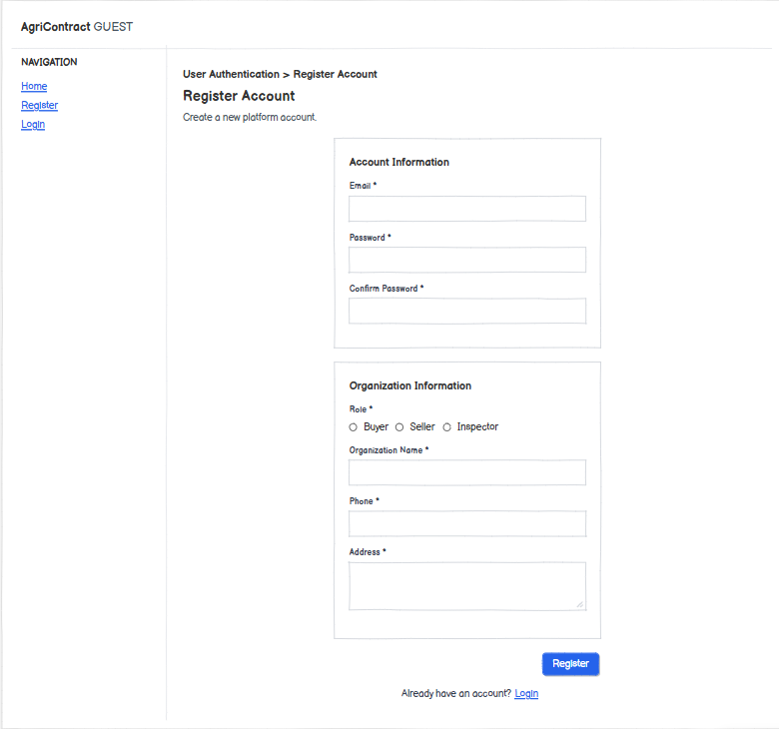

1.1.2 Login

This screen allows the Guest to:
- Log in: authenticate once with email and password and receive a session whose permissions depend on the user's role (BUYER, SELLER, INSPECTOR, OPERATOR, ARBITRATOR, ADMIN). A wrong combination shows MSG04. (UC02)
- Go to registration: open the Register Account screen. (UC01)
On the screen, the authenticated user can also:
- Log out: end the current session from the header user menu. (UC02)
- Be asked to log in again: signing a contract and submitting an inspection report require a recent login; the system then sends the user back to this screen (MSG05). (UC22, UC44)
Field Name | Description
Email | Data type: email string; required
Password | Data type: masked text; required

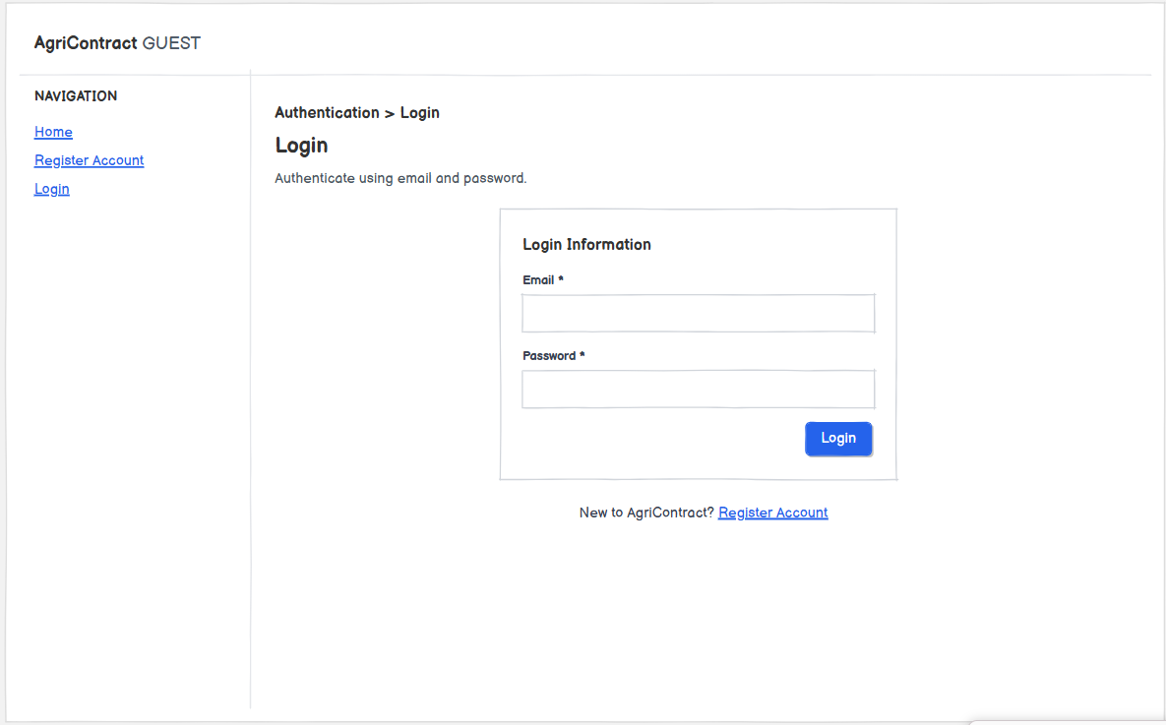

1.2 Profile & KYC

1.2.1 My Profile
This screen allows the Buyer, Seller and Inspector to:
- View eligibility status: see role, KYC status, authorization expiry date and current lock (locked until) to know whether they may publish listings, create offers or sign contracts. (UC03, GB-02)
- Update organization and contact information: edit organization name, phone and address (MSG06). (UC03)
- Enter representative information: declare the legal representative or authorized signatory of the organization. (UC03)
- Upload authority documents: attach business registration and authorization documents that prove the representative's authority; each file is scanned before it can be used (GB-03). (UC03)
- Submit / resubmit KYC: send the profile for Operator review (MSG07); a REJECTED profile shows the rejection reason and can be resubmitted, which returns it to PENDING. (UC03)
On the screen, the user can also:
- See trading restrictions: when KYC is not VERIFIED, the authorization has expired, or the account is locked, a banner explains which actions are blocked (MSG08). (UC03)
Field Name | Description
Status (read-only)
KYC Status | Display; values PENDING, VERIFIED, REJECTED; initial value PENDING after registration
Authorization Expires At | Display; date-time set by the Operator from the actual authorization document; "Indefinite" when empty; an expired date makes the user ineligible even though the status stays VERIFIED (GB-04)
Locked Until | Display; date-time or "Not locked"; comes from the reputation record
Rejection Reason | Display; shown only when status is REJECTED
Organization & Contact
Organization Name | Data type: text; 2–255 characters; required
Phone | Data type: text; 9–15 characters; required
Address | Data type: text; max 500 characters; required
Representative & Documents
Representative Full Name | Data type: text; max 255 characters; required
Representative Position | Data type: text; max 100 characters; required
Representative ID Number | Data type: text; 9–12 digits; required
Business Registration Document | Data type: file; JPG, PNG or PDF; max 10 MB; required; wrong type or size shows MSG09
Authorization Document | Data type: file; JPG, PNG or PDF; max 10 MB; required when the representative is not the legal representative

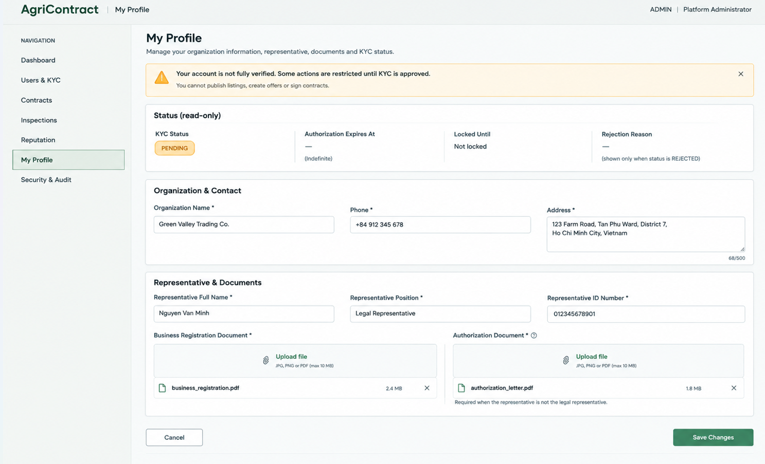

1.2.2 Public User Profile

This screen allows the Buyer and Seller to:
- View counterparty profile: see organization name, role and verification status of another user, without any private contact data (GB-05). (UC04)
- View reputation summary: see the counterparty's reputation score, whether they are currently locked, and their lock history, to assess risk before trading. (UC04)
- Check both directions: a Buyer checks a Seller from a listing; a Seller checks a Buyer before negotiating an offer. (UC04)
Field Name | Description
Verification Status | Display; PENDING, VERIFIED or REJECTED
Reputation Score | Display; number computed at read time from completed-contract, dispute and lock facts
Locked | Display; Yes / No
Lock History | Display table; one row per lock entry (locked-until date, reason, early-unlock marker)

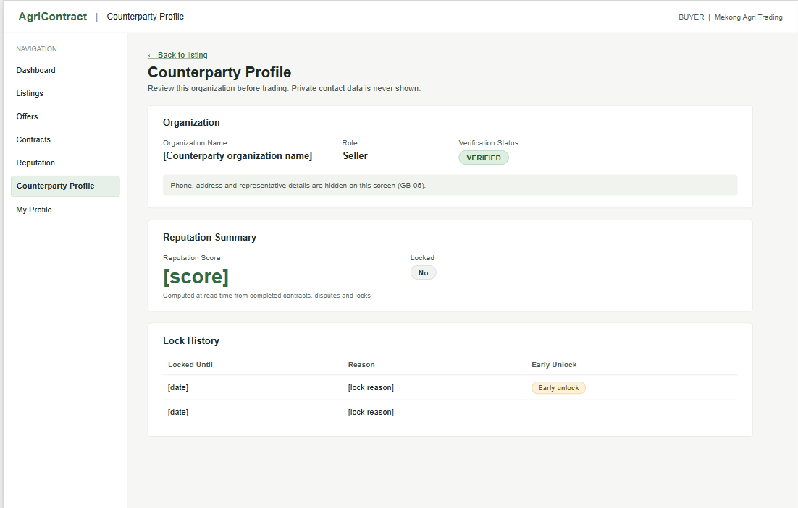

2. Account Administration

2.1 KYC Review

2.1.1 KYC Review Queue
This screen allows the Operator to:
- List pending profiles: view all user profiles waiting for KYC review (default filter PENDING). (UC05)
- Filter and search: narrow the queue by status, role or organization name. (UC05)
- Open a profile: go to KYC Detail to review documents and decide. (UC05)
Field Name | Description
Verification Status | Data type: dropdown; allowed values PENDING, VERIFIED, REJECTED; default PENDING
Role | Data type: dropdown; allowed values All, BUYER, SELLER, INSPECTOR; default All
Keyword | Data type: text; max 100 characters; optional; matches organization name

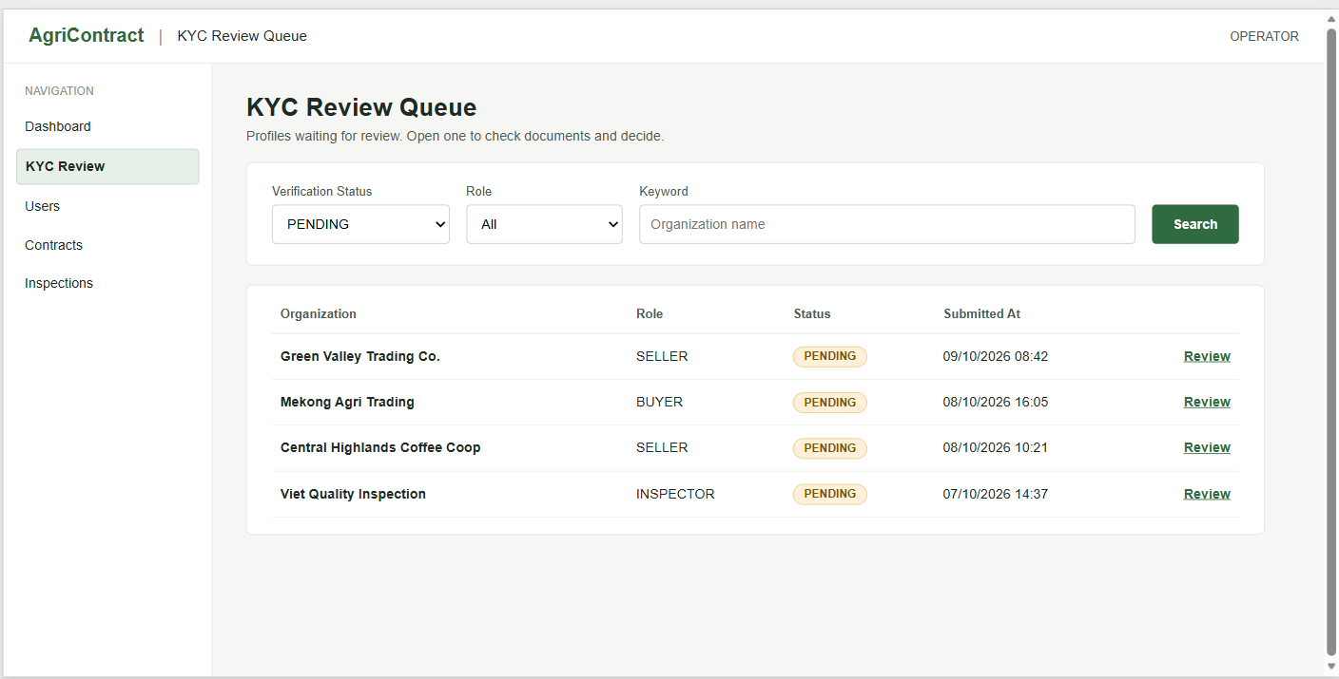

2.1.2 KYC Detail
[Mockup: Two-column layout: left = organization, contact and representative information; right = document viewer with file list; decision history panel; footer buttons "Verify" (primary) and "Reject" (danger)]
This screen allows the Operator to:
- Review submitted information: view organization, contact and representative data and open each uploaded document. (UC05)
- Verify the profile: open the Verify KYC Dialog for a PENDING profile. (UC05)
- Reject the profile: open the Reject KYC Dialog for a PENDING profile. (UC05)
- View decision history: see who made each KYC decision and when. (UC05)
Field Name | Description
Verify / Reject buttons | Shown only when the status is PENDING; a profile decided by someone else in the meantime shows MSG10
Decision History | Display table; decision, decided by, decided at, reason

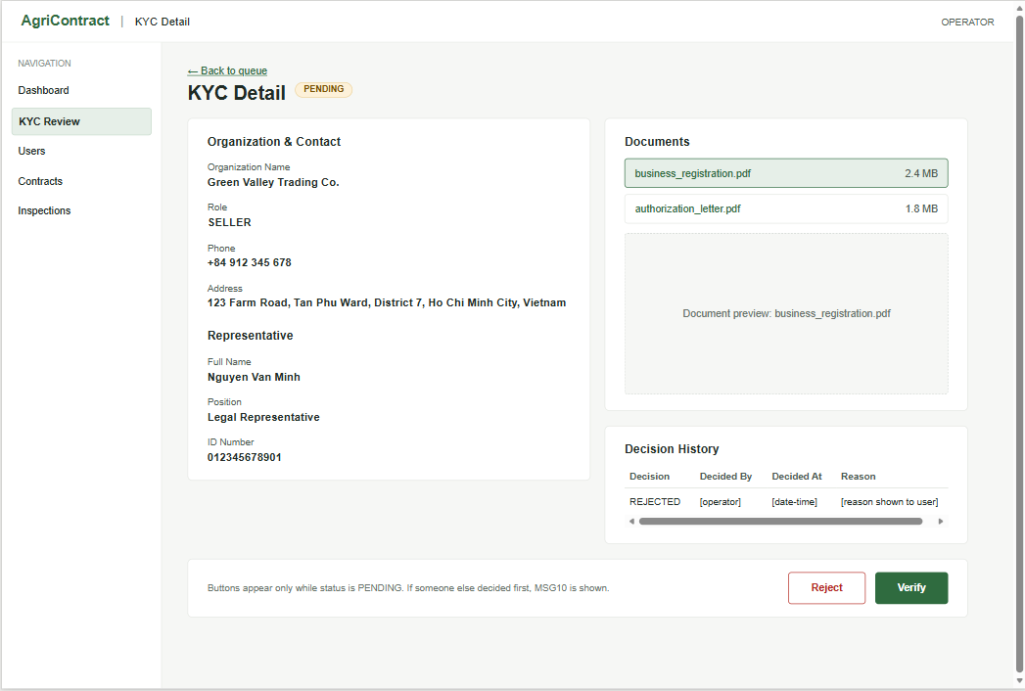

2.1.3 Verify KYC Dialog
[Mockup: Modal with date-time picker "Authorization expires at", checkbox "Indefinite authorization", "Confirm verify" and "Cancel" buttons]
This screen allows the Operator to:
- Confirm verification: set the authorization expiry and change the status from PENDING to VERIFIED; the user receives a result email (MSG11). (UC05, GB-04)
Field Name | Description
Authorization Expires At | Data type: date-time (a date-only entry is stored as 23:59:59.999 Vietnam time on that date); required unless "Indefinite" is ticked; must be later than now, otherwise MSG12; must be read from the actual document, not a platform default
Indefinite Authorization | Data type: checkbox; default unchecked; when ticked the expiry is empty (allowed only if the document states no expiry)

2.1.4 Reject KYC Dialog
[Mockup: Modal with multi-line "Rejection reason" textarea, "Confirm reject" (danger) and "Cancel" buttons]
This screen allows the Operator to:
- Confirm rejection: change the status from PENDING to REJECTED with a reason shown to the user; the user receives a result email (MSG13) and can resubmit. (UC05)
Field Name | Description
Reason | Data type: text; 1–1000 characters; required; must not be blank (MSG14)

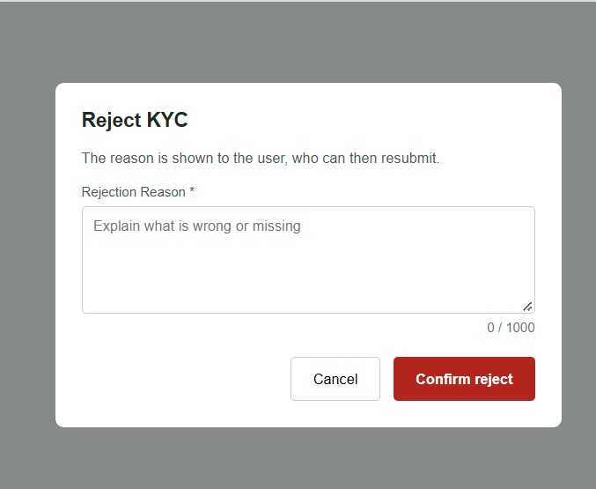

2.2 Reputation Governance

2.2.1 Reputation Action Requests

This screen allows the Operator and Arbitrator to:
- View requests: list reputation action requests with status PROPOSED, APPROVED or REJECTED. (UC06, UC07)
- Propose an action: open the Propose Reputation Action Dialog. (UC06)
On the screen, the Arbitrator can also:
- Approve a request: approve a PROPOSED request (MSG15); for UNLOCK_EARLY the target's lock is released early (other overlapping locks stay in effect); for CLEAR_ELEVATED_RISK the elevated-risk flag of the pair is cleared. (UC07, GB-06)
- Reject a request: reject a PROPOSED request; nothing changes for the target user. (UC07)
- Be stopped from deciding their own proposal: the system refuses with MSG16. (UC07, GB-06)
Field Name | Description
Status | Data type: dropdown; allowed values All, PROPOSED, APPROVED, REJECTED; default PROPOSED
Action Type | Data type: dropdown; allowed values All, UNLOCK_EARLY, CLEAR_ELEVATED_RISK; default All
Approve / Reject buttons | Shown only to the Arbitrator; disabled when the current user is the proposer or the status is not PROPOSED; a request decided in the meantime shows MSG10

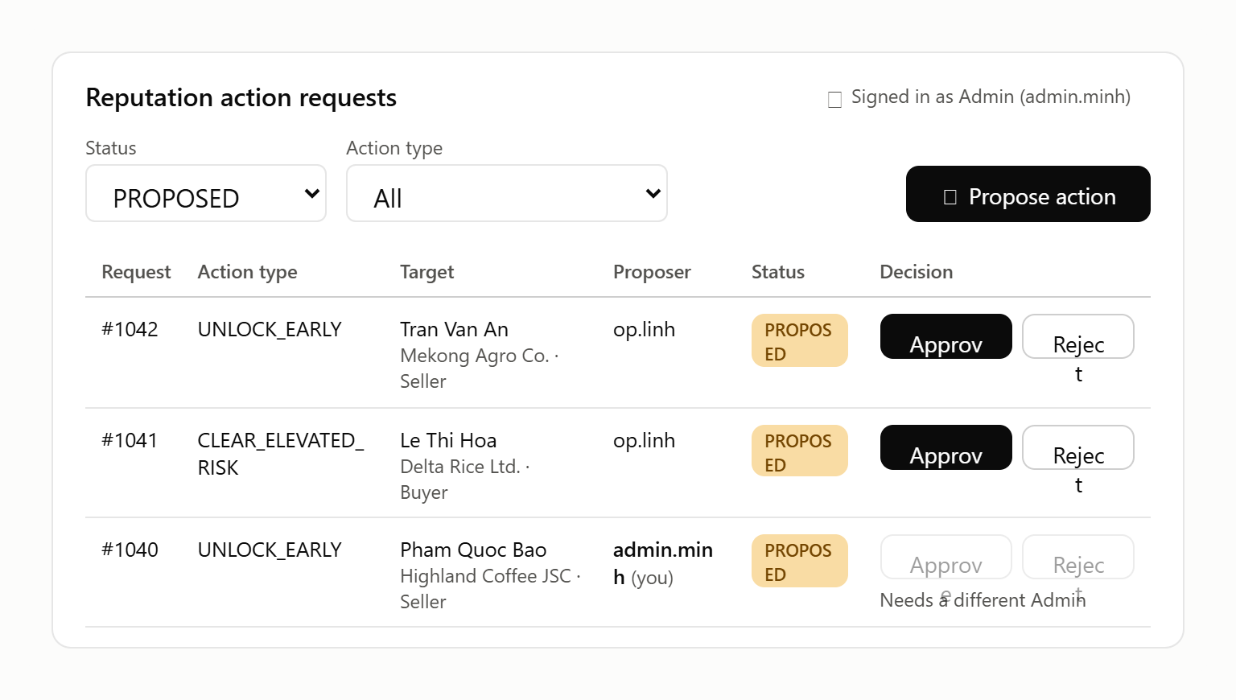

2.2.2 Propose Reputation Action Dialog
[Mockup: Modal with action type radio, target user search box (shows organization and current lock / risk state), reason textarea, "Submit proposal" and "Cancel" buttons]
This screen allows the Operator to:
- Submit a proposal: create a reputation action request in status PROPOSED that must be approved by an Arbitrator (MSG17). (UC06, GB-06)
Field Name | Description
Action Type | Data type: single choice; required; allowed values UNLOCK_EARLY, CLEAR_ELEVATED_RISK
Target User | Data type: user lookup; required; must be an existing Buyer or Seller; for UNLOCK_EARLY the user must currently be locked (MSG18); for CLEAR_ELEVATED_RISK the user must belong to a pair in ELEVATED_RISK
Reason | Data type: text; 1–1000 characters; required

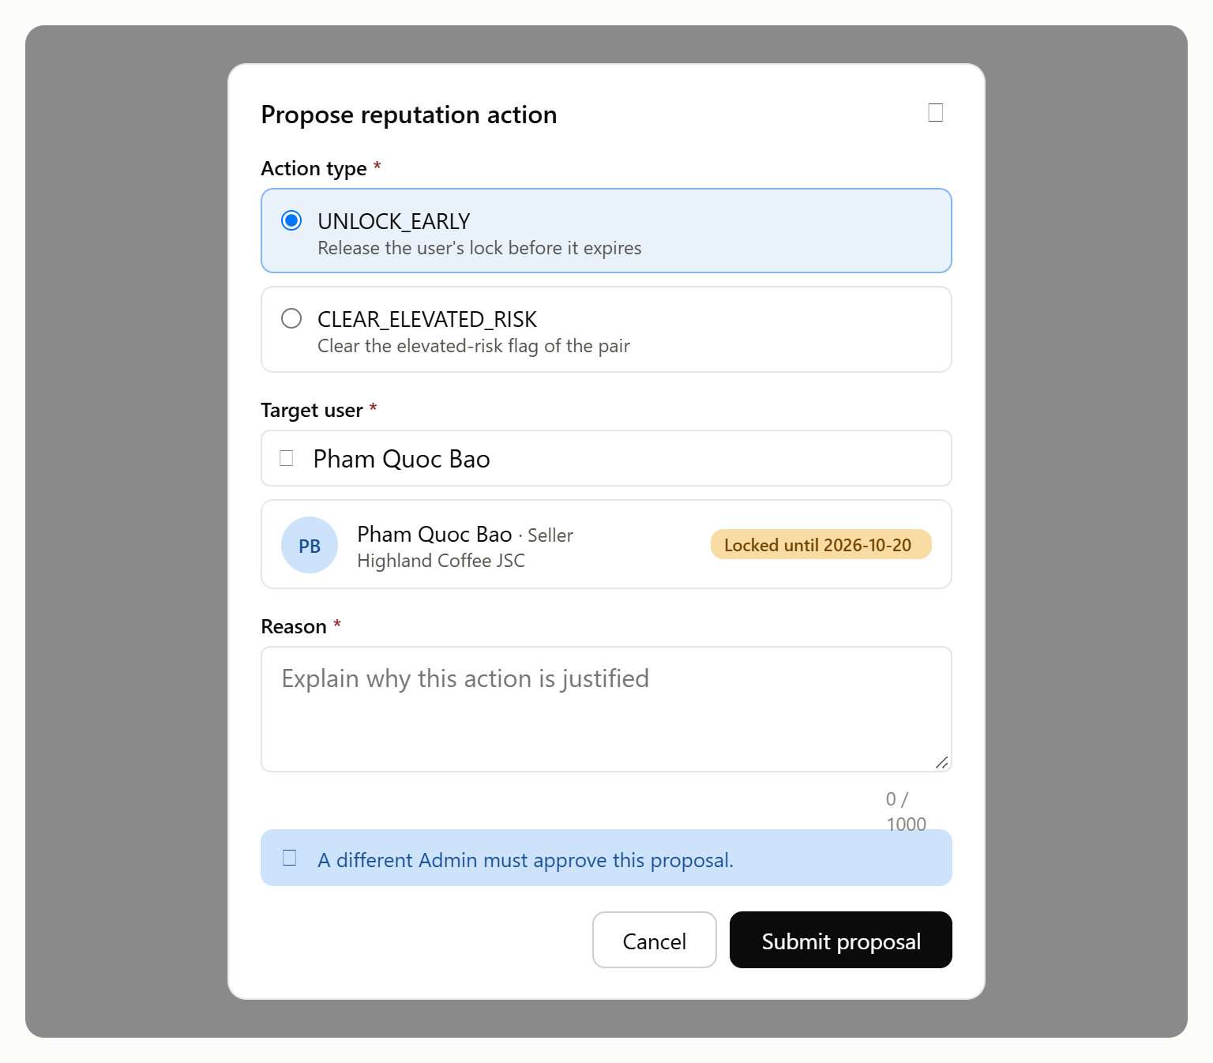

3. Plot & Listing

3.1 Plot Registry

3.1.1 My Plots

This screen allows the Seller to:
- View registered plots: see all plots of the organization's member households with their risk signals (province mismatch, forest-risk check status and level, cross-seller overlap risk). (UC09)
- Import plots from KML: open the Import KML Dialog; each placemark becomes a plot, and re-importing updates plots with the same household label. (UC09)
- Add a plot by GPS pin: open the Add Plot by GPS Pin Dialog when no KML file exists. (UC09)
- Upload cadastral extract: open the Upload Cadastral Extract Dialog for a plot. (UC10)
- Request geo re-evaluation: open the Request Geo Re-evaluation Dialog for a plot marked HIGH_RISK or INCONCLUSIVE. (UC11)
Field Name | Description
Geo Check | Display; PENDING (check running, plot cannot yet be linked to a listing), CHECKED, UNVERIFIED (no answer within 6 hours)
Forest Risk | Display; LOW_RISK, HIGH_RISK, INCONCLUSIVE; empty unless Geo Check is CHECKED; informational only, never blocks trading (GB-07)
Province Mismatch | Display; warning icon when the province derived from the coordinates differs from the declared province (MSG19); non-blocking
Overlap Risk | Display; HIGH when the plot overlaps another seller's plot; sent to Operator review, not rejected automatically
Verification Level | Display; SELF_DECLARED (default) or CADASTRAL_BACKED

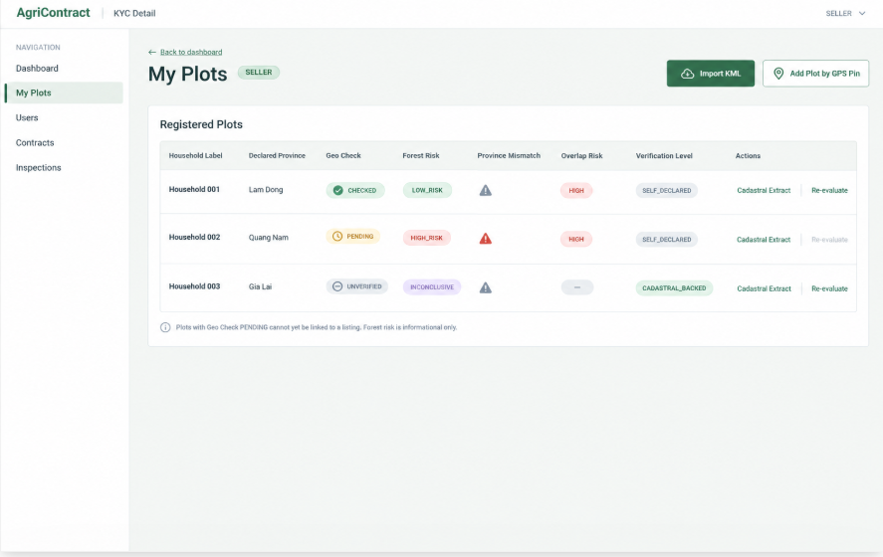

3.1.2 Import KML Dialog

This screen allows the Seller to:
- Upload a KML file: select the KML file and the province that applies to all placemarks. (UC09)
- Review per-placemark results: see which placemarks are valid, which failed geometry validation (each named with its error, MSG20) and which will update an existing household plot; invalid placemarks can be fixed or skipped without re-importing the whole file. (UC09)
- Enter missing area: type the area for point placemarks whose file has no area data. (UC09, GB-08)
Field Name | Description
KML File | Data type: file (.kml); max 10 MB; required
Declared Province | Data type: dropdown; required; allowed values: the 34 current provinces and cities; no default; chosen independently of the coordinates
Area (ha) | Data type: decimal > 0, 4 decimals; required for point placemarks without an area field; a point must be ≤ 4 ha, otherwise MSG21
Household Label | Display; taken from the placemark name; unique per seller; used to match re-imports

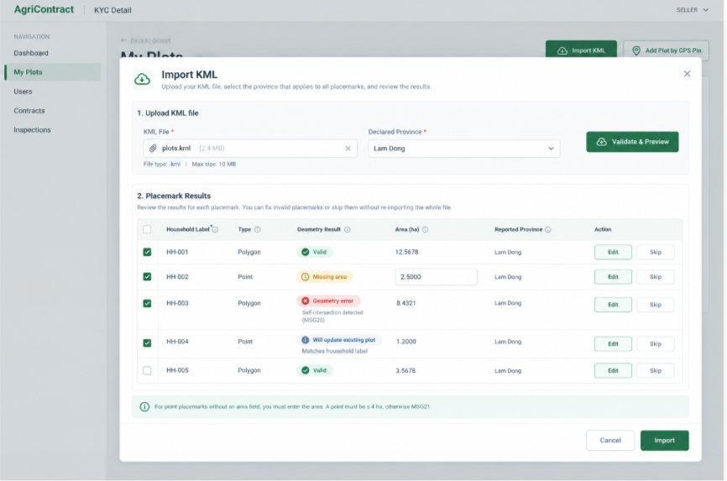

3.1.3 Add Plot by GPS Pin Dialog

This screen allows the Seller to:
- Capture current position: read the device GPS position and its accuracy. (UC09)
- Save a point plot: create, or update when the household label already exists, a POINT plot; polygons cannot be entered this way. (UC09)
- Heed the accuracy warning: when accuracy is worse than 20 m the system shows MSG22 but still allows saving. (UC09)
Field Name | Description
Household Label | Data type: text; 1–255 characters; required; unique per seller (an existing label updates that plot)
Latitude / Longitude | Data type: decimal degrees, 6 decimals; required; filled from device GPS, read-only
Accuracy (m) | Data type: decimal; filled from device GPS, read-only; warning if > 20 m
Declared Province | Data type: dropdown of 34 provinces; required
Area (ha) | Data type: decimal > 0 and ≤ 4, 4 decimals; required

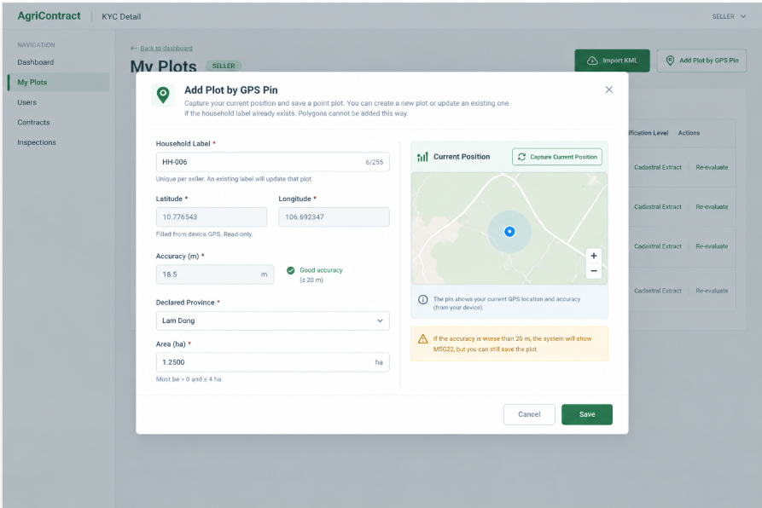

3.1.4 Upload Cadastral Extract Dialog

This screen allows the Seller to:
- Attach a cadastral extract: upload the extract for an existing plot; the plot becomes CADASTRAL_BACKED after the file passes the malware scan (MSG23); re-uploading replaces the current file and the previous one is kept for audit. (UC10)
Field Name | Description
Cadastral Extract File | Data type: file; JPG, PNG or PDF; max 10 MB; required; a file that fails the scan shows MSG24

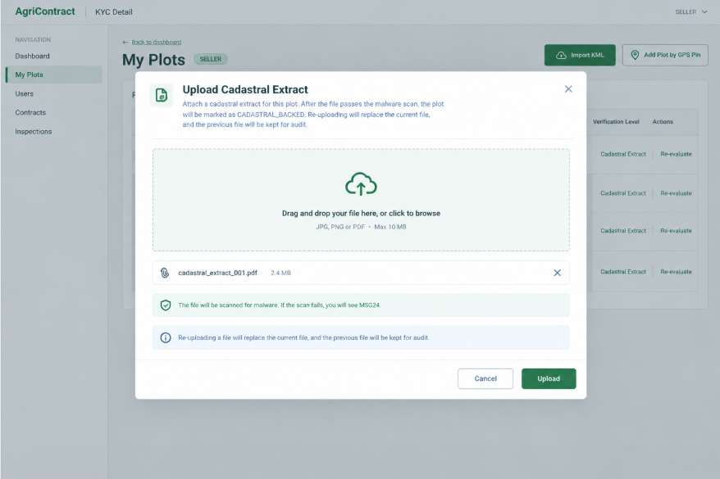

3.1.5 Request Geo Re-evaluation Dialog

This screen allows the Seller to:
- Take a field photo: capture a photo at the plot with the device camera; choosing an existing gallery photo is not allowed. (UC11, GB-09)
- Submit for re-evaluation: the system compares the photo's GPS location with the registered plot; inside the boundary it records "verified by field photo" next to the original risk label; outside the boundary or without GPS data it refuses with MSG25. (UC11)
Field Name | Description
Field Photo | Data type: image captured by camera (JPG / PNG); max 10 MB; required; must contain GPS and timestamp metadata; the action is enabled only when Forest Risk is HIGH_RISK or INCONCLUSIVE

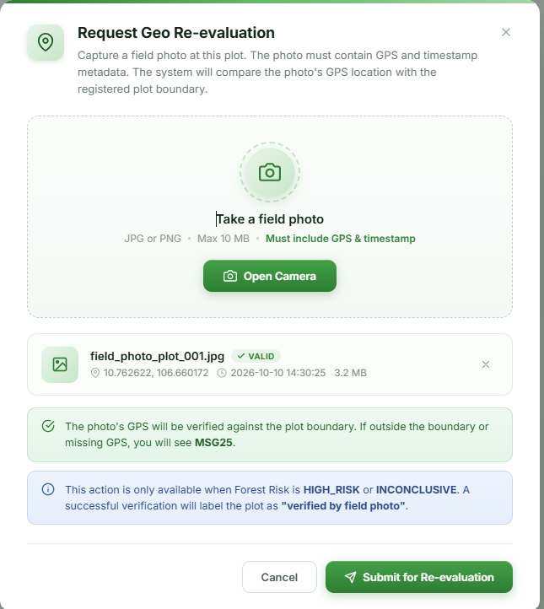

3.2 Plot Risk Review

3.2.1 Plot Risk Review Queue
[Mockup: Page title "Plot Risk Review"; filter bar (risk type, commodity, province); table columns Seller, Household Label, Province, Risk Type (Overlap / Yield / Forest), Risk Level, Detected At, Status; row action "Review"; detail drawer with a map overlaying the two plots, overlap metrics and decision form]
This screen allows the Operator to:
- List flagged plots: view plots with HIGH cross-seller overlap risk, a yield anomaly on a listing, or a forest-risk label needing attention. (UC12)
- Inspect a case: see both sellers' plots on a map with the overlap ratio, verification level and any cadastral extract or field-photo evidence. (UC12)
- Record a review decision: accept the plot as a legitimate case (for example a shared household, a land lease or a re-survey) or confirm the risk flag, with a note; the system never rejects a plot automatically. (UC12, GB-07)
- Request more evidence: ask the Seller for additional evidence for a yield anomaly or overlap (MSG26). (UC12)
Field Name | Description
Risk Type | Data type: dropdown; allowed values All, OVERLAP, YIELD, FOREST; default All
Commodity | Data type: dropdown; COFFEE (the only Phase 2 commodity); default COFFEE
Province | Data type: dropdown of 34 provinces; optional
Decision | Data type: single choice; required; ACCEPTED_LEGITIMATE, RISK_CONFIRMED, EVIDENCE_REQUESTED
Review Note | Data type: text; 1–1000 characters; required

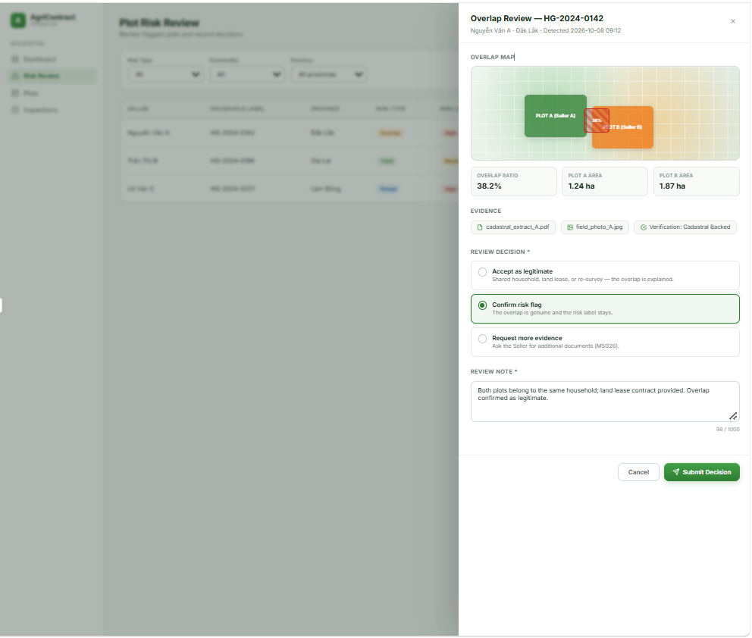

3.3 Product Management

3.3.1 My Products

This screen allows the Seller to:
- View products: list the Seller's products with category and commodity. (UC13)
- Create a product: describe goods by choosing an approved category (two levels, each mapped to one commodity) and entering variety, crop year, harvest season and self-declared certifications. (UC13)
- Edit a product: update product information; existing listings and contracts keep their snapshot and are not affected (GB-10). (UC13)
- Propose a new category: suggest a missing category; it can be used only after Operator approval (MSG27, GB-11). (UC13)
Field Name | Description
Product Name | Data type: text; 2–255 characters; required
Category | Data type: two-level dropdown; required; only APPROVED categories; determines the Commodity
Commodity | Display; derived from the category (COFFEE in Phase 2); read-only
Variety Name | Data type: text; max 100 characters; optional; free text with suggestions from reference-price item names
Crop Year | Data type: integer (4-digit year); optional
Harvest Season | Data type: text; max 100 characters; optional
Certifications | Data type: list of text tags; each max 100 characters; optional; seller-declared, not verified by the platform
Proposed Category Name | Data type: text; 2–255 characters; required in the "Propose category" form; must not equal an existing category name (MSG28)
Proposed Parent Category | Data type: dropdown of approved top-level categories; optional (empty = new top-level category)

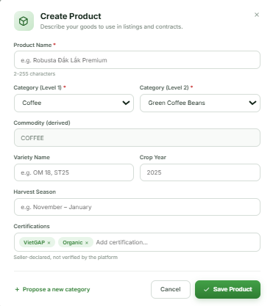

3.4 Listing Management

3.4.1 My Listings

This screen allows the Seller to:
- View listings and remaining quantity: see offered, available and minimum order quantities and the status of each listing after every contract. (UC15)
- Create or edit a listing: open the Listing Form. (UC14)
- Pause or close a listing: stop new offers (MSG29); a paused or closed listing is not reopened automatically when reserved quantity is returned. (UC15, GB-12)
- Republish a listing: explicitly reopen a paused listing; a legacy listing without a quality declaration must be completed first (MSG30). (UC15)
Field Name | Description
Status | Data type: dropdown filter; allowed values All, DRAFT, AVAILABLE, PARTIALLY_COMMITTED, PAUSED, CLOSED; default All
Available (kg) | Display; remaining quantity after reservations; decreases when a Buyer offer reserves goods

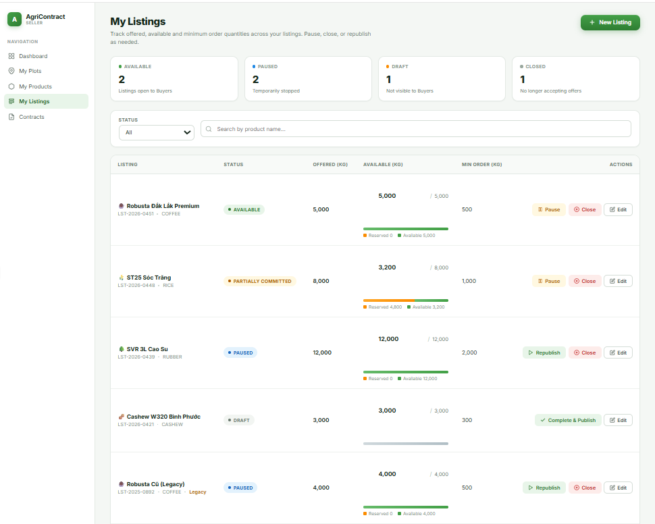

3.4.2 Listing Form
[Mockup: Multi-section form: "Goods" (product select), "Quantity" (offered, minimum order), "Declared quality" (fields change by commodity), "Linked plots" (checkbox list of registry plots with risk badges), "Additional info" (packaging, warehouse, estimated availability date); reference-price hint box; buttons "Save draft", "Publish", "Cancel"]
This screen allows the Seller to:
- Enter listing details: choose the product and declare offered quantity, minimum order quantity and quality. (UC14)
- Link plots: tick plots from the registry; at least one plot is required (MSG31); plots whose geo check is PENDING cannot be selected (MSG32). (UC14, GB-13)
- See the reference price: view the current market reference price for the commodity, province and variety as advisory information only. (UC18, GB-14)
- Save as draft: save the listing as DRAFT without showing it to Buyers (MSG06). (UC14)
- Publish: publish the listing (MSG33); the system checks that the Seller is eligible and refuses if eligibility cannot be confirmed (MSG08). A yield anomaly adds a review flag but does not block publishing (MSG34). (UC14, GB-02)
Field Name | Description
Goods
Product | Data type: dropdown of the Seller's products; required; determines the commodity and the quality fields
Quantity
Offered Quantity (kg) | Data type: decimal > 0, up to 2 decimals; required; unit KG
Minimum Order Quantity (kg) | Data type: decimal > 0 and ≤ Offered Quantity, otherwise MSG35; required; smallest quantity accepted per contract
Declared Quality — COFFEE
Type | Data type: dropdown; required; ARABICA, ROBUSTA
Moisture / Foreign Matter / Black & Broken Beans (%) | Data type: decimal 0–100; required
Linked Plots
Plots | Data type: multi-select of the Seller's registry plots; required (≥ 1); plots with Geo Check PENDING disabled; selected plots are copied as a snapshot
Additional Info
Packaging Declaration | Data type: text; max 500 characters; optional
Warehouse Location | Data type: text; max 255 characters; optional; not the delivery point
Estimated Availability Date | Data type: ISO date; optional; informational, creates no deadline

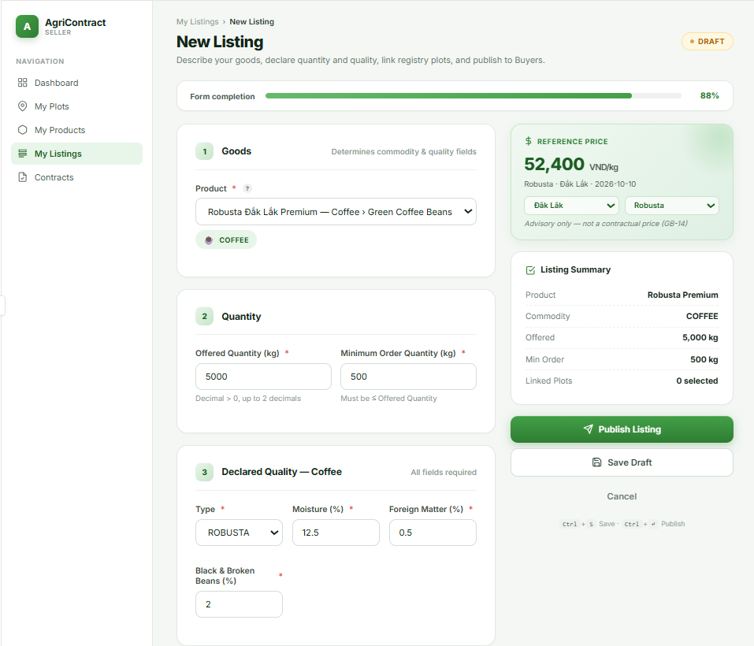

3.5 Listing Marketplace

3.5.1 Browse Listings
[Mockup: Left panel with category tree (commodity → category) and filters; main area card grid with Product, Commodity, Region, Available (kg), Min Order (kg), declared quality summary, Seller (verified badge and reputation score), plot verification badge; search box, sort, pagination]
This screen allows the Guest, Buyer and Seller to:
- Browse the catalog: navigate the two-level category tree grouped by commodity. (UC16)
- Search and filter listings: filter by commodity, category, province, quality and seller reputation; an empty result shows MSG36. (UC16)
- Open a listing: go to Listing Detail. (UC16)
Field Name | Description
Keyword | Data type: text; max 100 characters; optional; matches product or variety name
Commodity | Data type: dropdown; COFFEE (the only Phase 2 commodity); default COFFEE
Category | Data type: tree select; optional; APPROVED categories only
Province | Data type: dropdown of 34 provinces; optional
Quality | Data type: dropdown; coffee type (ARABICA or ROBUSTA); optional
Minimum Seller Reputation | Data type: decimal; optional
Status shown | Only AVAILABLE and PARTIALLY_COMMITTED listings are listed

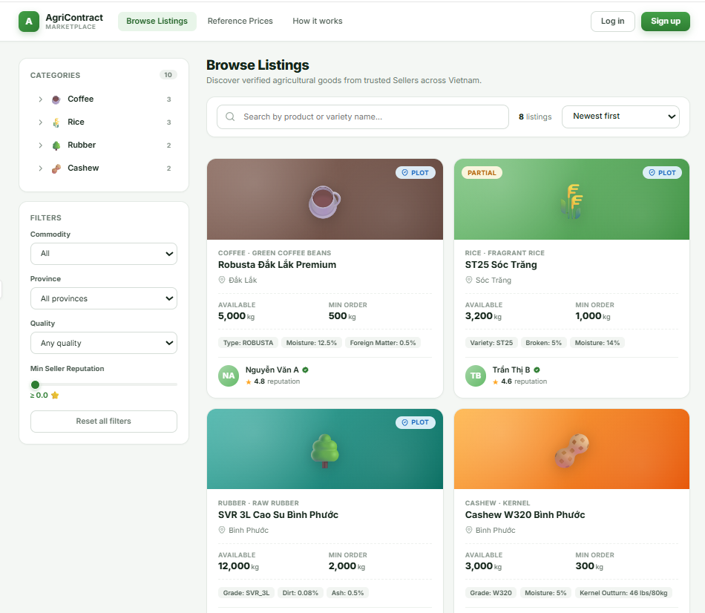

3.5.2 Listing Detail
[Mockup: Title block (product, category, commodity, status); quantity panel (available, minimum order); declared quality table; origin panel with map of linked plots (coloured by verification level, labels for forest risk and field-photo verification); additional info (crop year, harvest season, certifications, packaging, warehouse, availability date); seller card with link to public profile and reputation; reference price box; "Create offer" button for Buyers]
This screen allows the Guest, Buyer and Seller to:
- View listing information: see quantities, declared quality, product details and the linked plots with their verification level and risk labels. (UC16)
- Assess the Seller: open the Seller's public profile and reputation summary (login required). (UC04)
- See the reference price: view the advisory market price for the commodity and province. (UC18, GB-14)
- Start an offer: a logged-in Buyer clicks "Create offer" to open the Create Offer form for this listing version; a Guest is asked to log in first (MSG37). (UC20)
Field Name | Description
Certifications | Display; seller-declared commitments, labelled "not verified by the platform"
Forest Risk label | Display per plot; HIGH_RISK / INCONCLUSIVE / LOW_RISK shown as Buyer information, not a block
Create offer button | Shown to Buyers only; disabled when the listing is not AVAILABLE or PARTIALLY_COMMITTED

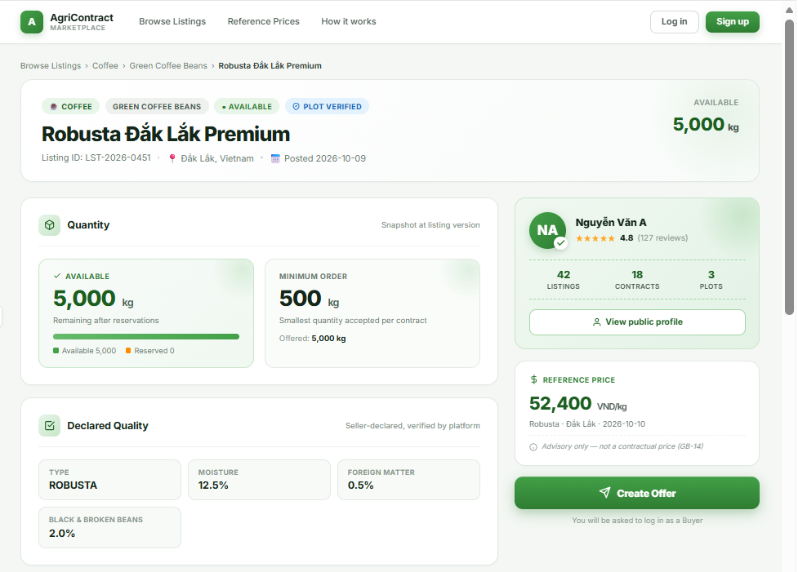

3.6 Listing Moderation

3.6.1 Category & Listing Moderation
[Mockup: Page with two tabs. Tab "Category proposals": table columns Proposed Name, Parent, Proposed By, Proposed At, Status; row buttons "Approve" (opens a small form to choose the commodity) and "Reject" (opens a reason box). Tab "Products & listings": search by seller or product, table columns Seller, Product, Listing Status, Review Flags (yield anomaly, overlap), Reported At; row buttons "Close listing", "View"]
This screen allows the Operator to:
- Review category proposals: list categories proposed by Sellers in status PENDING. (UC17)
- Approve a category: approve a proposal and assign the commodity it belongs to; the category becomes usable for products (MSG38). (UC17, GB-11)
- Reject a category: reject a proposal with a reason shown to the Seller. (UC17)
- Moderate products and listings: find products and listings that break platform rules (for example misleading descriptions or listings carrying review flags) and close a listing with a reason; the Seller is notified (MSG39). Closing does not affect contracts already created, which keep their snapshot. (UC17, GB-10)
Field Name | Description
Category Status | Data type: dropdown filter; allowed values PENDING, APPROVED, REJECTED; default PENDING
Commodity (on approve) | Data type: dropdown; required; allowed value COFFEE (the only Phase 2 commodity); no default; cannot be changed after approval
Rejection / Closing Reason | Data type: text; 1–500 characters; required
Seller / Product search | Data type: text; max 100 characters; optional

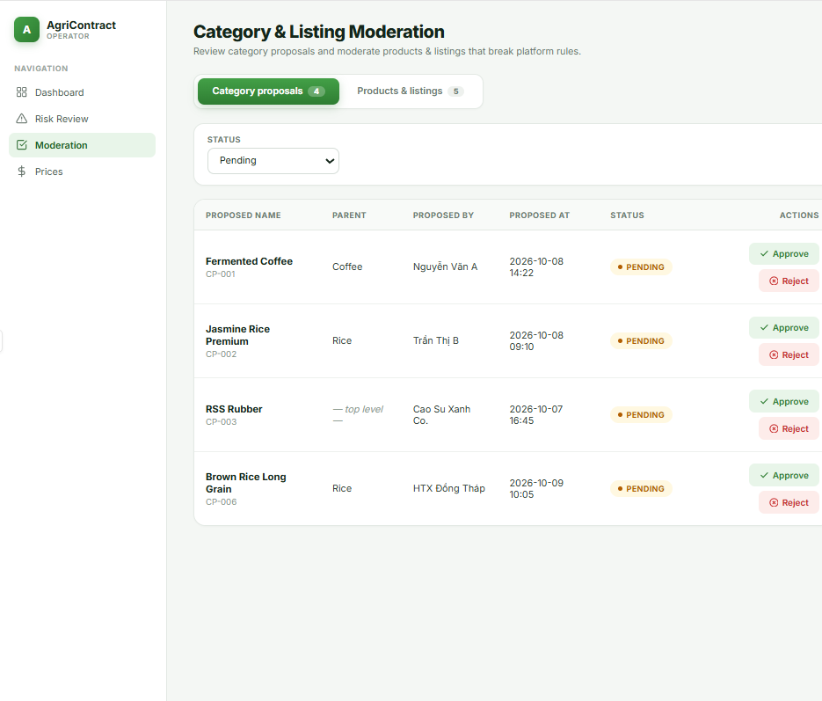

4. Market Prices

4.1 Reference Prices

4.1.1 Market Price Board
[Mockup: Coffee price board; filter bar (province, item); table columns Item, Province, Price (VND/kg), Price Date, Source, Freshness; "Stale" badge; footnote "Reference only, not used for settlement"]
This screen allows the Guest, Buyer, Seller, Operator, Arbitrator and Admin to:
- View reference prices: see the latest external market price per commodity, province and item. (UC18, GB-14)
- Filter by province and item: choose a province and, optionally, an item from the suggested list. (UC18)
- Judge freshness: prices older than 14 days are marked stale (MSG40); manual entries show their source as OPERATOR_MANUAL. (UC18)
Field Name | Description
Commodity | Display; fixed COFFEE (the only Phase 2 commodity)
Province | Data type: dropdown of 34 provinces; required
Item | Data type: dropdown with autocomplete of item names available for the province; optional
Price (VND/kg) | Display; decimal, 2 decimals, VND
Source | Display; VNSAT_SCRAPE or OPERATOR_MANUAL
Price Date | Display; ISO date the price applies to at the source

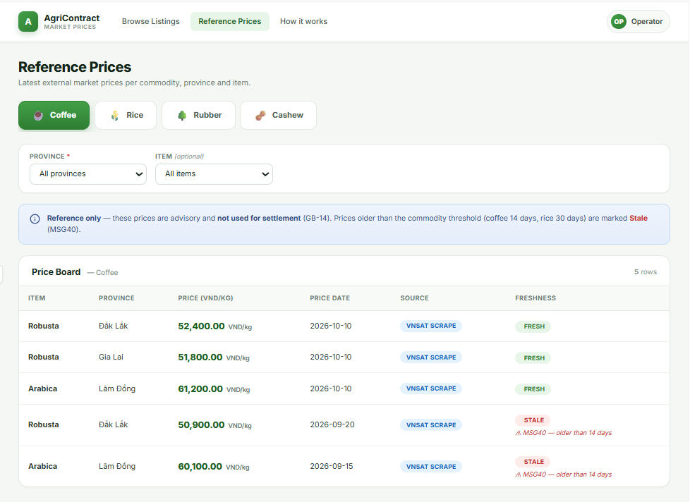

4.1.2 Manual Price Entry
[Mockup: Form card with province, item name, price, price date, reference source and reason; "Save" button; below, a table of recent manual entries (Item, Price, Price Date, Entered At, Entered By)]
This screen allows the Operator to:
- Enter a manual price: record a coffee reference price for a province when the VNSAT source is interrupted or needs a controlled correction, with the reference source and a reason; it appears on the price board immediately (MSG06). (UC19)
- View entry history: see recent manual entries; entries are append-only history and are not edited. (UC19)
Field Name | Description
Commodity | Display; fixed COFFEE
Item Name | Data type: text; 1–255 characters; required (for example a VNSAT item name)
Province | Data type: dropdown of 34 provinces; required
Reference Source | Data type: text; 1–255 characters; required; where the price was taken from
Reason | Data type: text; 1–1000 characters; required; why the price is entered by hand
Price (VND/kg) | Data type: decimal, 2 decimals, VND; required; must be > 0
Price Date | Data type: ISO date; required; default today; must not be in the future (MSG41)

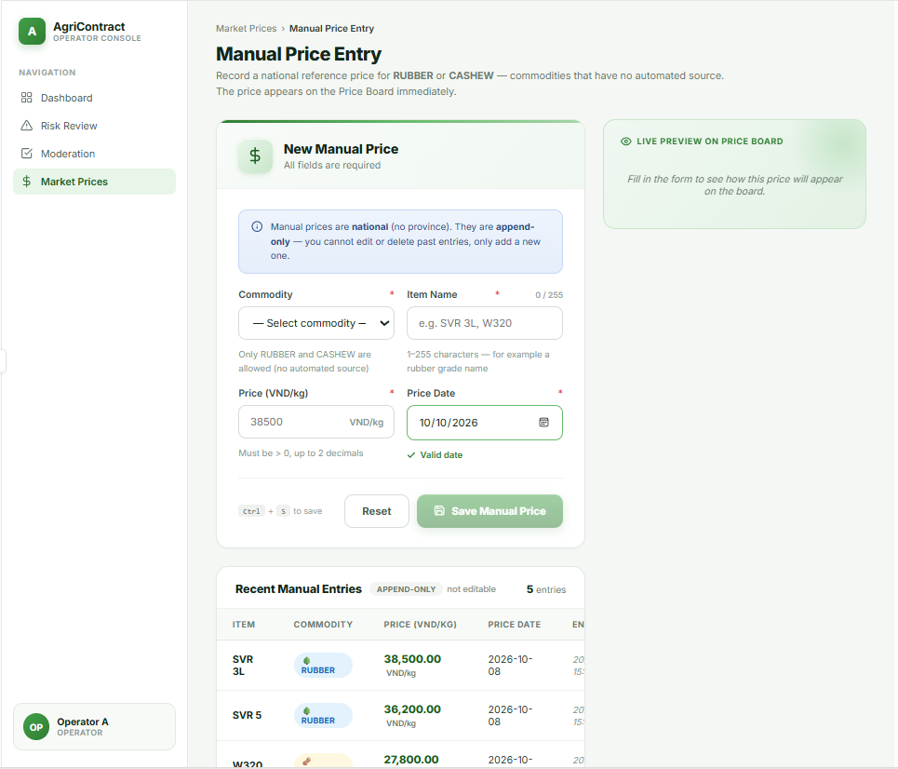

5. Contract

5.1 Offer Creation

5.1.1 Create Offer
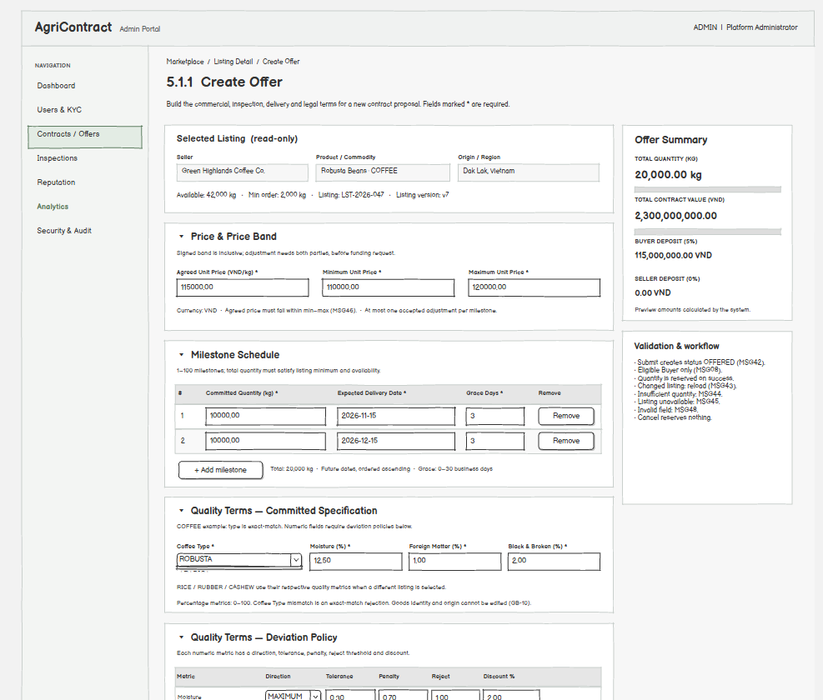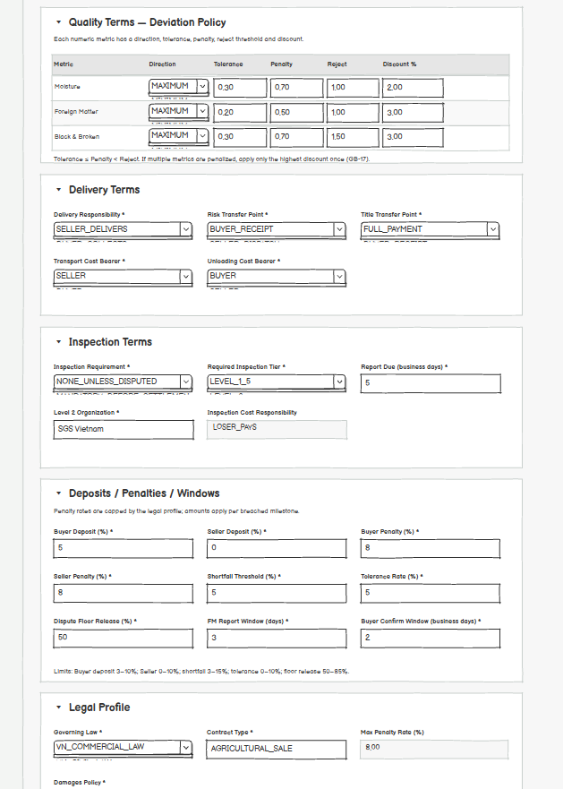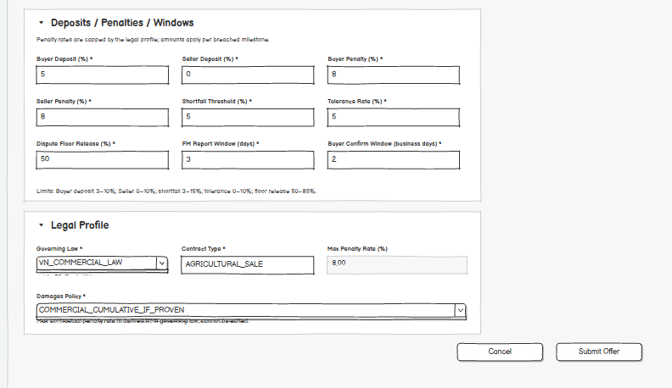
This screen allows the Buyer to:
- Create an offer: submit a full set of proposed contract terms for the selected listing; the system reserves the requested quantity on the listing, creates the contract in status OFFERED and notifies the Seller (MSG42). (UC20, GB-15)
- Build the milestone schedule: add, edit and remove delivery milestones, each with a committed quantity, expected delivery date and grace days. (UC20)
- Set quality terms: enter the committed quality specification for the listing's commodity and the deviation policy for each measured metric. (UC20)
- Preview money amounts: see the system-calculated total contract value and deposit amounts update as quantity, price and rates change. (UC20)
- Cancel: leave the form without creating an offer; no quantity is reserved. (UC20)
On the screen, the Buyer can also:
- Reload the listing: when the listing has changed (MSG43), no longer has enough quantity (MSG44) or is no longer open for offers (MSG45), reload the listing and review the form again instead of resubmitting. (UC20)
- See eligibility problems: an ineligible Buyer cannot submit (MSG08). (UC20, GB-02)
Field Name | Description
Listing (read-only)
Listing / Product / Commodity | Display only; taken from the selected listing; commodity is COFFEE. Goods identity and origin (region, plots) are copied by the system at creation and cannot be edited in the offer (GB-10)
Listing Version | Hidden; version of the listing as displayed; sent with the offer
Price & Price Band
Agreed Unit Price (VND/kg) | Money (decimal, 2 decimals); required; > 0 and ≤ 99,999,999.99; must lie within the price band (MSG46, GB-16)
Currency | Display only; fixed value VND
Minimum Unit Price (VND/kg) | Money; required; > 0 and ≤ Agreed Unit Price; lower bound of the signed price band (inclusive)
Maximum Unit Price (VND/kg) | Money; required; ≤ 99,999,999.99; ≥ Agreed Unit Price; upper bound of the signed price band (inclusive)
Price Adjustment Rule | Display only; both parties must accept, only before the milestone's funding request, at most 1 accepted adjustment per milestone
Milestone Schedule
Milestone # | Integer, auto-numbered 1..N; read-only; at least 1 and at most 100 milestones per contract
Committed Quantity (kg) | Decimal; required; > 0 and ≤ 1,000,000 kg per milestone. The sum over all milestones is the requested quantity and must be ≥ the listing's minimum order quantity and ≤ its available quantity
Expected Delivery Date | ISO date; required; a future date and not earlier than the previous milestone's date; the deadline ends at 23:59:59 Vietnam time of that day
Grace Days | Integer (Vietnamese business days); required; ≥ 0; max 30
Quality Terms — Committed Spec (fields depend on commodity)
Coffee: Type | Enum; required; ARABICA or ROBUSTA
Coffee: Moisture % / Foreign Matter % / Black & Broken Beans % | Decimal; required; 0–100
Quality Terms — Deviation Policy (one row per numeric metric)
Direction | Enum; required; MAXIMUM (value must not exceed the spec) or MINIMUM (value must not fall below the spec)
Tolerance / Penalty / Reject thresholds | Decimal; required; must satisfy Tolerance ≤ Penalty < Reject. A deviation equal to the Penalty threshold falls in the penalty zone; equal to the Reject threshold falls in the reject zone
Discount Rate (%) | Decimal; required; 0–100; applied to the Seller's entitlement when a metric falls in the penalty zone; if several metrics do, only the highest rate is applied once (GB-17)
Exact-match reject | Display only; fixed "reject on mismatch" for Coffee Type
Delivery Terms
Delivery Responsibility | Enum; required; SELLER_DELIVERS, BUYER_COLLECTS
Risk Transfer Point | Enum; required; SELLER_DISPATCH, BUYER_RECEIPT, BUYER_ACCEPTANCE
Title Transfer Point | Enum; required; FULL_PAYMENT, BUYER_RECEIPT, BUYER_ACCEPTANCE
Transport Cost Bearer | Enum; required; BUYER, SELLER, SHARED
Unloading Cost Bearer | Enum; required; BUYER, SELLER, SHARED
Inspection Terms
Inspection Requirement | Enum; required; NONE_UNLESS_DISPUTED (default) or MANDATORY_BEFORE_SETTLEMENT
Required Inspection Tier | Enum; required; LEVEL_1_5 or LEVEL_2
Report Due (business days) | Integer; required; 1–30
Level 2 Inspection Organization | Text; required when Required Inspection Tier = LEVEL_2, otherwise optional; max 200 characters
Inspection Cost Responsibility | Display only; fixed LOSER_PAYS
Deposits, Penalties and Windows
Buyer Deposit Rate (%) | Decimal; required; 3–10; default 5; calculated once on the total contract value and locked when the contract is activated (GB-18)
Seller Deposit Rate (%) | Decimal; optional; default 0; ≥ 0 and ≤ 10; when 0 no Seller deposit is locked
Buyer Penalty Rate (%) / Seller Penalty Rate (%) | Decimal; required; 0 to the Max Contractual Penalty Rate of the legal profile; applied to the value of the breached milestone, not the whole contract (GB-19)
Shortfall Penalty Threshold (%) | Decimal; required; 3–15; default 5
Tolerance Rate (%) | Decimal; required; 0–10; default 5; the screen shows MSG47 when the value is 0
Dispute Floor Release Rate (%) | Decimal; required; 50 to 85 (100 − the 15% Level 2 safety buffer); default 50
Force Majeure Report Window (days) | Integer; required; default 3; 1–30; counted from when the Seller becomes aware of the event
Buyer Confirm Window (business days) | Integer; required; 2–10; default 2
Legal Profile
Governing Law | Enum; required; VN_COMMERCIAL_LAW (default) or VN_CIVIL_LAW
Contract Type | Text; required; max 50 characters
Max Contractual Penalty Rate (%) | Decimal; derived from Governing Law (8% for VN_COMMERCIAL_LAW); read-only
Damages Policy | Enum; required; COMMERCIAL_CUMULATIVE_IF_PROVEN (default for VN_COMMERCIAL_LAW), CIVIL_PENALTY_ONLY_UNLESS_EXPRESSLY_CUMULATIVE (default for VN_CIVIL_LAW), EXPRESS_PENALTY_ONLY
Summary (read-only)
Total Quantity (kg) | Sum of milestone committed quantities
Total Contract Value (VND) | Agreed Unit Price × Total Quantity; calculated by the system; ≤ 9,999,999,999,999,999.99
Buyer / Seller Deposit Amount (VND) | Total Contract Value × the respective deposit rate
Any value missing or outside its range blocks the submission and is shown next to its field (MSG48).

5.2 Contract Viewing and Negotiation

5.2.1 My Contracts
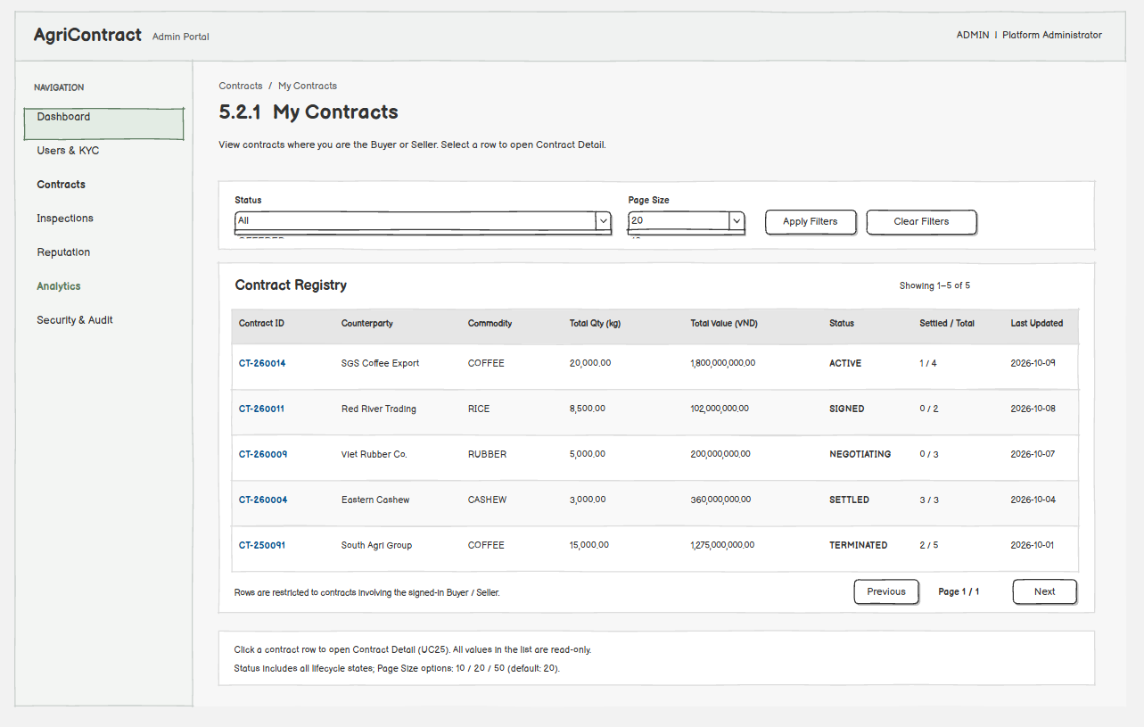
This screen allows the Buyer and Seller to:
- View their contracts: see a paginated list of contracts in which they are the Buyer or the Seller. (UC25)
- Filter by status: narrow the list by contract status. (UC25)
- Open a contract: open the Contract Detail screen. (UC25)
Field Name | Description
Status | Dropdown; optional; default All. Values: OFFERED, NEGOTIATING, SIGNED, ACTIVE, REPLACEMENT_PENDING, SUPERSEDE_REFUND_PENDING, ACTIVATION_REFUND_PENDING, SETTLED, TERMINATED, WITHDRAWN, SUPERSEDED, ACTIVATION_FAILED
Page Size | Dropdown; 10 / 20 / 50; default 20

5.2.2 Contract Detail
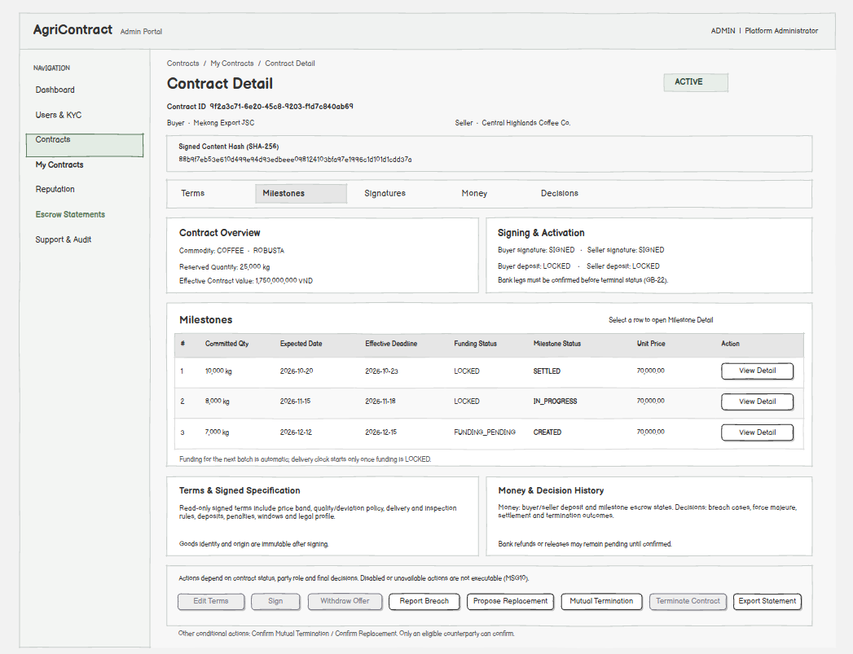
This screen allows the Buyer and Seller to:
- View the contract: see full terms, status, milestones with funding and delivery status, deposits, signature state, signed content hash and the decision history. (UC25)
- Edit terms: open Edit Contract Terms while the contract is OFFERED or NEGOTIATING and nobody has signed yet. (UC21, GB-20)
- Sign the contract: open Sign Contract. (UC22)
- Withdraw the offer: withdraw before the second signature, with no penalty (MSG49); the contract becomes WITHDRAWN and the reserved listing quantity is released. (UC24)
- Ask to cancel a contract whose deposit lock failed: confirm the cancel statement with an e-mail OTP (MSG94); withdraw the request until the refund starts. The contract ends with no penalty when both parties ask, or one asks after 5 business days. (UC29, GB-22)
- Propose or confirm mutual termination: one party proposes ending all remaining unsettled obligations (MSG50) and the other party confirms; deposits and locked milestone funds return to their owners with no penalty or reputation effect. The proposer cannot confirm their own proposal (MSG51). (UC26, GB-21)
- Propose or confirm replacement: open Propose Replacement Contract, or confirm the counterparty's replacement proposal. (UC27)
- Report a breach: open the Report Breach Dialog while the contract is ACTIVE. (UC40)
- Terminate the contract: open the Terminate Contract Dialog when a final decision allows termination. (UC54)
On the screen, the Buyer and Seller can also:
- Open a milestone: open Milestone Detail for a row in the Milestones tab. (UC25)
- Export a statement: open Export Escrow Statement. (UC28)
- See terminal progress: while money is being returned the contract stays in its current or pending status; it reaches a final status only after every bank leg is confirmed (GB-22). (UC25)
Field Name | Description
Status | Display; contract status (see 5.2.1). Edit Terms is shown only for OFFERED / NEGOTIATING before the first signature; Withdraw only before the second signature; mutual termination, replacement and breach report only while ACTIVE. An action that is no longer allowed in the current status shows MSG10
Signed Content Hash | Display; SHA-256 hash (64 hex characters) of the terms; empty until the first signature; both signatures must match this hash
Reserved Quantity (kg) | Display; quantity reserved on the listing; must equal the sum of milestone committed quantities for signing to succeed
Confirmation dialogs (withdraw, mutual termination) | No input fields; show the effect (no penalty, funds returned to owners) and "Confirm" / "Cancel"

5.2.3 Edit Contract Terms
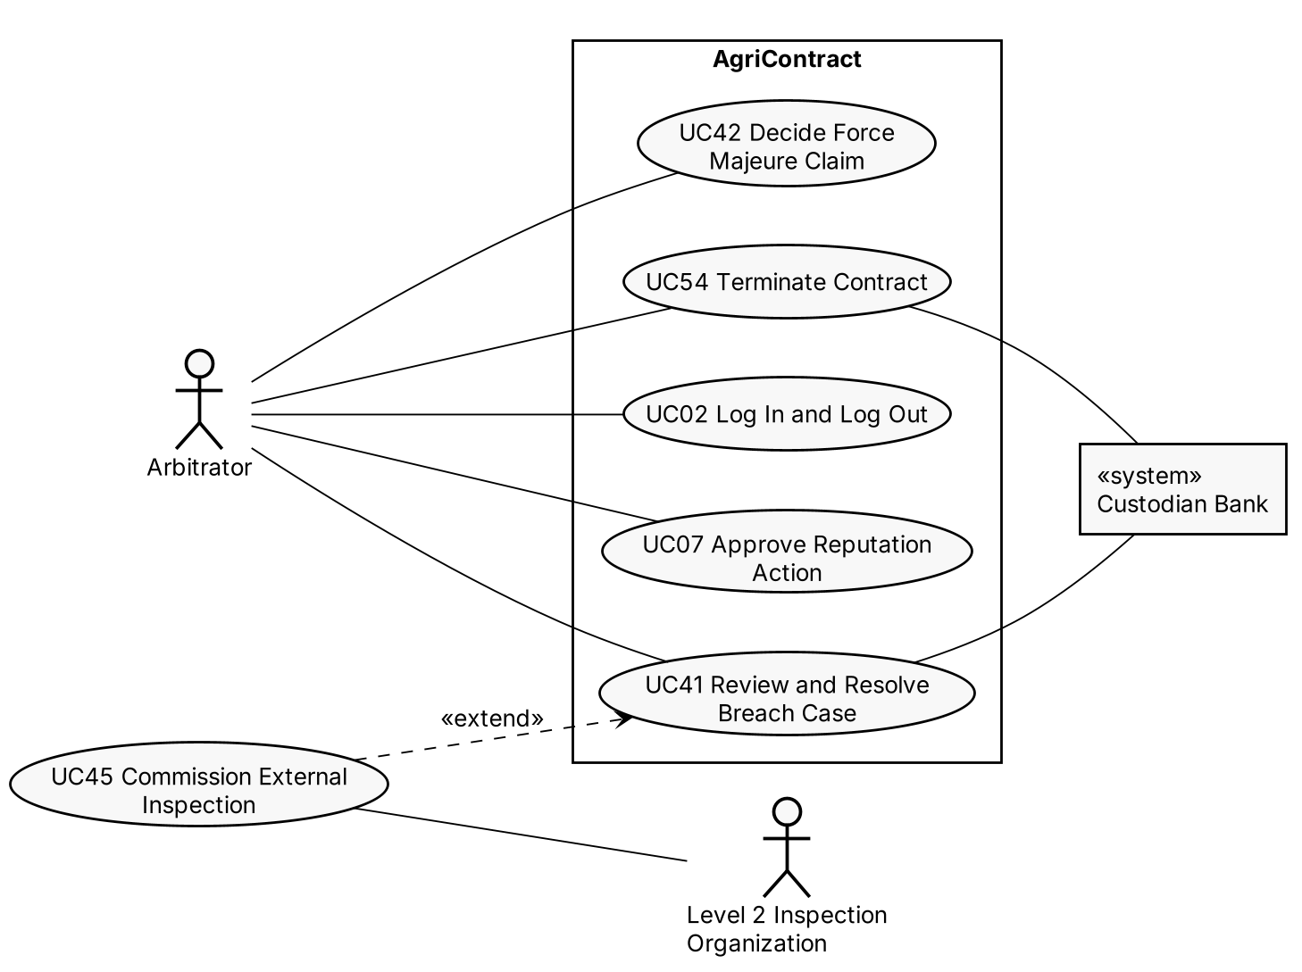
This screen allows the Buyer and Seller to:
- Edit terms: change any proposed term (price and band, milestone schedule, quality, delivery, inspection, rates, windows, legal profile) while the contract is OFFERED or NEGOTIATING. (UC21)
- Save terms: save the updated terms (MSG52); the contract moves to NEGOTIATING, the other party is notified, and any OTP issued for the old terms can no longer be used. (UC21)
- Cancel: discard changes. (UC21)
Field Name | Description
All term fields | Same data types, ranges and validation as 5.1.1
Save guard | Rejected once either party has signed (MSG53); rejected when the other party saved newer terms in the meantime (MSG54). Goods identity and origin cannot be changed; changing goods requires a replacement (GB-20)

5.3 Contract Signing

5.3.1 Sign Contract
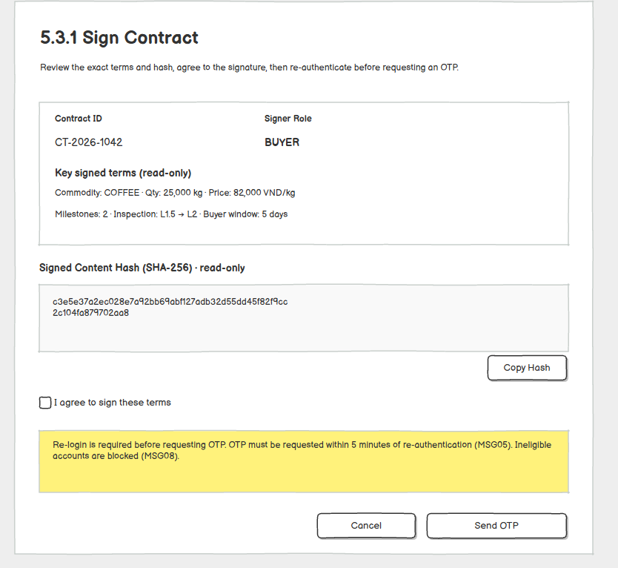
This screen allows the Buyer and Seller to:
- Review the hash: see the SHA-256 hash of the exact terms being signed; the same hash is included in the OTP email. (UC22, GB-23)
- Re-authenticate: log in again; the OTP must be requested within 5 minutes of this login, otherwise MSG05. (UC22)
- Request an OTP: ask the system to email a one-time code bound to the user, the contract and the current terms hash (MSG55); an ineligible user is blocked (MSG08). (UC22, GB-02)
Field Name | Description
Signer Role | Display; BUYER or SELLER, derived from the user's role in the contract
Signed Content Hash | Display; 64 hex characters
I agree to sign these terms | Checkbox; required; default unchecked

5.3.2 OTP Verification
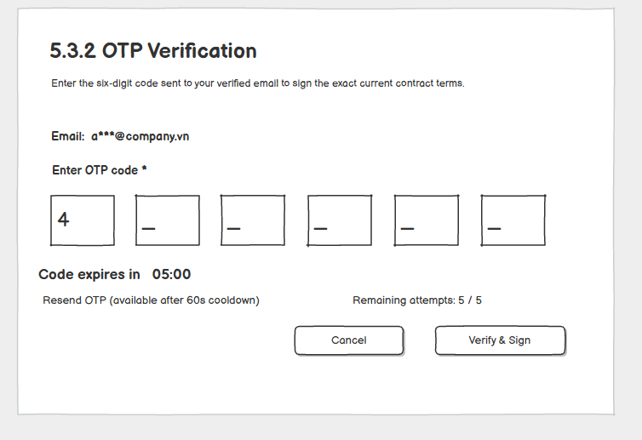
This screen allows the Buyer and Seller to:
- Verify the OTP and sign: enter the emailed code; on success the signature is recorded for the current terms hash (MSG56). When both parties have signed the same hash the contract becomes SIGNED, the terms are frozen and activation starts (MSG57). (UC22, UC23)
- Resend the OTP: request a new code; the previous code becomes invalid immediately. (UC22)
- Cancel: close the dialog without signing. (UC22)
Field Name | Description
OTP Code | Numeric; required; exactly 6 digits; expires 300 seconds after sending (MSG58); a wrong code shows MSG59; after 5 wrong attempts the code is locked and a new one must be requested (MSG60)
Resend OTP | Link; allowed after a 60-second cooldown; max 5 resends per hour (MSG61)
Countdown | Display; time remaining until the OTP expires
Other rejections | Terms changed after the OTP was issued or the second signature's hash does not match the first (MSG62); committed quantities no longer equal the reserved quantity (MSG63); nothing is signed in these cases

5.4 Contract Replacement

5.4.1 Propose Replacement Contract
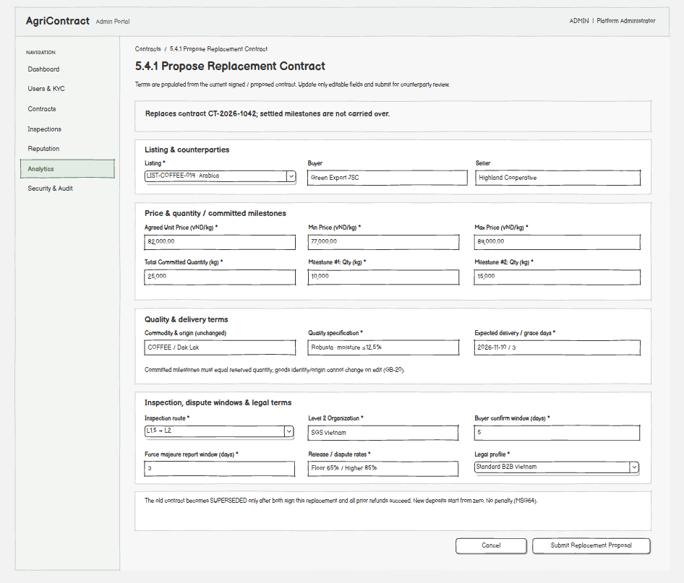
This screen allows the Buyer and Seller to:
- Propose a replacement: submit new terms for a replacement contract while the current contract is ACTIVE; a new draft contract linked to the current one is created and the other party is notified (MSG64). (UC27)
- Understand the effect: the old contract is closed as SUPERSEDED only after the new contract is signed by both parties and every refund on the old contract is confirmed; the new contract locks its own deposits from zero, with no penalty for either side. (UC27, GB-21, GB-22)
Field Name | Description
Listing | Selection; required; defaults to the current contract's listing
All term fields | Same data types, ranges and validation as 5.1.1

5.5 Escrow Statement

5.5.1 Export Escrow Statement
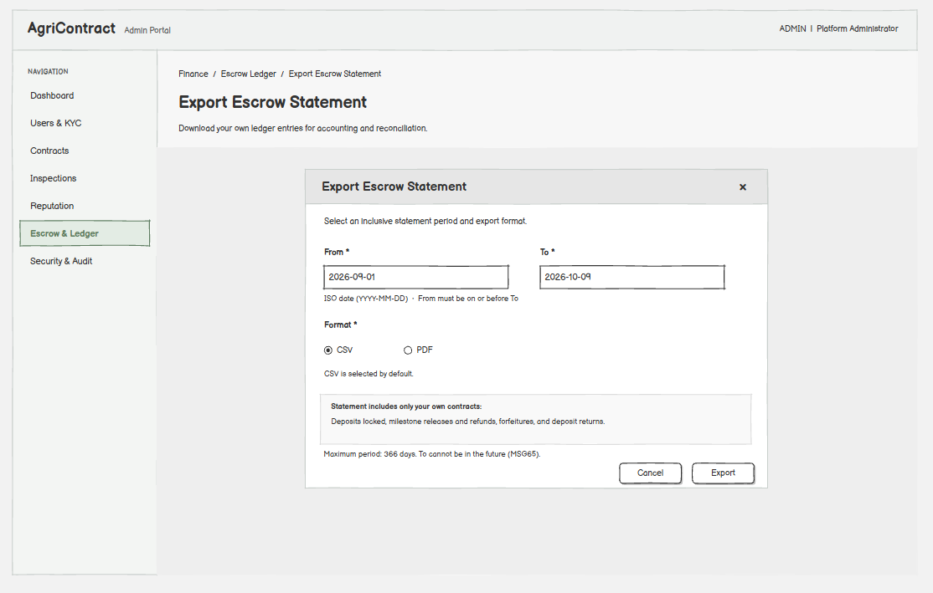
This screen allows the Buyer and Seller to:
- Export a statement: download a statement of the money movements of their own contracts for a period, for reconciliation with their accounting. (UC28, GB-24)
Field Name | Description
From | ISO date; required; must be ≤ To
To | ISO date; required; not in the future; range max 366 days; an invalid range shows MSG65
Format | Radio; CSV or PDF; default CSV

6. Milestone & Delivery

6.1 Milestone Tracking

6.1.1 Milestone Detail
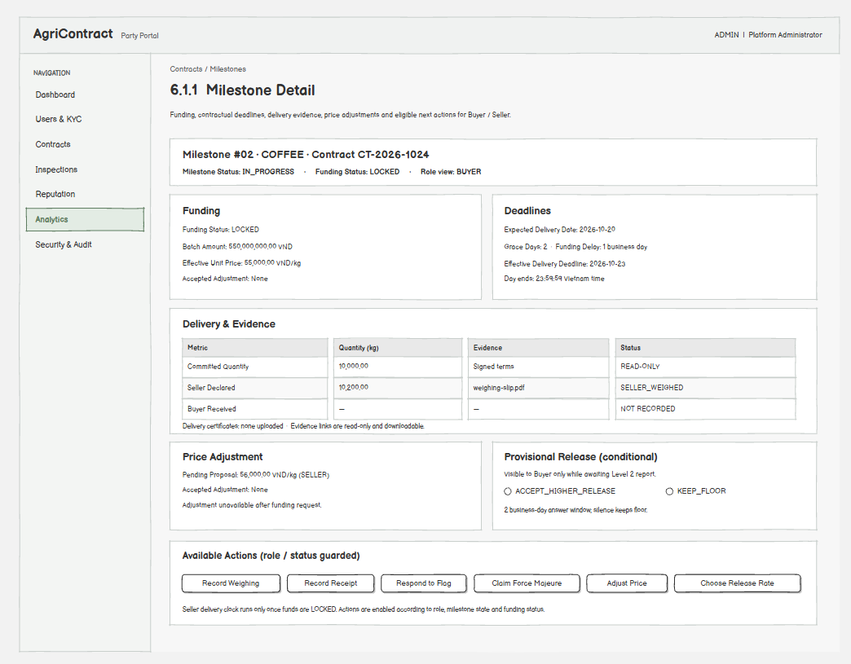
This screen allows the Buyer and Seller to:
- View the milestone: see milestone status, funding status, amounts, deadlines and delivery evidence. (UC25)
- Track funding: the system requests the batch amount lock from the Buyer's account when the milestone becomes the next one to fund; both parties see whether it is FUNDING_PENDING, LOCKED or FUNDING_FAILED (MSG66). The Buyer keeps funds available; there is no manual payment step. The Seller's delivery clock runs only once funding is LOCKED. (UC30, GB-25)
- Start delivery actions: open Record Weighing (Seller), Record Receipt (Buyer), Respond to Flag (Seller) or Claim Force Majeure (Seller), as allowed by role and status. (UC32, UC33, UC36, UC37)
- Start a price adjustment: open Milestone Price Adjustment while it is still allowed. (UC31)
On the screen, the Buyer can also:
- Choose the provisional release rate: when no confirmed Level 2 report has arrived within the buffer window, accept the higher release rate (85%) or keep the floor rate; silence until the window ends keeps the floor rate (Dispute Floor Release Rate). (UC41, GB-26)
Field Name | Description
Milestone Status | Display; CREATED, IN_PROGRESS, SELLER_WEIGHED, BUYER_RECEIVED, AWAITING_SELLER_RESPONSE, CONTESTED, FORCE_MAJEURE_PENDING_REVIEW, SETTLED
Funding Status | Display; FUNDING_PENDING, LOCKED, FUNDING_FAILED
Batch Amount (VND) | Display; committed quantity × effective unit price, fixed at the funding request
Effective Unit Price (VND/kg) | Display; accepted adjusted price if any, otherwise the agreed price
Effective Delivery Deadline | Display; ISO date = expected delivery date + funding delay business days + grace days; ends 23:59:59 Vietnam time
Release Rate Choice | Data type: radio; shown to the Buyer only in the provisional-release step; allowed values ACCEPT_HIGHER_RELEASE, KEEP_FLOOR; no default; answer window 2 business days

6.2 Delivery Recording

6.2.1 Record Weighing
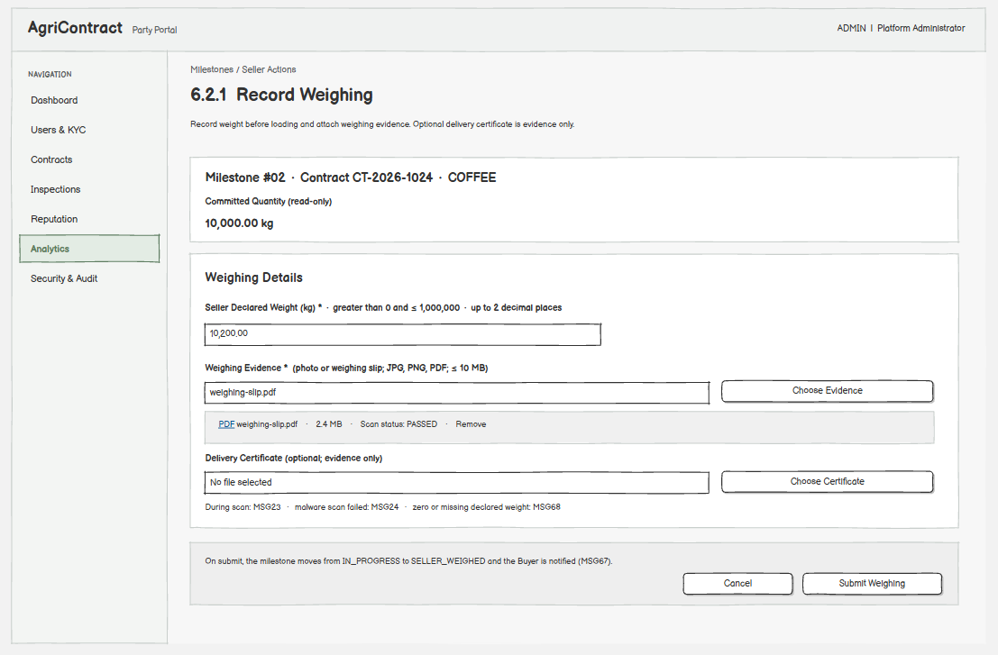
This screen allows the Seller to:
- Record weighing: declare the weight weighed before loading, with evidence; the milestone moves from IN_PROGRESS to SELLER_WEIGHED and the Buyer is notified (MSG67). (UC32)
- Upload evidence: attach the weighing evidence and, optionally, a delivery certificate; only files that pass the scan can be attached. (UC38, GB-03)
Field Name | Description
Seller Declared Weight (kg) | Decimal; required; > 0 and ≤ 1,000,000; up to 2 decimals; 0 or empty shows MSG68
Weighing Evidence | File; required; JPG, PNG or PDF; max 10 MB; while scanning shows MSG23, a failed scan shows MSG24
Delivery Certificate | File; optional; JPG, PNG or PDF; max 10 MB; evidence only, not used as a quality measurement

6.2.2 Record Receipt
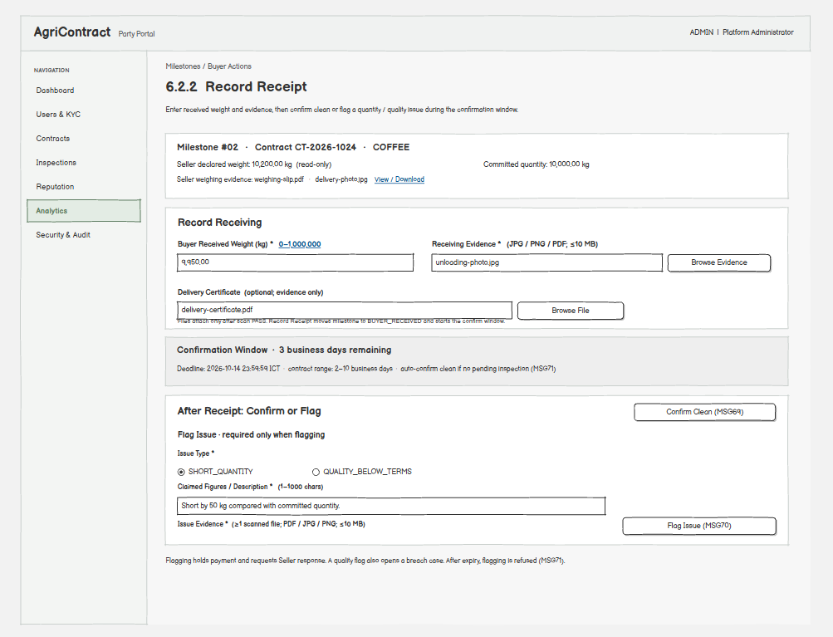
This screen allows the Buyer to:
- Record the received weight: declare the weight weighed at unloading, with evidence; the milestone moves to BUYER_RECEIVED and the confirmation window starts. (UC33)
- Confirm clean: accept the batch (MSG69); the system settles the milestone, pays the Seller and returns any unpayable part to the Buyer, sharing transit loss within the tolerance rate. A shortfall beyond the contract threshold opens a breach case instead of an automatic penalty. (UC34, GB-27)
- Flag an issue: report a short quantity or a quality problem with the claimed figures and evidence; the payment is held, the milestone moves to AWAITING_SELLER_RESPONSE and the Seller is asked to respond (MSG70). A quality issue also opens a breach case. (UC35, GB-28)
- Understand auto-confirm: if neither action is taken within the Buyer Confirm Window, the system confirms clean automatically, unless an inspection is pending; after the window a flag is refused (MSG71). (UC34, GB-29)
Field Name | Description
Buyer Received Weight (kg) | Decimal; required; ≥ 0 and ≤ 1,000,000; up to 2 decimals
Receiving Evidence | File; required; JPG, PNG or PDF; max 10 MB
Delivery Certificate | File; optional; JPG, PNG or PDF; max 10 MB; evidence only
Confirm Window | Display; deadline for confirm or flag in business days (2–10 per contract), ending 23:59:59 Vietnam time
Flag Issue
Issue Type | Data type: radio; required when flagging; allowed values SHORT_QUANTITY, QUALITY_BELOW_TERMS
Claimed Figures / Description | Data type: text; 1–1000 characters; required when flagging; the quantity or quality problem the Buyer claims
Issue Evidence | File list; at least 1 file required (MSG72); JPG, PNG or PDF; max 10 MB each

6.3 Delivery Issue Handling

6.3.1 Respond to Flag
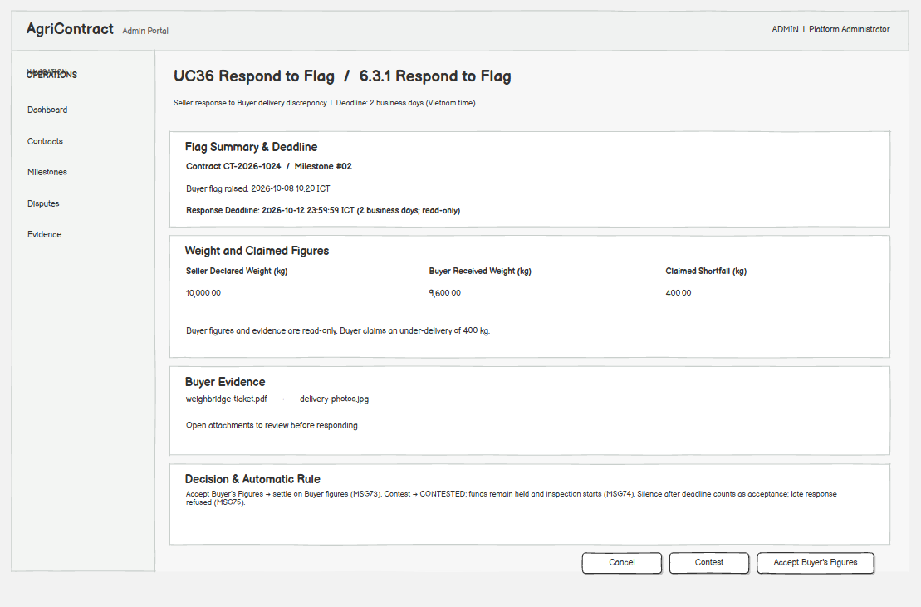
This screen allows the Seller to:
- Accept the flag: accept the Buyer's figures (MSG73); the milestone is settled on the Buyer's figures. (UC36)
- Contest the flag: dispute the Buyer's claim; the milestone becomes CONTESTED, the payment stays held and the dispute is routed to inspection (MSG74). (UC36, GB-30)
- See the response deadline: silence for 2 business days after the flag counts as acceptance of the Buyer's figures; after the deadline the screen refuses a response (MSG75). (UC36, GB-31)
Field Name | Description
Response Deadline | Display; flag time + 2 business days, ending 23:59:59 Vietnam time
Buyer Received Weight / Claimed Figures / Evidence | Display; read-only
Decision | Buttons; ACCEPT or CONTEST

6.3.2 Claim Force Majeure
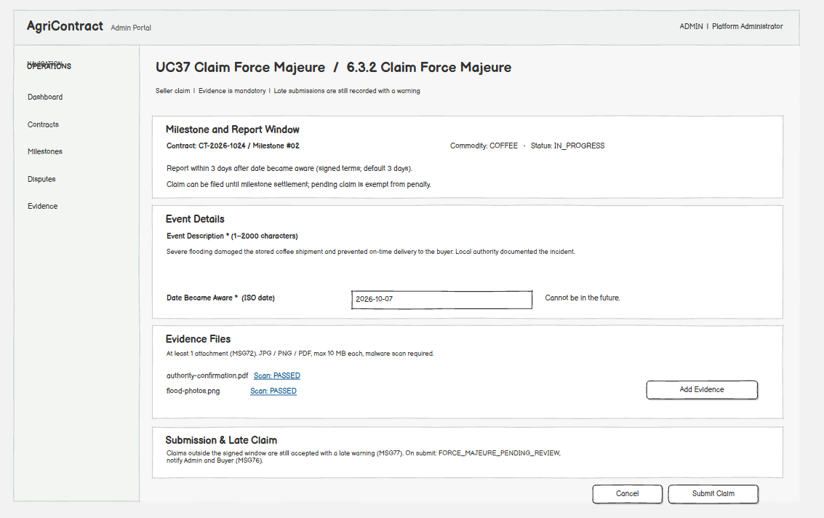
This screen allows the Seller to:
- Claim force majeure: submit a claim with evidence at any time from IN_PROGRESS until the milestone is settled; the milestone moves to FORCE_MAJEURE_PENDING_REVIEW, and the Arbitrator and Buyer are notified (MSG76). No penalty applies while the claim is pending. (UC37, GB-32)
- Upload evidence: attach proof of the event; at least one file is required (MSG72). (UC38)
- Be warned of a late claim: a claim after the report window is still recorded with a warning (MSG77), and the Arbitrator takes the delay into account. (UC37)
Field Name | Description
Event Description | Data type: text; 1–2000 characters; required
Date Became Aware | Data type: ISO date; required; not in the future
Evidence Files | File list; required (≥ 1); JPG, PNG or PDF; max 10 MB each; must pass the scan
Report Window | Display; Force Majeure Report Window days from the contract (default 3), counted from the date the Seller became aware

6.4 Milestone Price Adjustment

6.4.1 Milestone Price Adjustment
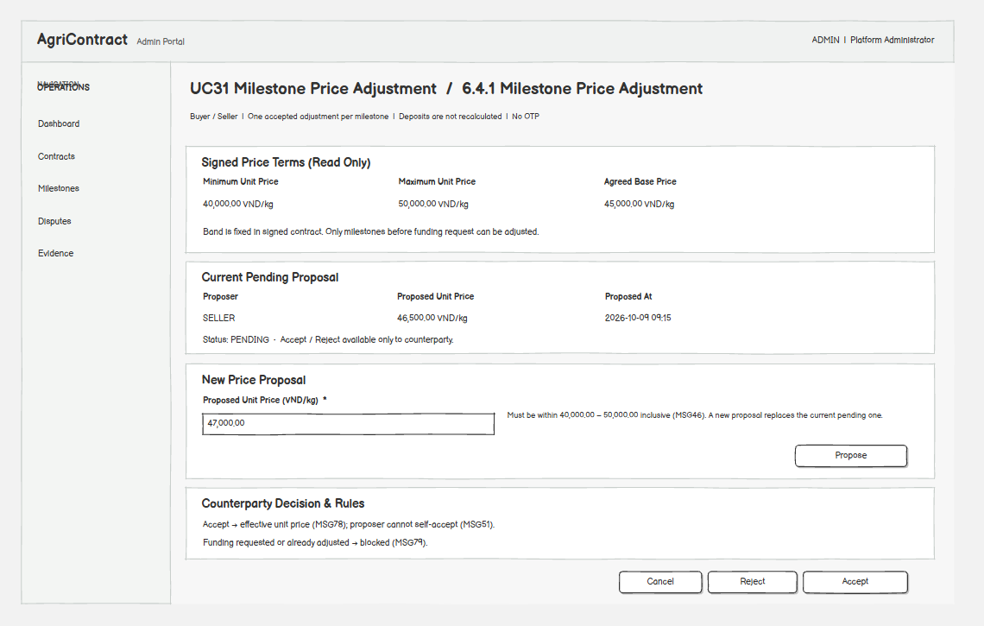
This screen allows the Buyer and Seller to:
- Propose a price: propose a new unit price within the signed band for a milestone whose funding has not been requested yet; a new proposal replaces the pending one. (UC31, GB-16)
- Accept or reject a price: the counterparty accepts the pending proposal (MSG78) or rejects it; the accepted price becomes the milestone's effective unit price. The proposer cannot accept their own proposal (MSG51). (UC31)
- See the limits: only one accepted adjustment per milestone, no OTP, and deposits are not recalculated. (UC31)
Field Name | Description
Proposed Unit Price (VND/kg) | Money (decimal, 2 decimals); required; within [Minimum Unit Price, Maximum Unit Price] inclusive (MSG46)
Price Band | Display; signed minimum and maximum unit price
Pending Proposal | Display; proposer, proposed price, proposed at, status PENDING
Cutoff | Guard; propose and accept are rejected once the milestone's funding request has been issued or an adjustment was already accepted (MSG79)

7. Dispute & Inspection

7.1 Breach Reporting

7.1.1 Report Breach Dialog
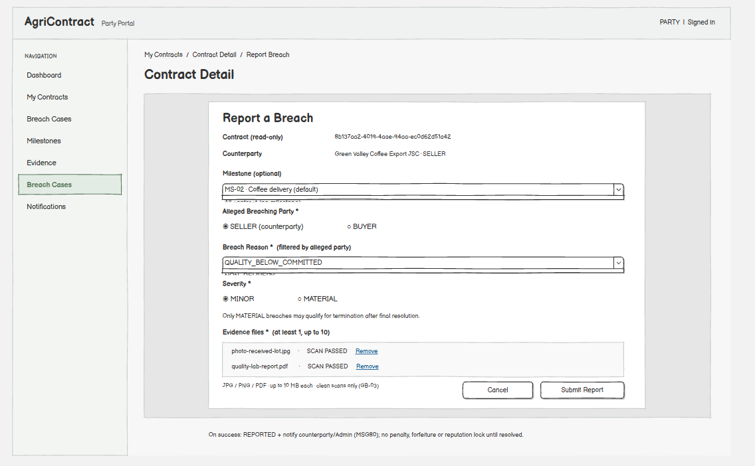
This screen allows the Buyer and Seller to:
- Report a breach: submit an allegation that the counterparty breached the contract, for the whole contract or for one milestone; the case opens in status REPORTED, the other party and the Arbitrator are notified, and no penalty, forfeiture or reputation lock is applied until the case is resolved (MSG80). (UC40, GB-28)
- Attach evidence: upload photos or documents; only files that pass the scan can be attached. (UC38, GB-03)
- Remove an attached file: remove an evidence file before submitting. (UC38)
- Cancel: close the dialog without creating a case. (UC40)
Field Name | Description
Contract | Data type: text (read-only); pre-filled with the current contract; the reporter must be its Buyer or Seller
Milestone | Data type: dropdown of the contract's milestones; optional; empty = contract-level breach
Alleged Breaching Party | Data type: radio; required; allowed values BUYER, SELLER; default: the counterparty's role
Breach Reason | Data type: dropdown; required; values filtered by the alleged party. Seller: NON_DELIVERY, SHORTFALL, LATE_DELIVERY, QUALITY_BELOW_COMMITTED, SIDE_SELLING, PRODUCTION_SHOCK_NON_FM. Buyer: FUNDING_FAILURE, LATE_PAYMENT, FAILURE_TO_RECEIVE, WRONGFUL_REJECTION. A reason that does not match the party shows MSG81
Severity | Data type: radio; required; allowed values MINOR, MATERIAL; default MINOR; hint: only a MATERIAL breach can lead to termination
Evidence Files | Data type: file list; at least 1 file required (MSG72); max 10 files; each JPG, PNG or PDF, max 10 MB

7.1.2 Breach Case Detail (Party View)
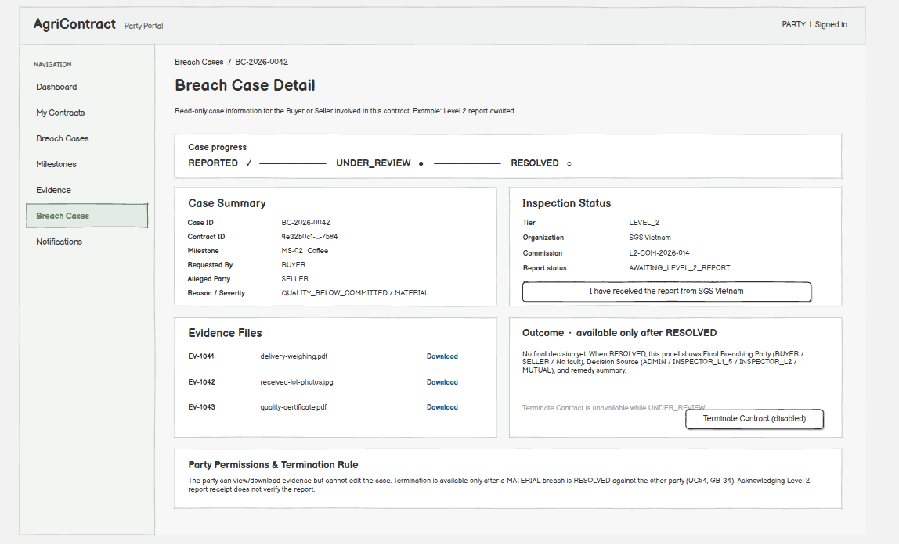
This screen allows the Buyer and Seller to:
- View the case status: see the current status, reason, severity, who reported and the alleged party. (UC40)
- View and download evidence: open the evidence files attached to the case. (UC38)
- View the outcome: after resolution, see the final breaching party (or "No fault"), the decision source and the resulting remedy summary. (UC40, GB-33)
- Acknowledge receipt of a Level 2 report: declare that the report was received directly from the Level 2 organization; the system records only the party's statement (MSG82). (UC40)
- Request termination: after a MATERIAL breach is resolved against the other party, open the Terminate Contract Dialog. (UC54, GB-34)
- Contest the decision: the party found at fault on a milestone-level case can contest once before the contest deadline; the case then goes to a Level 1.5 inspection whose result is final, unless the decision already rests on an inspection report. (UC41, GB-50)
Field Name | Description
Status | Data type: label; allowed values REPORTED, UNDER_REVIEW, RESOLVED
Requested By | Data type: label; allowed values BUYER, SELLER, SYSTEM
Final Breaching Party | Data type: label; shown only when RESOLVED; allowed values BUYER, SELLER, or "No fault"
Decision Source | Data type: label; shown only when RESOLVED; allowed values ARBITRATOR, INSPECTOR_L1_5, INSPECTOR_L2, MUTUAL
Contest Status | Data type: label; shown only when RESOLVED; allowed values NOT_APPLICABLE (contract-level case or no sanction), OPEN, CONTESTED, EXPIRED
Contest Deadline | Data type: date-time (read-only); shown while Contest Status is OPEN; resolution time + 2 business days, ending 23:59:59 Vietnam time

7.2 Breach Case Management

7.2.1 Breach Case Queue
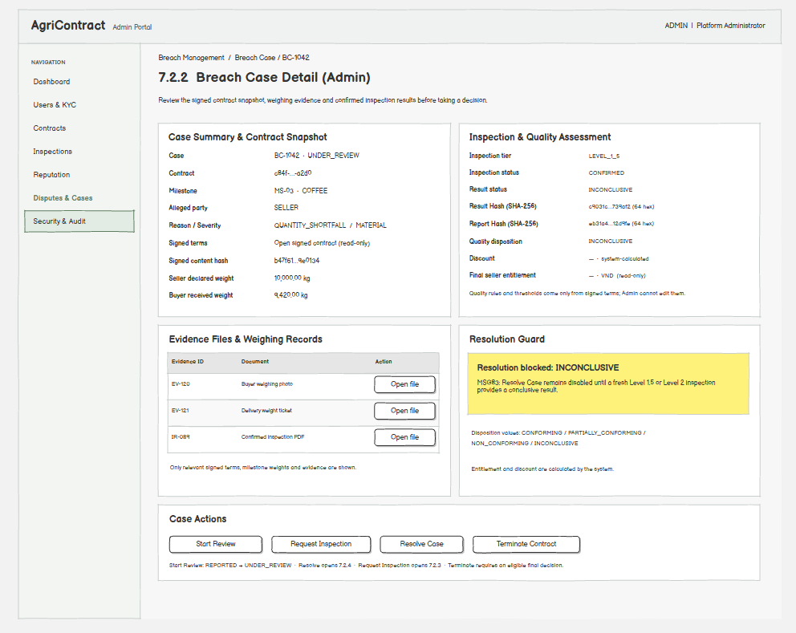
This screen allows the Arbitrator to:
- Browse open cases: list breach cases, newest first, defaulting to cases not yet RESOLVED. (UC41)
- Filter and search: narrow the list by status, severity, reason, requester or contract ID. (UC41)
- Open a case: go to Breach Case Detail (Arbitrator). (UC41)
Field Name | Description
Status | Data type: multi-select; optional; allowed values REPORTED, UNDER_REVIEW, RESOLVED; default REPORTED + UNDER_REVIEW
Severity | Data type: dropdown; optional; allowed values All, MINOR, MATERIAL; default All
Reason | Data type: dropdown; optional; the breach reasons listed in 7.1.1 plus All; default All
Requested By | Data type: dropdown; optional; allowed values All, BUYER, SELLER, SYSTEM; default All
Contract ID | Data type: text (UUID); optional; exact match; an invalid format shows MSG48

7.2.2 Breach Case Detail (Arbitrator)
This screen allows the Arbitrator to:
- Start the review: move a REPORTED case to UNDER_REVIEW. (UC41)
- Review evidence: open evidence files, the signed terms and the milestone weighing records. (UC41)
- Request an inspection: open the Request Inspection Dialog. (UC41, UC45)
- Check quality results: for a quality dispute, see the confirmed inspection result and the disposition calculated by the system from the signed quality terms; the Arbitrator only confirms this result and cannot change thresholds or add criteria. (UC41, GB-17)
- Resolve the case: open the Resolve Breach Case Dialog. (UC41)
- Terminate the contract: open the Terminate Contract Dialog after a final decision. (UC54)
On the screen, the Arbitrator can also:
- See why resolution is blocked: while the quality result is INCONCLUSIVE, Resolve is disabled until a new inspection or a Level 2 inspection gives a conclusive result (MSG83). (UC41)
Field Name | Description
Quality Disposition | Data type: label (read-only, calculated); allowed values CONFORMING, PARTIALLY_CONFORMING, NON_CONFORMING, INCONCLUSIVE; shown only for quality cases
Final Seller Entitlement | Data type: decimal, 2 decimals, VND (read-only, calculated)
Result Hash / Report Hash | Data type: text, 64 hex characters (read-only); integrity hashes of the confirmed inspection report

7.2.3 Request Inspection Dialog
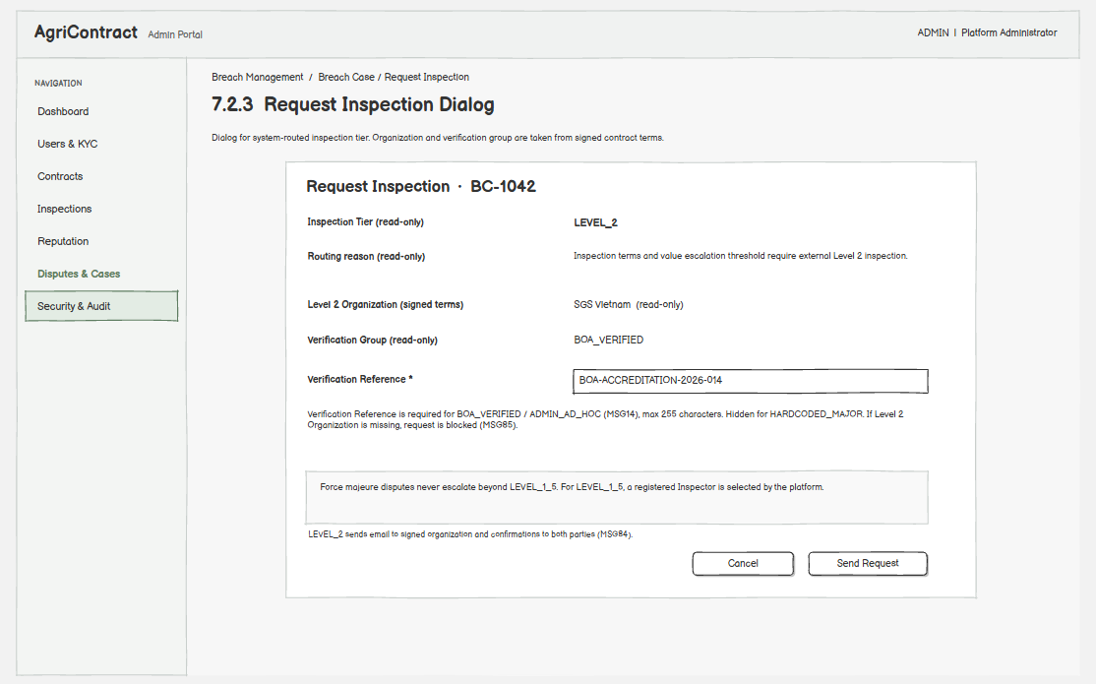
This screen allows the Arbitrator to:
- Request a Level 1.5 inspection: send the case to a platform-registered Level 1.5 Inspector selected by the system. (UC41, GB-30)
- Commission a Level 2 inspection: create a commission to the Level 2 organization named in the signed terms; the system emails the organization (with the platform intake address) and sends confirmations to the Buyer and Seller (MSG84). (UC45)
- Cancel: close without requesting. (UC41)
Field Name | Description
Inspection Tier | Data type: label (read-only); allowed values LEVEL_1_5, LEVEL_2; set by the contract's inspection terms and escalation thresholds; force majeure disputes are always capped at LEVEL_1_5
Level 2 Organization | Data type: text (read-only); taken from the signed terms; cannot be typed by the Arbitrator; if empty, Level 2 cannot be requested (MSG85)
Verification Group | Data type: label (read-only); allowed values HARDCODED_MAJOR, BOA_VERIFIED, ARBITRATOR_AD_HOC
Verification Reference | Data type: text; max 255 characters; required when Verification Group is BOA_VERIFIED or ARBITRATOR_AD_HOC (MSG14); hidden for HARDCODED_MAJOR

7.2.4 Resolve Breach Case Dialog
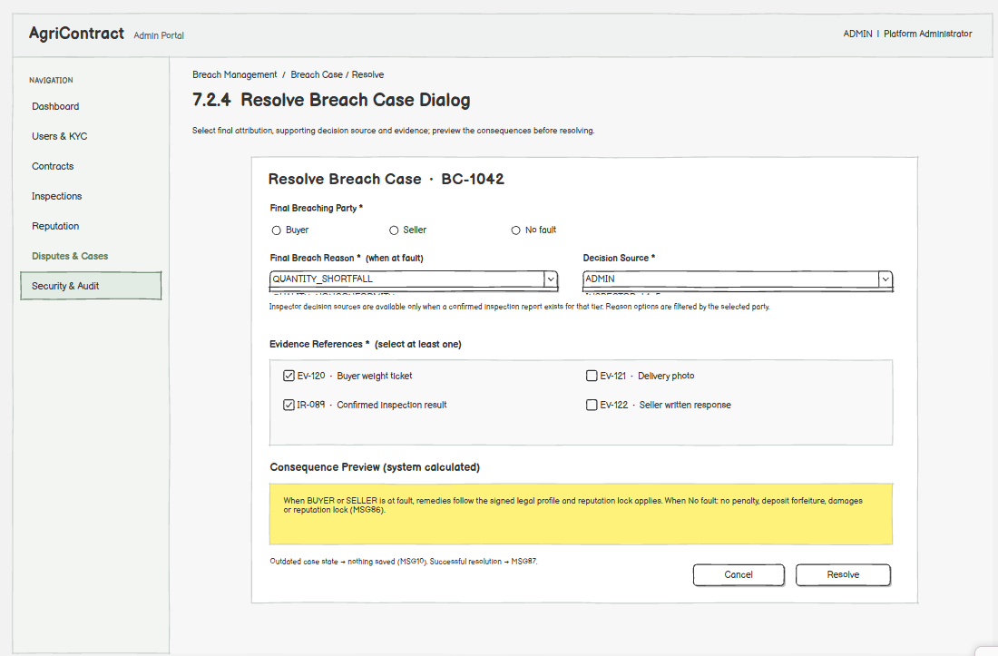
This screen allows the Arbitrator to:
- Select the final breaching party: choose BUYER, SELLER or No fault; No fault means no penalty, no deposit forfeiture, no damages and no reputation lock (MSG86). (UC41, GB-33)
- Select the decision source and evidence: record who made the attribution and the files and reports it relies on. (UC41)
- Resolve: close the case as RESOLVED; the system records the decision in the audit chain and notifies both parties (MSG87); the remedy is calculated from the legal profile, and for a milestone-level case that brings a penalty, deposit forfeiture or reputation lock it is executed only after the 2-business-day contest window (GB-50). A case changed in the meantime shows MSG10. (UC41, GB-19, GB-35)
Field Name | Description
Final Breaching Party | Data type: radio; required; allowed values BUYER, SELLER, No fault (null); no default
Final Breach Reason | Data type: dropdown; required when a party is at fault; same values as 7.1.1, filtered by the party; default: the reported reason
Decision Source | Data type: dropdown; required; allowed values ARBITRATOR, INSPECTOR_L1_5, INSPECTOR_L2, MUTUAL; INSPECTOR_L1_5 / INSPECTOR_L2 selectable only when a confirmed report of that tier exists
Evidence References | Data type: multi-select of file and report IDs; required, at least 1

7.3 Contract Termination

7.3.1 Terminate Contract Dialog
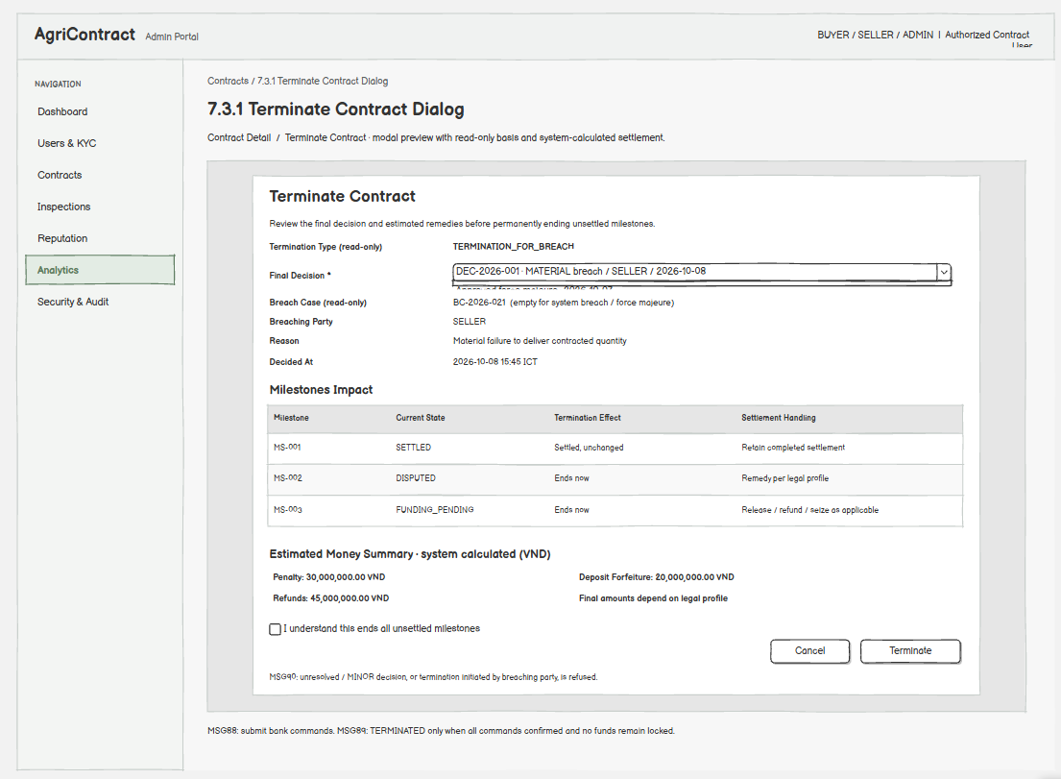
This screen allows the Buyer, Seller and Arbitrator to:
- Review the basis: see the final decision the termination relies on: a breach case resolved as a MATERIAL breach with a breaching party, a breach recorded automatically by the system (for example a Buyer funding failure after the cure window), or an approved force majeure claim. (UC54, GB-34)
- See the effect: settled milestones stay as they are, unsettled milestones end, and the penalty, deposit forfeiture or refunds follow the contract's legal profile; for force majeure there is no penalty and payment follows the quantity actually delivered. (UC54, GB-19)
- Terminate: confirm the termination (MSG88); the system calculates the remedy and sends the release, refund and seize commands to the bank. The contract becomes TERMINATED only when every command is confirmed and nothing remains locked (MSG89). (UC54, GB-22)
On the screen, the user can also:
- See why termination is not allowed: when the case is not resolved, was resolved as MINOR, or the user is the breaching party, the action is refused (MSG90). (UC54)
Field Name | Description
Termination Type | Data type: label (read-only); derived from the decision; allowed values TERMINATION_FOR_BREACH, TERMINATION_FOR_FORCE_MAJEURE
Decision | Data type: dropdown of the contract's final decisions that allow termination; required; pre-selected when opened from a case (sent as attributionDecisionId)
Breach Case | Data type: label (read-only); empty for a system-recorded breach or force majeure
Money Summary | Display; amounts in VND, 2 decimals, calculated by the system; informational
I understand this ends all unsettled milestones | Checkbox; required; default unchecked

7.4 Force Majeure Review

7.4.1 Force Majeure Review Queue
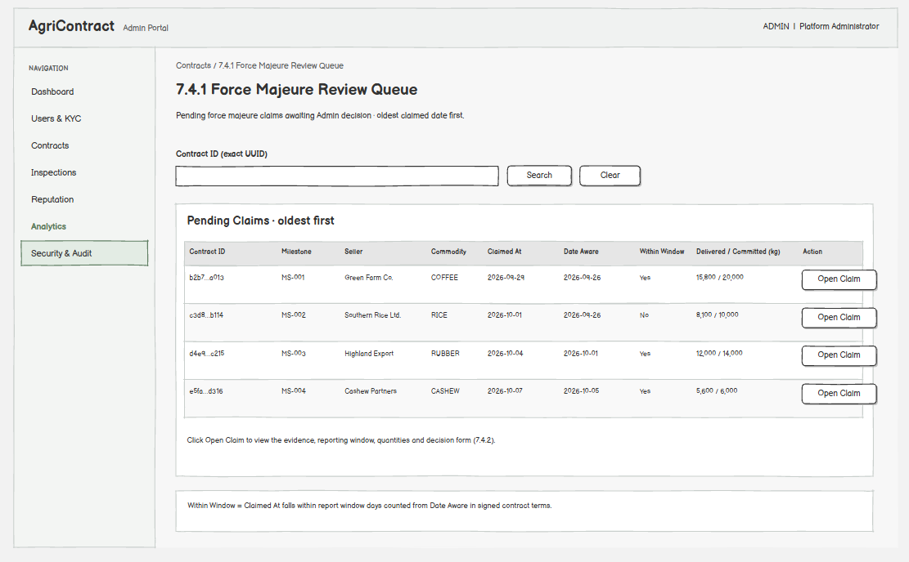
This screen allows the Arbitrator to:
- List pending claims: see all milestones waiting for a force majeure decision, oldest first. (UC42)
- Open a claim: go to Force Majeure Claim Detail. (UC42)
Field Name | Description
Contract ID | Data type: text (UUID); optional search filter; exact match
Within Window | Display; Yes when the claim was filed within the contract's report window counted from the date aware

7.4.2 Force Majeure Claim Detail
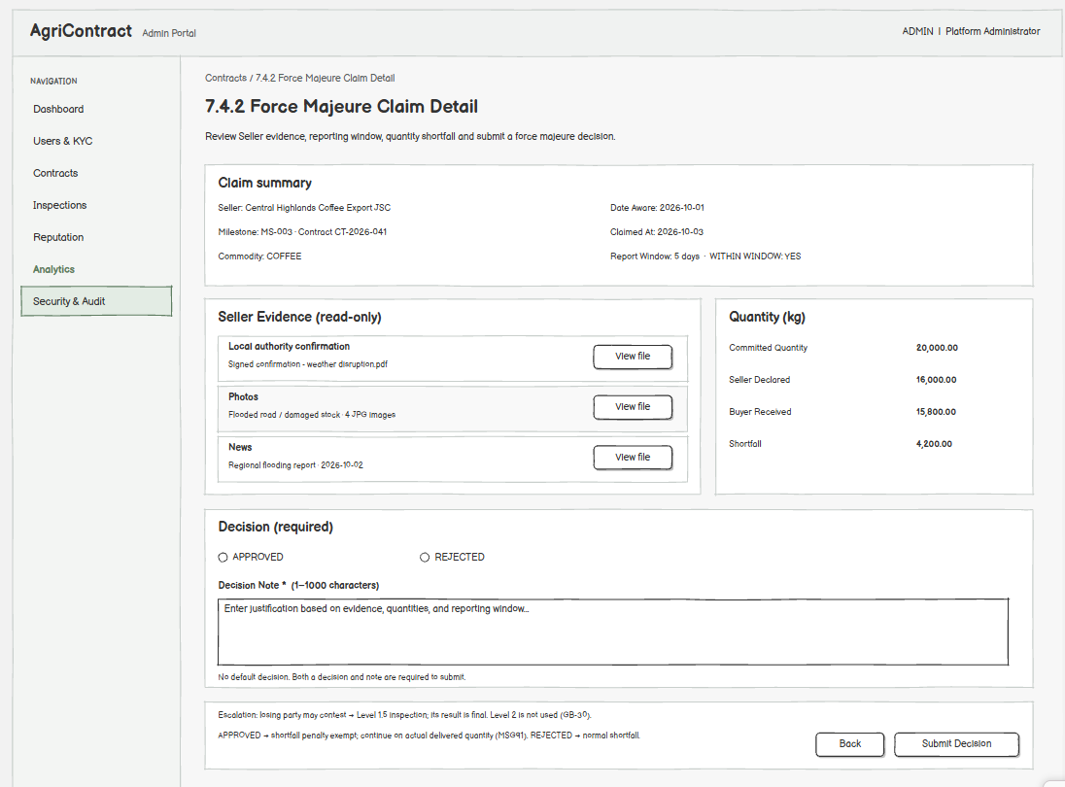
This screen allows the Arbitrator to:
- Review evidence: open the evidence submitted by the Seller. (UC42)
- Check the reporting window: see whether the claim was filed within the contract's force majeure report window. (UC42)
- Approve the claim: accept force majeure; the shortfall on this milestone is exempt from penalty and the milestone continues with the quantity actually delivered (MSG91). (UC42, GB-32)
- Reject the claim: refuse force majeure; the shortfall is handled as a normal shortfall. (UC42)
On the screen, the Arbitrator can also:
- See the escalation rule: the losing party may contest the decision, which sends the claim to a Level 1.5 inspection whose result is final; Level 2 is not used for force majeure. (UC42, GB-30)
Field Name | Description
Decision | Data type: radio; required; allowed values APPROVED, REJECTED; no default
Decision Note | Data type: text; 1–1000 characters; required
Force Majeure Report Window | Data type: integer days (read-only); from the signed contract terms

7.5 Contract Operations

7.5.1 Activation Failures
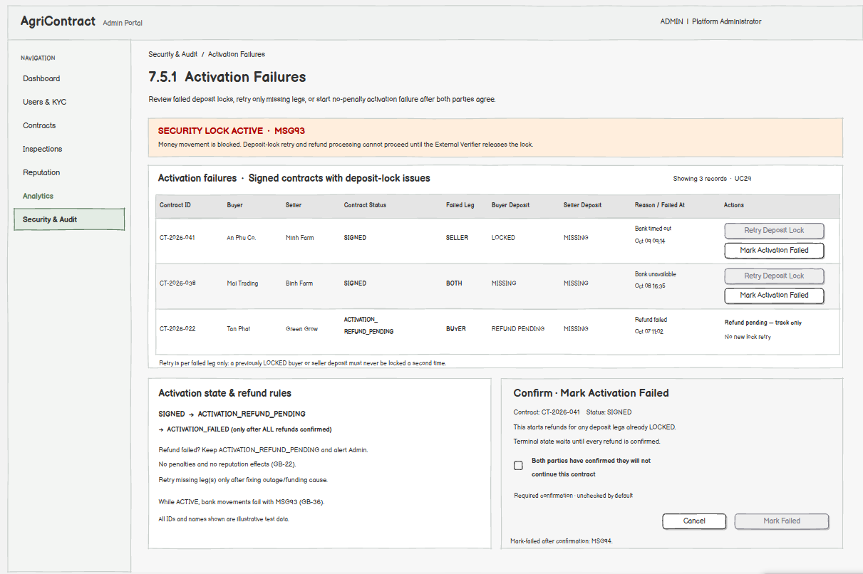
This screen allows the Operator to:
- View contracts that failed activation: list signed contracts whose deposit lock failed after automatic retries. (UC29)
- Retry the deposit lock: re-run the lock only for the deposit leg still missing, after the cause is fixed (MSG92); while the security lock is ACTIVE the screen shows MSG93. (UC29, GB-36)
- View cancel requests: see which party asked to cancel and from when one party's request is enough; the Operator cannot cancel the contract, the parties decide (D42). (UC29)
- Track refunds: see contracts held in ACTIVATION_REFUND_PENDING because a refund failed. (UC29)
Field Name | Description
Failed Leg | Data type: label; allowed values BUYER, SELLER, BOTH
Buyer / Seller Deposit State | Data type: label; shows for each deposit leg whether it is locked or still missing; only the missing leg is retried
Cancel Requests | Data type: label; the parties that asked to cancel and oneSidedCancelAllowedFrom, the time from which one party's request is enough

7.5.2 Milestone Funding Failures
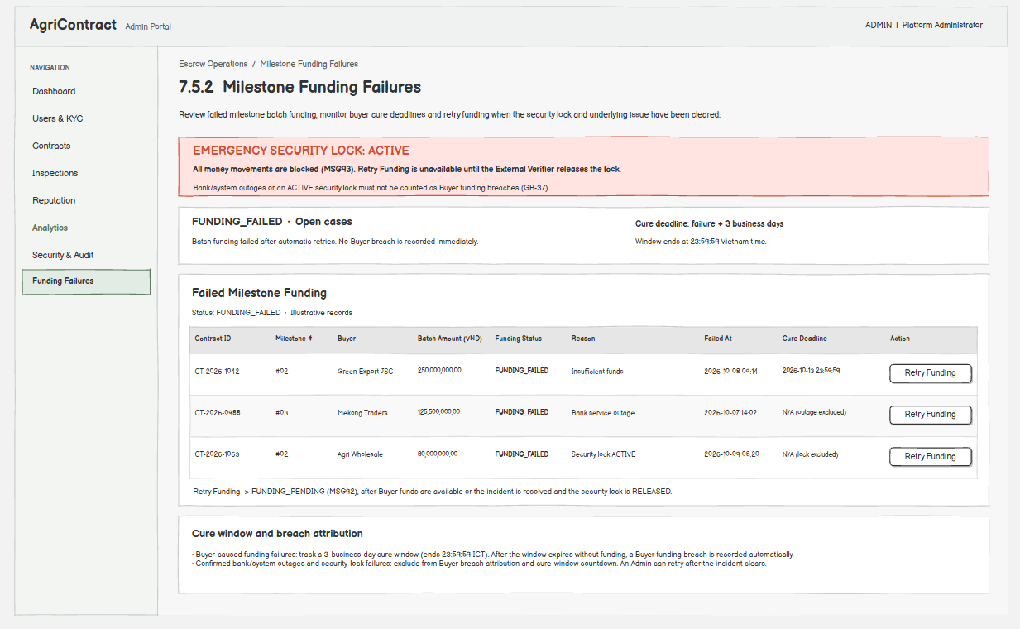
This screen allows the Operator to:
- View failed milestone funding: list milestones whose batch amount could not be locked after automatic retries. (UC39)
- Retry milestone funding: restart the funding lock after the Buyer confirms funds are available or after a bank or system outage is resolved; the milestone returns to FUNDING_PENDING (MSG92). Failures caused by an outage or the security lock are not counted against the Buyer. (UC39, GB-37)
- Monitor the cure deadline: see when the Buyer's cure window ends, after which the system records a Buyer funding breach automatically. (UC39)
Field Name | Description
Cure Deadline | Data type: date-time (read-only); failure time + 3 business days, ending 23:59:59 Vietnam time
Batch Amount | Data type: decimal, 2 decimals, VND (read-only)

7.6 Level 1.5 Inspection

7.6.1 Assigned Cases
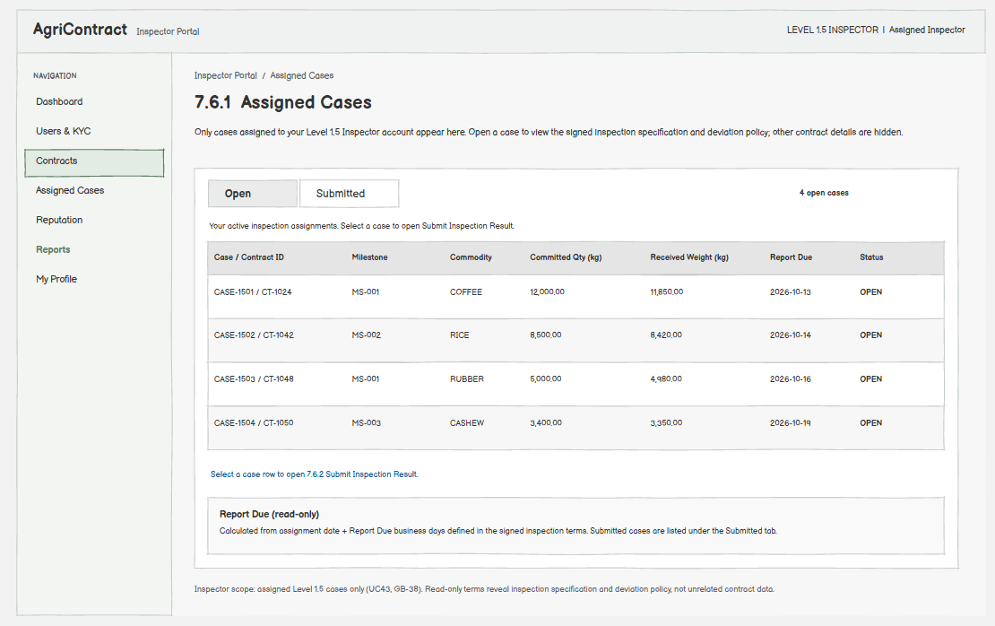
This screen allows the Inspector to:
- View assigned cases: see only the cases assigned to the logged-in Level 1.5 Inspector. (UC43, GB-38)
- See what to measure: open a case to see the committed quality specification and deviation policy from the signed terms; other contract data is not shown. (UC43)
- Track due dates: see the report due date from the contract's inspection terms. (UC43)
Field Name | Description
Status | Data type: tab filter; allowed values Open, Submitted; default Open
Report Due | Data type: date (read-only); assignment date + Report Due business days from the inspection terms

7.6.2 Submit Inspection Result
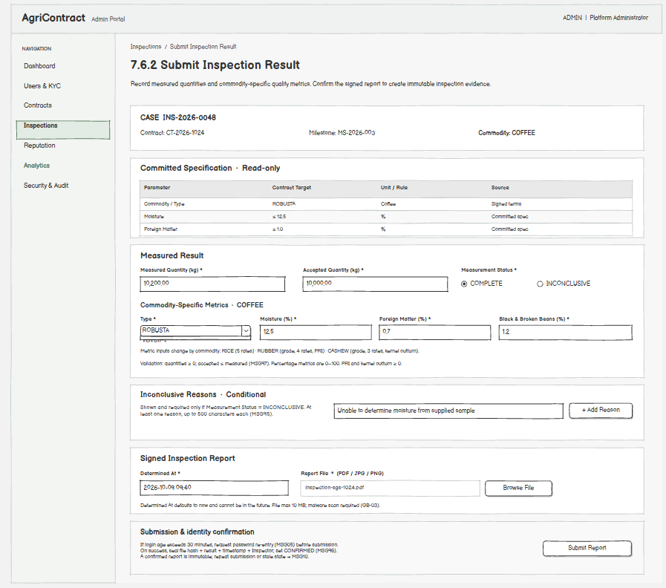
This screen allows the Inspector to:
- Enter measurements: record the measured and accepted quantity and the actual quality metrics for the contract's commodity. (UC44)
- Mark as inconclusive: record that the inspection could not reach a conclusion, with at least one reason (MSG95). (UC44)
- Upload the report file: attach the signed inspection report document. (UC44, GB-03)
- Re-authenticate: confirm identity again if the last login is older than 30 minutes (MSG05). (UC44)
- Submit: the system hashes the report file, the result, the time and the Inspector so they cannot be changed afterwards, and the report becomes CONFIRMED (MSG96). A report already submitted cannot be changed (MSG10). (UC44, GB-39)
Field Name | Description
Measured Quantity (kg) | Data type: decimal; required; min 0
Accepted Quantity (kg) | Data type: decimal; required; min 0; must be ≤ Measured Quantity (MSG97)
Measurement Status | Data type: radio; required; allowed values COMPLETE, INCONCLUSIVE; default COMPLETE
Inconclusive Reasons | Data type: list of text; required (at least 1) when status is INCONCLUSIVE; max 500 characters each
Coffee Metrics
Type | Data type: dropdown; required; allowed values ARABICA, ROBUSTA
Moisture / Foreign Matter / Black & Broken Beans (%) | Data type: decimal percent; required; 0–100
Report
Determined At | Data type: date-time; required; default now; not in the future
Report File | Data type: file; required; PDF, JPG or PNG; max 10 MB; must pass the malware scan

7.7 Level 2 Inspection Handling

7.7.1 Level 2 Commissions
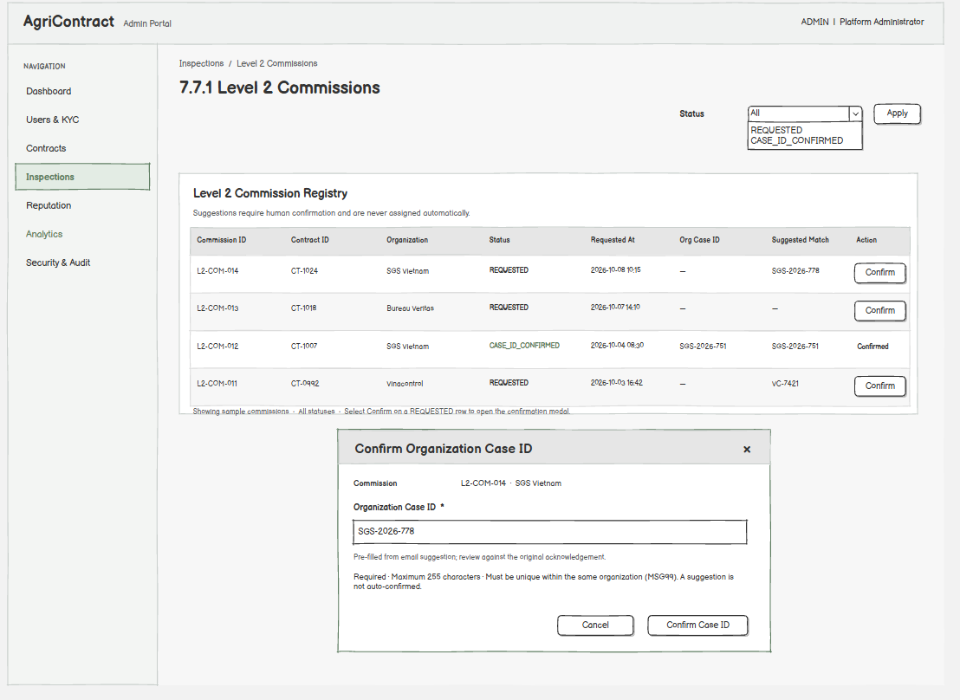
This screen allows the Operator to:
- Track commissions: see every Level 2 commission and whether the organization's case ID has been confirmed. (UC45)
- See match suggestions: see case IDs the system found in acknowledgement emails from the organization's domain, shown as suggestions only. (UC45)
- Confirm the case ID: confirm the organization's case ID for a commission so that the final report can be matched to it (MSG98). (UC45)
Field Name | Description
Organization Case ID | Data type: text; required in the confirm modal; max 255 characters; unique for the same organization (MSG99); pre-filled with the suggestion if one exists
Status | Data type: dropdown filter; optional; allowed values All, REQUESTED, CASE_ID_CONFIRMED; default All

7.7.2 Pending External Report Review
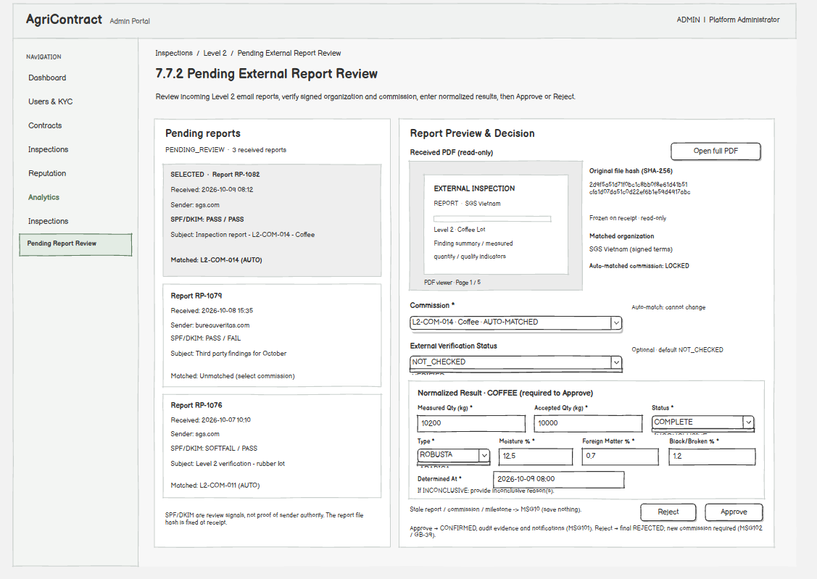
This screen allows the Operator to:
- Review received reports: open Level 2 reports received by email, with the file hash fixed on receipt and the sender SPF/DKIM result shown as a signal. (UC47)
- Match to a commission: link an unmatched report to the correct commission; an automatically matched report cannot be switched to another commission. The organization must be the one named in the signed terms (MSG100). (UC47)
- Record the normalised result: enter the quantities and metrics stated in the report. (UC47)
- Approve: confirm the report; it becomes evidence for the case and is recorded in the audit chain; the Arbitrator and both parties are notified (MSG101). (UC47)
- Reject: reject the report; rejection is final for that report and a new commission is needed (MSG102). (UC47, GB-39)
Field Name | Description
Commission | Data type: dropdown of open commissions of the same organization; required for Approve; locked when matched automatically
External Verification Status | Data type: dropdown; optional; allowed values NOT_CHECKED, VERIFIED, UNVERIFIED, UNAVAILABLE; default NOT_CHECKED
Result fields | Same fields and rules as 7.6.2 (quantities, status, commodity metrics); required for Approve
State guard | When the report, commission or milestone changed state in the meantime, nothing is saved (MSG10)

7.7.3 Manual External Report Upload
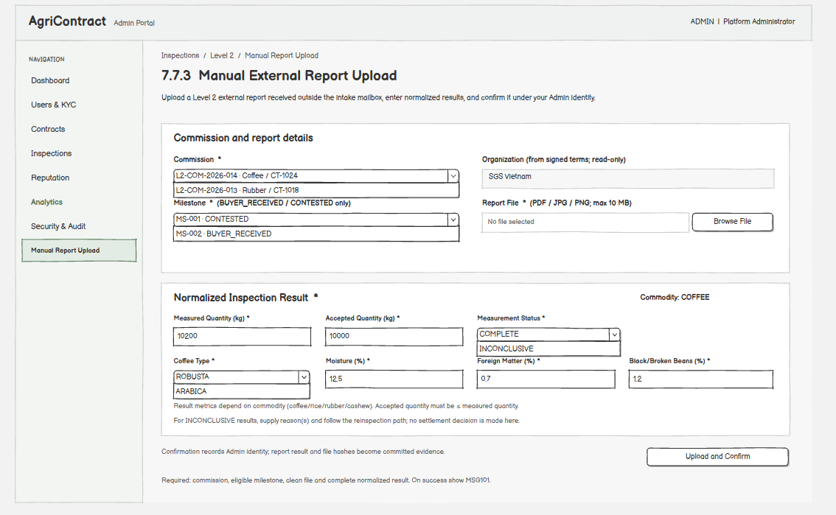
This screen allows the Operator to:
- Upload a report manually: upload a Level 2 report received outside the intake mailbox; the file hash is fixed at upload. (UC47)
- Record the normalised result and confirm: enter the result and confirm the report under the Operator's identity (MSG101). (UC47)
Field Name | Description
Commission | Data type: dropdown; required
Organization | Data type: text (read-only); from the signed terms; cannot be edited
Milestone | Data type: dropdown; required; milestone must be BUYER_RECEIVED or CONTESTED
Report File | Data type: file; required; PDF, JPG or PNG; max 10 MB; must pass the malware scan
Result fields | Same fields and rules as 7.6.2; required

7.7.4 Email Intake Failures
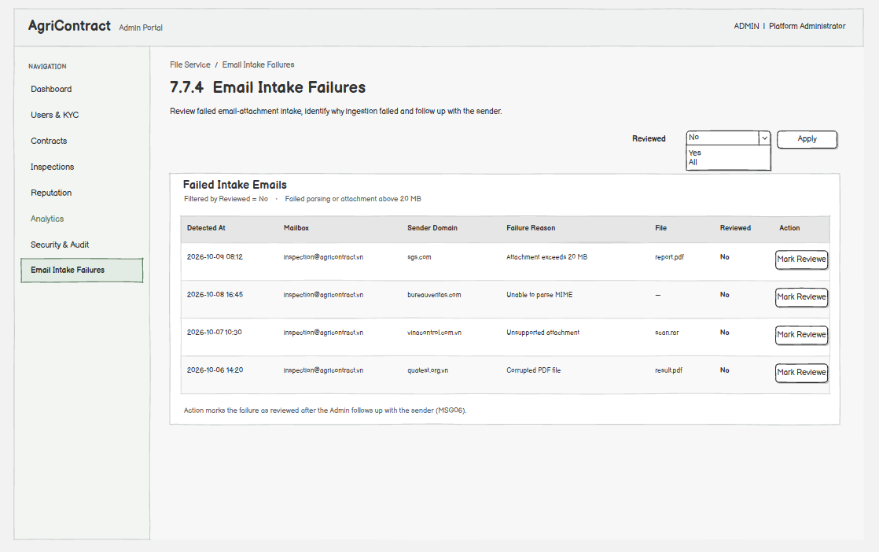
This screen allows the Operator to:
- View failed intake emails: see emails whose attachment could not be parsed or exceeded 20 MB, so the sender can be asked to resend. (UC47)
- Mark as reviewed: record that the failure has been followed up (MSG06). (UC47)
Field Name | Description
Reviewed | Data type: dropdown filter; optional; allowed values All, Yes, No; default No

8. Audit & Security

8.1 Audit Evidence

8.1.1 Audit Chain Verification Status
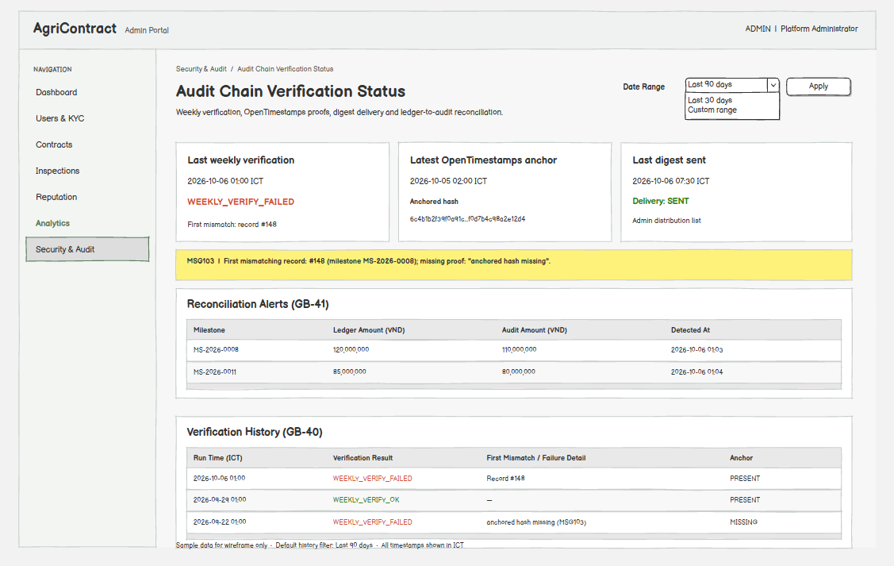
This screen allows the Admin to:
- View verification status: see the result of the latest weekly audit chain verification and past runs. (UC49, GB-40)
- See failure details: when verification failed, see the first mismatching record or "anchored hash missing" (MSG103). (UC49)
- View the latest anchor: see the most recent anchored hash and its time. (UC49)
- View reconciliation alerts: see milestones whose ledger amounts do not match the settlement amounts in the audit chain. (UC49, GB-41)
Field Name | Description
Verification Result | Data type: label; allowed values WEEKLY_VERIFY_OK, WEEKLY_VERIFY_FAILED
Date Range | Data type: date range filter for history; optional; default last 90 days

8.1.2 Contract Evidence Export
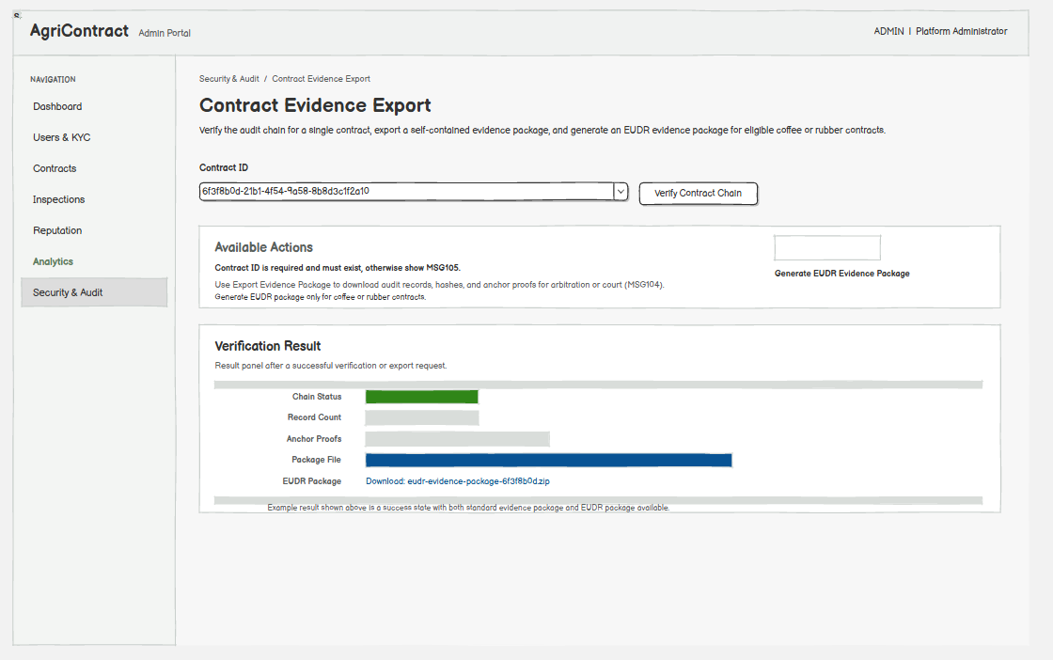
This screen allows the Admin to:
- Verify a contract's chain: check the audit chain of one contract. (UC48)
- Export evidence: download the self-contained evidence package for one contract (audit records, hashes, anchor proofs) for arbitration or court (MSG104). (UC48)
- Generate the EUDR evidence package: create the evidence export that supports an EUDR due diligence statement for a coffee contract. (UC48)
Field Name | Description
Contract ID | Data type: text (UUID); required; must exist, otherwise MSG105

8.2 System Security

8.2.1 Security Lock Status
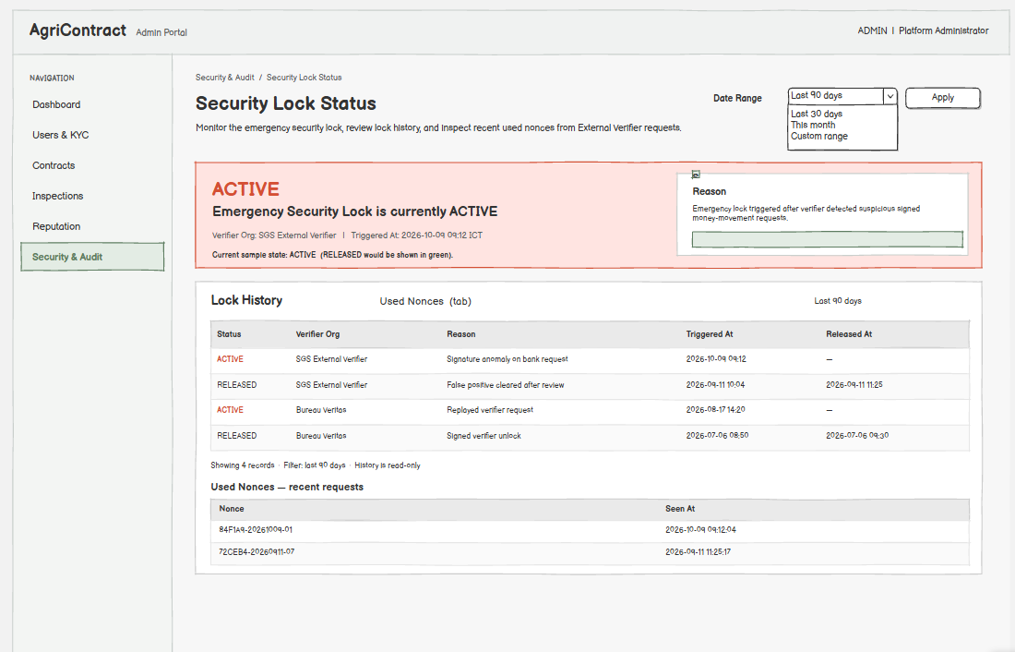
This screen allows the Admin to:
- View the current lock status: see whether the emergency security lock is ACTIVE; while ACTIVE, every money movement fails (MSG93). (UC50, GB-36)
- View lock history: see past lock and unlock events and their reasons. (UC50)
- View the nonce log: see the nonces used by recent verifier requests. (UC50, GB-42)
On the screen, the Admin can also:
- Read the unlock rule: only the External Verifier can unlock, by a signed request; the Admin has no unlock action. (UC50)
Field Name | Description
Status | Data type: label; allowed values ACTIVE, RELEASED
Date Range | Data type: date range filter for history; optional; default last 90 days

9. Analytics

9.1 Analytics Reports

9.1.1 Termination Report by Commodity
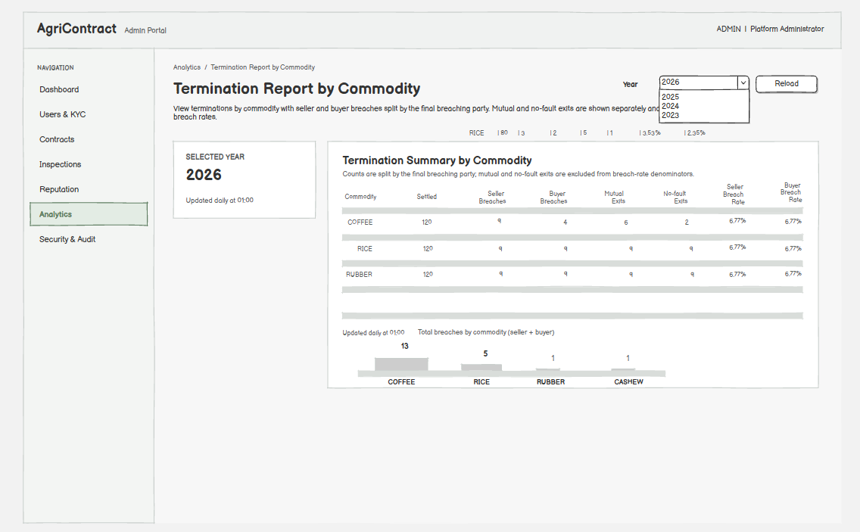
This screen allows the Admin to:
- View terminations by commodity: see breach counts split by the final breaching party, with mutual and no-fault exits reported separately and excluded from breach rates. (UC53, GB-43)
- Change the year: reload the report for another year; a year with no data shows MSG36. (UC53)
Field Name | Description
Year | Data type: integer (YYYY); required; default current year
Seller / Buyer Breach Rate | Data type: percent (read-only) = breaches ÷ (settled + Seller breaches + Buyer breaches)

9.1.2 Escrow Effectiveness Report
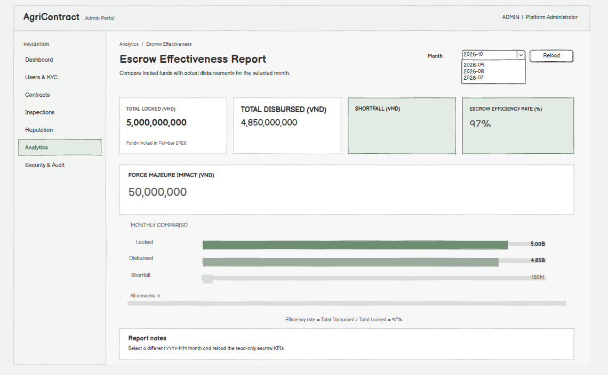
This screen allows the Admin to:
- View escrow effectiveness: compare locked amounts with amounts actually disbursed in a month. (UC53)
- Change the month: reload for another month. (UC53)
Field Name | Description
Month | Data type: month (YYYY-MM); required; default current month
Amounts | Data type: decimal, VND (read-only)

9.1.3 Force Majeure Trends
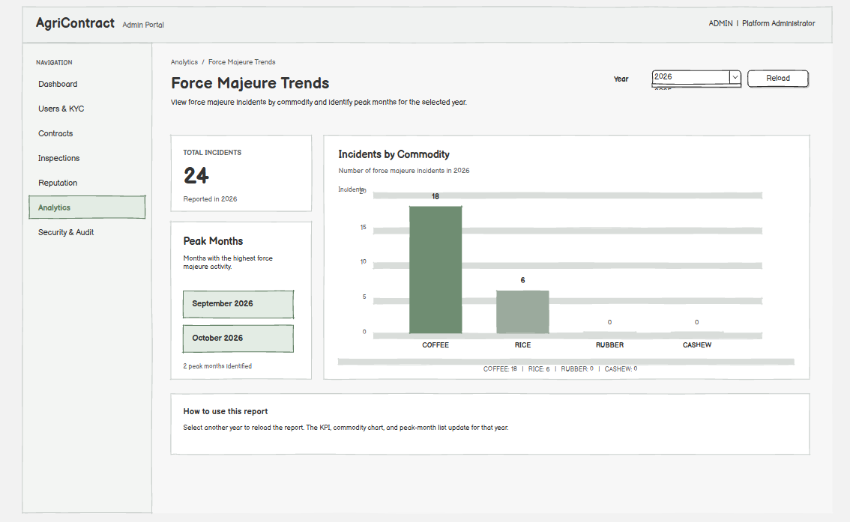
This screen allows the Admin to:
- View force majeure trends: see force majeure incidents per commodity and the peak months of a year. (UC53)
- Change the year: reload for another year. (UC53)
Field Name | Description
Year | Data type: integer (YYYY); required; default current year

10. Background Job Inventory

10.1 Transactional Outbox Relay (JOB-01)
Trigger: Scheduled — every 5 seconds, in each service that writes events
Purpose: Publish domain events and notification commands that were saved together with a business change, so no event is lost if the service stops right after the change.
Processing steps:
1. Read outbox rows not yet confirmed as published.
2. Publish each row to the message broker with its original event ID.
3. Mark the row as published after the broker confirms it.
Failure behavior:
Scenario | System behavior
Broker unavailable | The row stays unpublished and is retried on the next run; the business change is not rolled back
Duplicate publish after a crash | Consumers skip a repeated event ID, so the side effect happens once
Restore from backup | Unconfirmed outbox rows are sent again after the restore

10.2 Milestone Completion Sync (JOB-02)
Trigger: Scheduled — every 5 seconds
Purpose: Detect that the last milestone of a contract is SETTLED and start normal contract completion.
Processing steps:
1. Read unprocessed milestone-settled records.
2. For each record, check whether every milestone of that contract is SETTLED.
3. If yes, create the no-fault completion decision that returns the contract deposits and queue it for execution; the contract stays ACTIVE until JOB-03 confirms the money.
4. Mark the record processed.
Failure behavior:
Scenario | System behavior
Error or crash during processing | The retry count increases and the record is processed again on the next run
Not the last milestone | The record is marked processed with no further action

10.3 Contract Settlement Reconciler (JOB-03)
Trigger: Scheduled — every 5 minutes
Purpose: Move a contract to SETTLED only after the bank ledger shows that every deposit return succeeded and nothing remains locked (GB-22).
Processing steps:
1. Read the bank ledger entries of each contract that has a pending completion decision.
2. Check that every money leg of the decision has a successful ledger entry and the remaining locked amount is 0.00.
3. If yes, set the contract to SETTLED and publish the contract-settled event.
Failure behavior:
Scenario | System behavior
Legs not yet confirmed | The contract stays ACTIVE and is checked again on the next run
Ledger unavailable | No state change; retried on the next run

10.4 Deposit Lock Retry (JOB-04)
Trigger: Event-driven — on a failed deposit lock after the contract is signed; retries after 5 minutes, 30 minutes and 2 hours (3 attempts)
Purpose: Absorb temporary bank or network failures when locking the Buyer and Seller deposits of a newly signed contract (GB-44).
Processing steps:
1. Retry only the deposit leg that failed (Buyer, Seller or both), reusing the same source event ID.
2. When every required leg is locked, set the contract to ACTIVE and start funding the first milestone.
3. After the last failed attempt, record the deposit lock failure with the failed leg and each leg's state.
4. Keep the contract SIGNED and notify the Buyer, Seller and Operator with the next actions (UC29).
Failure behavior:
Scenario | System behavior
Security lock ACTIVE | Every attempt fails by design; the contract then waits for the Operator; no penalty or reputation effect
Duplicate retry | The bank skips a repeated source event ID; nothing is locked twice
Partial success | The locked leg is kept; only the missing leg is retried

10.5 Milestone Funding Lock Retry (JOB-05)
Trigger: Event-driven — on a failed milestone funding lock; retries after 5 minutes, 30 minutes and 2 hours (3 attempts)
Purpose: Lock the next milestone's batch amount while tolerating temporary failures (GB-25).
Processing steps:
1. Keep the milestone funding FUNDING_PENDING and retry the lock with the same source event ID.
2. When the lock succeeds, set funding to LOCKED and compute the funding delay business days and the new effective delivery deadline.
3. After the last attempt, set funding to FUNDING_FAILED and notify the Buyer, Seller and Operator.
Failure behavior:
Scenario | System behavior
Retries exhausted | FUNDING_FAILED; nothing is seized; the cure window starts (JOB-06)
Seller clock | The Seller has no delivery obligation for the milestone until funding is LOCKED

10.6 Funding Cure Window Expiry (JOB-06)
Trigger: Scheduled — hourly; acts when 3 business days (ending 23:59:59 Vietnam time) have passed since FUNDING_FAILED
Purpose: Record a Buyer funding breach when the Buyer did not cure the funding failure in time (GB-37).
Processing steps:
1. Find milestones still FUNDING_FAILED after the cure deadline.
2. Exclude failures caused by a confirmed bank or system outage or by the security lock.
3. Create a system decision: final breaching party BUYER, reason FUNDING_FAILURE, decision source SYSTEM, without a breach case.
4. Finalise the remedy and notify both parties; the Seller may then terminate the contract (UC54).
Failure behavior:
Scenario | System behavior
Failure caused by an outage | Not counted; the Operator retries funding (UC39) instead
Job runs again | The decision is unique per milestone; no duplicate remedy

10.7 Buyer Confirmation Auto-Confirm (JOB-07)
Trigger: Scheduled — hourly; acts when the Buyer Confirm Window (2–10 business days per contract, default 2) has passed since the milestone entered BUYER_RECEIVED
Purpose: Settle a milestone as clean when the Buyer neither confirms nor flags in time (GB-29).
Processing steps:
1. Find milestones in BUYER_RECEIVED past the confirm window.
2. Check that the milestone is still BUYER_RECEIVED and has no pending inspection (a mandatory inspection blocks auto-confirm).
3. Settle using the recorded Seller and Buyer weights with the tolerance rule and release the funds.
Failure behavior:
Scenario | System behavior
Milestone flagged or inspection pending | Skipped; no settlement
Settlement command fails | Milestone state unchanged; retried on the next run

10.8 Seller Response Window Timeout (JOB-08)
Trigger: Scheduled — hourly; acts when 2 business days have passed in AWAITING_SELLER_RESPONSE
Purpose: Treat Seller silence after a Buyer flag as acceptance of the Buyer's figures (GB-31).
Processing steps:
1. Find milestones in AWAITING_SELLER_RESPONSE past the response deadline.
2. Settle each milestone on the Buyer's figures and notify both parties.
Failure behavior:
Scenario | System behavior
Seller contested before the deadline | Skipped; dispute routing continues
Settlement fails | Retried on the next run

10.9 Buyer Receive Window Timeout (JOB-09)
Trigger: Scheduled — hourly; acts when 2 business days have passed in SELLER_WEIGHED
Purpose: Prevent a milestone from staying in SELLER_WEIGHED forever when the Buyer never records receipt, without ever settling on the Seller's weight alone (GB-45).
Processing steps:
1. When the window passes, notify the Buyer; the milestone state does not change.
2. If the Buyer is still silent after the notice, open a breach case for the Arbitrator to decide on the existing evidence.
3. When the Seller's evidence includes objective proof of delivery (for example a carrier receipt or arrival record), the case is recorded as the Buyer's FAILURE_TO_RECEIVE; without it, the Arbitrator reviews the case like any other.
Failure behavior:
Scenario | System behavior
Only the Seller's own weight exists | Never settled on that figure; the Arbitrator decides
Notification fails | Retried by JOB-28

10.10 Seller Delivery Deadline Overdue (JOB-10)
Trigger: Scheduled — daily after midnight Vietnam time; checks the effective delivery deadline = expected delivery date + funding delay business days + grace days, ending 23:59:59 Vietnam time
Purpose: Detect milestones not delivered by the effective delivery deadline, so the Buyer can report a late-delivery breach while the Seller can still claim force majeure.
Processing steps:
1. Find milestones still IN_PROGRESS past the effective delivery deadline.
2. Mark them overdue and notify both parties; the Buyer can now report LATE_DELIVERY or NON_DELIVERY (UC40).
3. The Buyer deposit is never seized in this branch.
Failure behavior:
Scenario | System behavior
Force majeure claim pending | Skipped until the claim is decided
Funding was delayed | The deadline already includes the funding delay; the Seller is not penalised for it

10.11 Level 2 Buffer and Provisional Settlement (JOB-11)
Trigger: Scheduled — hourly; acts when 10 business days pass without a CONFIRMED Level 2 report, then when the Buyer's 2-business-day answer window ends
Purpose: Avoid locking the Seller's money indefinitely while a Level 2 report is awaited (GB-26).
Processing steps:
1. Commission a Level 1.5 inspection as the provisional ruling.
2. When the Level 1.5 result exists, ask the Buyer whether to accept the higher release rate (Milestone Detail).
3. Buyer accepts: release rate = 85% (1 − the 15% safety buffer). Buyer refuses or stays silent: release rate = the contract's Dispute Floor Release Rate (≥ 50%).
4. Release the Seller's provisional amount and keep the remainder locked (PROVISIONALLY_RELEASED).
Failure behavior:
Scenario | System behavior
Level 2 report confirmed later | Reconciliation releases or refunds the difference; an over-release is recorded as evidence only
Money conservation check fails | No money command is sent

10.12 Level 2 Buffer Terminal Settlement (JOB-12)
Trigger: Scheduled — daily; acts when 30 days have passed after the buffer window without a CONFIRMED Level 2 report
Purpose: Make the Level 1.5 ruling final and release the held buffer (GB-26).
Processing steps:
1. Compute the final Seller entitlement from the Level 1.5 result.
2. Release the additional Seller amount and refund the Buyer amount (positive amounts only).
Failure behavior:
Scenario | System behavior
Bank command fails | Handled by the bank failure path and retried; zero-value commands are never sent

10.13 Orphan Reservation Reaper (JOB-13)
Trigger: Scheduled — every 5 minutes; releases reservations older than 30 minutes
Purpose: Return listing quantity held by a reservation whose contract was never created (GB-15).
Processing steps:
1. Find reservations still RESERVED, with no contract-created event, older than 30 minutes.
2. Change each from RESERVED to RELEASED with a conditional update and restore the quantity.
3. Write an operational log entry and alert the Operator.
Failure behavior:
Scenario | System behavior
Two runs at the same time | The conditional update restores the quantity only once
Contract-created event arrives after the release | Error log and Operator alert; no automatic re-reservation
Listing paused or closed by the Seller | Only the quantity counter is restored; the listing is not reopened (GB-12)

10.14 Plot Geo-risk Check (JOB-14)
Trigger: Event-driven — once after a plot is created or updated (KML import or GPS pin)
Purpose: Check the plot against the province boundaries and the 2020 forest baseline and set its geo-risk level (GB-07).
Processing steps:
1. Compare the plot location with the declared province and record a mismatch warning if they differ.
2. Query the 2020 forest baseline for the plot geometry.
3. Set the forest risk to LOW_RISK, HIGH_RISK or INCONCLUSIVE and the geo check to CHECKED.
Failure behavior:
Scenario | System behavior
No answer within 6 hours | Geo check becomes UNVERIFIED; the plot can then be linked to a listing
HIGH_RISK or overlap | Routed to Operator review; never rejected automatically

10.15 VNSAT Price Ingestion (JOB-15)
Trigger: Scheduled — daily, for COFFEE
Purpose: Read coffee reference prices by province from VNSAT (GB-14).
Processing steps:
1. Read the VNSAT price page for the commodity (API-09).
2. Save the price quotes in one database transaction.
3. Update the price cache after the commit.
Failure behavior:
Scenario | System behavior
Parse error, network error or page layout change | A price ingestion failure is recorded; the scheduler keeps running
Any failure | The last stored price stays visible and is marked stale when it passes the freshness threshold

10.16 Email Intake Mailbox Poll (JOB-16)
Trigger: Scheduled — every 5 minutes (API-07)
Purpose: Receive Level 2 inspection reports and acknowledgements sent by email (UC46).
Processing steps:
1. Read new emails from the intake mailbox.
2. For an email with attachments, store each raw file as PROCESSING and queue it for parsing (JOB-17).
3. For an email without attachments, pass the sender domain, SPF/DKIM result, subject and snippet on as a notice used for case ID suggestions.
Failure behavior:
Scenario | System behavior
Mailbox unreachable | Retried on the next poll
Attachment over 20 MB | Rejected while reading; an intake failure is recorded for the Operator

10.17 File Parse and Malware Scan (JOB-17)
Trigger: Event-driven — on each uploaded file or received email attachment
Purpose: Make every file pass format checks and malware scanning before it can be used as evidence (GB-03).
Processing steps:
1. Email attachments: parse the email and check format and size, then send to scanning.
2. Direct uploads: send straight to scanning.
3. Scan the file; mark it READY (with the email details if it came by email) or FAILED.
Failure behavior:
Scenario | System behavior
Temporary system error | 3 retries with fixed backoff, then the dead-letter queue and a technical alert
Email cannot be parsed | FAILED, an intake failure record and an Operator notice
Infected file | FAILED; it cannot be attached to any record

10.18 Orphan File Cleanup (JOB-18)
Trigger: Scheduled — daily
Purpose: Delete files that no business record claimed within one week.
Processing steps:
1. Find files not attached to any record and older than one week.
2. Delete each in two steps: mark it deleted, then remove the stored file.
Failure behavior:
Scenario | System behavior
Partial deletion | The next run completes the remaining step

10.19 Retention and Legal Hold Deletion (JOB-19)
Trigger: Scheduled — daily, run by each owning service for its own data
Purpose: Delete or anonymise data whose retention period has ended, for example KYC files 5 years after the relationship ends, OTP records 90 days after expiry and ordinary notification logs after 2 years (GB-46).
Processing steps:
1. Select records and files past retention; for a shared file, the longest retention wins.
2. Skip anything under legal hold.
3. Delete files in two steps (mark deleted with a reason, then remove the stored file) and anonymise closed-account contact data.
Failure behavior:
Scenario | System behavior
Legal hold set | Deletion refused; the file is kept
Stored file deletion fails after marking | The next run completes the deletion
Audit chain records | Never deleted (kept permanently, hashes and IDs only)

10.20 Audit Anchor Worker (JOB-20)
Trigger: Event-driven — on each anchor request saved together with an important audit record; retries with backoff
Purpose: Anchor the hash of important audit records with OpenTimestamps and email the proof at milestone settlement (API-08).
Processing steps:
1. Read pending anchor requests.
2. Request an OpenTimestamps proof for the record hash.
3. Save the proof as a new anchor record and mark the request done.
4. For a milestone settlement, request the settlement email with the proof to the Buyer and Seller.
Failure behavior:
Scenario | System behavior
OpenTimestamps timeout | Retried with backoff; the request stays pending
Crash after the audit record was written | The pending request survives and is processed later

10.21 Weekly Audit Chain Verification (JOB-21)
Trigger: Scheduled — weekly, Sunday 02:00
Purpose: Detect tampering in the audit chain and create the weekly anchor (GB-40).
Processing steps:
1. Recompute every record hash in order and compare it with the stored value.
2. Check that the latest anchored hash still exists in the chain.
3. Create a new OpenTimestamps anchor for the current chain head.
4. Record WEEKLY_VERIFY_OK, or WEEKLY_VERIFY_FAILED with the first mismatch position.
Failure behavior:
Scenario | System behavior
Mismatch or anchored hash missing | Result FAILED; an alert is sent automatically to the Admin and the External Verifier at the same time

10.22 Weekly Audit Digest (JOB-22)
Trigger: Scheduled — weekly, Sunday 02:30, only after JOB-21 has finished
Purpose: Email the current chain head hash to the External Verifier (GB-40).
Processing steps:
1. If the verification is OK, compute the head hash and request the digest email.
2. If the verification FAILED, send the audit failure alert instead of the digest.
Failure behavior:
Scenario | System behavior
Email delivery fails | Retried by JOB-28; a dead-lettered security or evidence email raises an alert

10.23 Ledger and Audit Reconciliation (JOB-23)
Trigger: Scheduled — daily
Purpose: Check that money moved in the ledger matches the settlement amounts recorded in the audit chain (GB-41).
Processing steps:
1. For each milestone SETTLED in the period, read its audit records.
2. Sum the ledger release and seize entries of the milestone and compare them with the settled and seized amounts.
3. On a mismatch, alert the Admin (shown on Audit Chain Verification Status) and record a metric.
Failure behavior:
Scenario | System behavior
Mismatch | Alert only; no automatic fix (a correction is made only by an attributed reversal entry)
Audit service unavailable | Operational alert; money flows are not blocked

10.24 Used Nonce Cleanup (JOB-24)
Trigger: Scheduled — daily
Purpose: Remove External Verifier nonces older than the 300-second timestamp window (GB-42).
Processing steps:
1. Delete nonce records older than the allowed window.
Failure behavior:
Scenario | System behavior
Cleanup fails | Retried on the next run; replay protection is not affected, because requests outside the window are rejected anyway

10.25 Analytics Monthly Aggregation (JOB-25)
Trigger: Scheduled — daily at 01:00
Purpose: Recompute monthly statistics by commodity (settled counts, breaches by party, mutual and no-fault exits, breach rates, force majeure incidents, escrow efficiency) (GB-43).
Processing steps:
1. Find the months touched by events of the last 7 days.
2. Recompute each touched month fully from the fact data.
3. Overwrite the month's figures (no increment).
Failure behavior:
Scenario | System behavior
Job runs again | Same result, because figures are overwritten
Event more than 7 days late | Accepted error; a month can be recomputed manually
Analytics outage | No effect on settlement; the backlog is processed after recovery

10.26 AML Structuring Pattern Scan (JOB-26)
Trigger: Scheduled — daily
Purpose: Detect Buyer–Seller pairs with repeated contracts just below the 500 million VND reporting threshold (GB-47).
Processing steps:
1. Select contracts settled in the last 90 days with a total amount from 475,000,000 VND up to but not including 500,000,000 VND.
2. Group them by Buyer–Seller pair and keep pairs with at least 5 contracts.
3. Publish a structuring-pattern signal: the pair is set to ELEVATED_RISK and a suspicious transaction report is recorded.
Failure behavior:
Scenario | System behavior
Same window scanned again | Duplicates are skipped per pair and window end; no duplicate report
Job fails | Retried on the next run; no transaction is held

10.27 Elevated Risk Review Expiry (JOB-27)
Trigger: Scheduled — daily
Purpose: Return a Buyer–Seller pair to NORMAL when 6 months pass after detection without a repeat, so a false positive does not stay flagged forever (GB-47).
Processing steps:
1. Find pairs in ELEVATED_RISK past their review date with no new pattern.
2. Set them to NORMAL.
Failure behavior:
Scenario | System behavior
New pattern detected | The pair stays ELEVATED_RISK with a new review date

10.28 Notification Delivery Retry (JOB-28)
Trigger: Event-driven — on each notification command; retries up to 3 times with exponential backoff
Purpose: Send each template email exactly once per event, recipient and notification type (API-06).
Processing steps:
1. Check the command and reserve its de-duplication key (PENDING).
2. Render the template and send it through the email service.
3. Mark it SENT, or retry a temporary failure.
Failure behavior:
Scenario | System behavior
Temporary failure after 3 retries | FAILED and moved to the dead-letter queue
Invalid command | Moved to the dead-letter queue at once
Duplicate command | Skipped when already SENT
Security or evidence email dead-lettered | Operational alert raised
OTP email | Not retried in the background; the failure is returned to the user, who requests a new OTP

10.29 Dead-Letter Queue Monitoring and Replay (JOB-29)
Trigger: Event-driven — when any message is dead-lettered; replay is started by the Operator, with Admin approval for money, security and evidence messages
Purpose: Recover messages that exhausted their retries without creating duplicate business effects (GB-48).
Processing steps:
1. Classify the message: temporary, invalid, or money / security / evidence.
2. Temporary: the Operator replays it under its original event ID after the cause is fixed.
3. Invalid: developers fix the code or data first, then the message is replayed under its original event ID.
4. Money / security / evidence: check the target state, the Operator proposes the replay, the Admin approves, then it is replayed.
5. Check the target state after the replay; a message that cannot be recovered is PARKED with a reason.
Failure behavior:
Scenario | System behavior
Replay of an event already processed | The consumer skips it by event ID
Wrong payload | Never edited; handled as an invalid message
Money mismatch after replay | Caught by JOB-23

11. External API Inventory

11.1 Emergency Lock API (API-01)
URL | POST: /api/v1/security/emergency-lock
Purpose | Freeze all money movements (lock, release, refund, seize) platform-wide when the External Verifier suspects tampering (UC52, GB-36)
Caller | External Verifier
Auth | Yes: ES256 signature over the canonical signed payload {action: LOCK, reason, timestamp, nonce}; the key ID must match the registered public key; timestamp within ±300 seconds; single-use nonce (GB-42); no user login and no staff bypass; body max 64 KB; rate limit per IP (10 requests per minute)
Request | ExternalVerifierRequest {keyId, signedPayload, signature}
Response | 204 locked; 401 MSG106 / MSG107 / MSG108; 409 MSG109 / MSG110

11.2 Emergency Unlock API (API-02)
URL | POST: /api/v1/security/emergency-unlock
Purpose | Release the emergency lock; the only way to unlock (UC52)
Caller | External Verifier
Auth | Same as API-01 with action UNLOCK; the action in the payload must match the endpoint
Request | ExternalVerifierRequest {keyId, signedPayload, signature}
Response | 204 unlocked; 401 MSG106 / MSG107 / MSG108; 409 MSG109 / MSG111

11.3 Audit Hash Query API (API-03)
URL | GET: /api/v1/security/audit-hash?contractId={uuid}
Purpose | Let the External Verifier read the current audit hash of a contract and compare it with the hash it holds, independently of the platform's own jobs (UC51)
Caller | External Verifier
Auth | Yes: X-Api-Key header and rate limit; read-only
Request | Query parameter contractId (UUID)
Response | 200 {contractId, recordHash}; 401 MSG112; 404 MSG105

11.4 Escrow Bank Commands (API-04)
URL | Message queue (RabbitMQ): bank.lock_requested, bank.release_requested, bank.refund_requested, bank.seize_requested
Purpose | Send the lock, release, refund and seize commands for deposits and milestone payments to the Custodian Bank
Caller | AgriContract (escrow-service); the Custodian Bank is simulated by the mock bank-service
Auth | Yes: broker credentials of the internal service; every command carries a unique source event ID so the bank never executes it twice; amounts are always positive
Request | {contractId, milestoneId (optional), userId, amount, entryType, sourceEventId}
Response | Asynchronous, see API-05; while the emergency lock is ACTIVE every command is answered as failed

11.5 Bank Command Results (API-05)
URL | Message queue (RabbitMQ): bank.lock_completed / bank.lock_failed, bank.release_completed / _failed, bank.refund_completed / _failed, bank.seize_completed / _failed; ledger read GET: /internal/v1/bank/ledger?contractId= or ?participantId=&from=&to=
Purpose | Return the result of each bank command, and the ledger entries used for statements, contract completion and reconciliation
Caller | Custodian Bank (mock bank-service)
Auth | Yes: broker credentials; the ledger read uses the internal service secret and is not exposed through the API gateway
Request | Result: {sourceEventId, result, reason}; ledger read: contract or participant and period
Response | Ledger entries {entryType, fundType, contractId, milestoneId, amount, createdAt} (append-only)

11.6 Outbound Email (API-06)
URL | SMTP to the configured mail provider (MailHog in development)
Purpose | Send signing OTPs, notifications, Level 2 commission letters, the weekly audit digest and evidence attachments
Caller | AgriContract (notification-service)
Auth | Yes: SMTP credentials stored as secrets, never in the code
Request | Rendered template email with recipient, subject, body and optional attachments
Response | Accepted or rejected by the provider; failures are retried by JOB-28 (except OTP emails)

11.7 Inspection Report Intake (API-07)
URL | IMAP polling of the platform intake mailbox every 5 minutes (JOB-16)
Purpose | Receive Level 2 inspection reports and acknowledgements that quote a commission or case ID (UC46)
Caller | AgriContract (file-service) reads the mailbox; the Level 2 Inspection Organization sends the email
Auth | Yes: mailbox credentials stored as secrets; the sender's SPF/DKIM result is recorded as a trust signal, not as proof
Request | New emails since the last poll
Response | Email with attachments (max 20 MB each) or a notice without attachments

11.8 Timestamp Anchoring (API-08)
URL | HTTPS POST to public OpenTimestamps calendar servers
Purpose | Submit important audit hashes and the weekly chain head, and receive the timestamp proofs (JOB-20, JOB-21)
Caller | AgriContract (audit-service)
Auth | No (public service); only hashes are sent, never contract data
Request | SHA-256 record hash
Response | OpenTimestamps proof (.ots), stored as a new anchor record

11.9 Reference Price Ingestion (API-09)
URL | GET then POST (form postback): thitruongnongsan.gov.vn/vn/nguonwmy.aspx
Purpose | Read coffee reference prices by province once a day (JOB-15)
Caller | AgriContract (pricing-service)
Auth | No (public website)
Request | Form fields of the price search page for the commodity
Response | HTML price table (item, market or province, date, price), parsed into price quotes

11.10 Geo Dataset Lookup (API-10)
URL | Province boundaries: Free-GIS-Data 34-province dataset loaded into the platform; forest baseline: ForTy 2020 (Google Earth Engine Data Catalog) and Natural Forests 2020
Purpose | Check a plot's location against the province boundaries and the 2020 forest baseline to set its geo-risk level (JOB-14)
Caller | AgriContract (product-service)
Auth | Province data: none (local); forest baseline: service account key of the data provider
Request | Plot geometry (point or polygon, WGS84)
Response | Derived province; forest classification probability, mapped to LOW_RISK, HIGH_RISK or INCONCLUSIVE; no answer within 6 hours gives UNVERIFIED

IV. Non-Functional Requirements

1. External Interfaces
AgriContract is used through a web interface and exchanges data with the identity provider, the escrow bank, the email service, the timestamp service, the reference price source, the geo dataset and the External Verifier.
Interface | Type | Description
Web user interface | User | Browser-based interface for Guest, Buyer, Seller, Inspector, Operator, Arbitrator and Admin; each user sees only the screens and actions allowed for the role carried by the session.
Identity provider | Software | Receives the login credentials and returns an authenticated session with the user's role (BUYER, SELLER, INSPECTOR, OPERATOR, ARBITRATOR, ADMIN); also performs the re-login required before signing a contract and before submitting an inspection report. Staff accounts and roles are created in its administration console.
Escrow bank | Communication | Receives the lock, release, refund and seize commands for deposits and milestone payments, each carrying contract, milestone, participant, amount and a unique source event identifier (API-04), and returns the completed or failed result of every command together with the append-only ledger entries used for statements, contract completion and reconciliation (API-05).
Email service | Communication | Receives outbound email for signing OTPs, notifications, Level 2 commission letters, the weekly audit digest and evidence attachments, and reports acceptance or rejection (API-06); the platform intake mailbox supplies incoming Level 2 inspection reports and acknowledgements with their attachments (API-07).
OpenTimestamps | Software | Receives the hash of an important audit record or of the weekly chain head and returns the corresponding timestamp proof; only hashes are exchanged, never contract data (API-08).
VNSAT reference prices | Software | Supplies published coffee reference prices by province and date, read once a day and stored as price quotes (API-09).
Geo dataset | Software | Supplies the 34-province boundaries and the 2020 forest baseline classification for a plot geometry, from which the platform derives the plot's province and geo-risk level (API-10).
Emergency lock / unlock clients | Communication | Accepts signed lock and unlock requests from the External Verifier that freeze or release all money movements platform-wide, and returns the outcome of the request (API-01, API-02).
External Verifier audit hash query | Communication | Accepts a contract identifier from the External Verifier and returns the contract's current audit record hash so the Verifier can compare it with the hash it holds (API-03).

2. Quality Attributes

2.1 Usability
Requirement | Description
Learnability for a first listing | A Seller whose KYC is VERIFIED can publish a first listing within 15 minutes of first using the system, without training and without reading a manual.
Field-level validation | Every form shows a validation message next to the field that caused the error, and keeps the values the user already entered.
Money presentation | Every money amount is shown in VND with thousands separators and two decimal places, and the currency is never left to the reader to guess.
Date and time presentation | Every date is shown as dd/MM/yyyy and every date-time is shown in Asia/Ho_Chi_Minh time, including deadlines and window expiry times.
Status badges | Contract, milestone, dispute, inspection, KYC and file statuses are shown as badges whose colour and wording are the same on every screen that displays them.
Blocked actions explained | When an action is blocked because of KYC status, an expired authorization, an account lock or the emergency lock, the screen states the reason instead of only disabling the control.
Supported browsers | All screens are usable on desktop Chrome, Edge and Firefox in their latest two versions, at a screen width of 1366 pixels or more.
Confirmation before irreversible actions | Signing a contract, releasing or refunding money, and submitting an inspection report require an explicit confirmation step that restates what will happen.

2.2 Performance
Requirement | Target | Condition
Page load | A screen is fully rendered within 3 seconds | Demo deployment on one machine, 100 concurrent users, data set of the demo scale
Form submission | A form submission returns its result within 2 seconds | Excluding file upload and excluding steps that wait for an external service
Listing browse and search | A filtered listing or search page returns its first page of results within 3 seconds | Up to 10,000 listings, page size of 20 rows
Signing OTP delivery | The OTP email is accepted by the email provider within 10 seconds of the signing request, and the code stays valid for 300 seconds after it is sent | The user requests the OTP after a successful re-login; one OTP request per 60-second cooldown
Bank command result processing | A completed or failed bank command result updates the contract or milestone state within 10 seconds of arriving | Message broker and escrow bank available; the emergency lock is not ACTIVE
Event publication cadence | Pending events are published by the outbox relay within 5 seconds of being written | Scheduled relay running in each service that writes events
Money state synchronisation | Milestone completion is synchronised every 5 seconds, and settlement is reconciled every 5 minutes | Scheduled jobs running on the demo deployment
File availability after upload | An uploaded file of up to 10 MB becomes usable within 60 seconds of upload | Scan queue not in backlog; a file larger than 10 MB is rejected at upload
Concurrent users | 100 concurrent users without errors and without exceeding the targets above by more than 50% | Single-machine demo deployment with all services running

2.3 Security
Requirement | Description
Authentication for non-public screens | Every screen other than registration, login and the public listing and profile pages requires an authenticated session; an unauthenticated request is sent to the login screen.
Role-based permissions | A user can perform only the actions allowed for the role of the session, as defined in I.4.4; Operator, Arbitrator and Admin actions are never available to Buyer, Seller or Inspector, and the Admin's only money-related action is approving the replay of a failed money, security or evidence message (GB-48).
Re-login before high-value actions | Signing a contract and submitting an inspection report require a fresh login; signing is refused when more than 300 seconds have passed since that login, and an inspection report when more than 1800 seconds have passed (MSG05).
OTP rules for signing | Signing requires a 6-digit code sent by email that expires 300 seconds after it is sent, allows at most 5 wrong attempts before a new code must be requested, allows at most 5 requests per hour with a 60-second cooldown between requests, and is valid only for the exact contract terms it was issued for.
Account restriction | A user whose KYC is not VERIFIED, whose authorization has expired, or who is locked until a given date cannot publish listings, create offers or sign contracts, and the restriction is enforced by the system, not by hiding the controls.
Password protection | Passwords are held only by the identity provider, are never stored by the platform, and are never written to logs, emails or exports.
Private contact data | Email, phone, address and representative identity data are never shown on public pages; a counterparty profile shows only organization name, role, verification status and reputation.
Evidence and document access | A file can be read only by the users the owning business context allows, and only through that context; direct access to the file store is not available to end users.
Malware scan before use | Every uploaded file and every email attachment is scanned and becomes usable only after the scan passes; a file that fails is rejected with a reason and is never attached to a business record.
Emergency lock requests | A lock or unlock request is accepted only when it carries a valid signature made with a registered External Verifier key using ES256, a timestamp within 300 seconds of the server time and a nonce that has not been used before; no user login and no Admin action can replace or bypass it.
Tamper-evident audit records | Audit records are append-only and chained by hash, important records and the weekly chain head are anchored with an external timestamp proof, and a weekly verification reports the first mismatch to the Admin and the External Verifier at the same time.
Read traceability for restricted data | Every opening of a KYC profile, a ledger detail or an AML record by an Operator, Arbitrator or Admin is recorded with the actor, the resource and the time.
Personal data retention and deletion | Personal data is kept only for its stated period and is then deleted or anonymised: KYC files and authority documents 5 years after the relationship ends, AML records and EUDR reports 5 years, contracts, signatures and settlement evidence 10 years after the contract closes, ordinary notification logs 2 years, OTP records 90 days after expiry, closed-account contact data anonymised after 5 years, and unattached files after 1 week; data under legal hold is never deleted.

2.4 Reliability
Requirement | Description
No lost money movement | Every bank command is published from the transactional outbox of the service that recorded the decision, so a command is never lost when a service restarts and never published twice for the same decision.
Idempotent command execution | Every bank command carries a unique source event identifier, the bank executes it at most once, and a repeated command or a repeated result is skipped instead of moving money again.
Automatic retry of failed locks | A failed deposit lock or milestone funding lock is retried three times, after 5 minutes, 30 minutes and 2 hours, and the contract is never left silently stuck when the retries are exhausted.
Daily reconciliation | A daily reconciliation compares the money moved in the ledger with the settled and seized amounts recorded in the audit chain and alerts the Admin on a mismatch; corrections are made only by an attributed reversal entry.
Notification retry | A failed notification is retried up to three times with increasing delays, and the same event, recipient and notification type never produces a duplicate email; a signing OTP failure is reported to the user instead of being retried in the background.
Dead-letter monitoring and replay | A message that exhausts its retries is moved to a dead-letter queue that the Operator monitors daily, a money, security or evidence message raises an operational alert immediately, a replay keeps the original event identifier so consumers can skip what they already processed, and a message that cannot be recovered is parked with a reason.

2.5 Auditability and Compliance
Requirement | Description
Audit trail of key actions | Signing, funding, settlement, dispute decisions, reputation locks, emergency lock and unlock, and every money movement are recorded with the actor, the time and the affected contract, and the record cannot be altered or removed afterwards.
Independent verification | The External Verifier can read the current audit hash of a contract at any time, receives the chain head hash in the weekly digest, and is alerted together with the Admin when the weekly verification fails.
EUDR geolocation evidence | For coffee, every plot that contributes to a contracted lot is declared with its geolocation and checked against the 2020 forest baseline, no plot may stand in for another, and the resulting report is kept for 5 years.
Retention periods | Each category of data is kept for its defined period, 10 years for contracts, signatures, settlement evidence and ledger entries, 5 years for KYC documents, AML records and EUDR reports, 2 years for ordinary notification logs, and is then deleted or anonymised, except audit chain records and their proofs, which are kept permanently as hashes and identifiers only.
Vietnamese personal data obligations | Personal data is processed only on a stated lawful basis, data subjects can view and correct their own data, request deletion within the limits of the platform's legal retention duties, and withdraw the consent given for sharing reputation data with credit institutions, which stops any further sharing.

V. Requirement Appendix

1. Business Rules
GBR-ID | Rule Statement | Applies To | Rationale | Enforced By
GB-01 | Only Buyer, Seller and Inspector accounts can be self-registered. Operator, Arbitrator and Admin accounts and roles are created by an Admin in the identity provider. | Account registration, role assignment | Privileged operational roles must not be obtainable by anyone who signs up, which limits the damage a single compromised or bought account can cause. | The system automatically on every registration; an Admin in the identity provider for Operator, Arbitrator and Admin accounts
GB-02 | A user can publish a listing, create an offer or sign a contract only when their KYC is VERIFIED, the representative's authorization has not expired and they have no active reputation lock. If eligibility cannot be confirmed, the action is refused. | Listing publication, contract offer, contract signing | Only identified legal entities acting through a validly authorized representative may enter binding commercial contracts, and the system fails closed so that an unverified party never slips through. | The system automatically on every listing publication, offer creation and OTP request for signing
GB-03 | A file can be attached as evidence only after it passes the format check and malware scan (READY). Direct uploads are limited to 10 MB, email attachments to 20 MB. | Profile documents, weighing evidence, breach evidence, inspection reports, emailed reports | Evidence used in disputes and KYC must be safe to open and reliable, so unscanned or malicious files are never accepted into a case. | The system automatically on every file upload and email attachment intake
GB-04 | The authorization expiry is entered by the Operator from the actual document, never as a platform default. An expired authorization makes the user ineligible even though the KYC status stays VERIFIED. | KYC verification, representative authorization | A representative may only bind the company within the period stated on the real authorization document, so a guessed default would let unauthorized people sign contracts. | The Operator during KYC review; the system automatically on every eligibility check
GB-05 | A public profile shows organization, verification status and reputation only; email, phone and address are never shown to other users. | Public user profile | Personal contact data must be protected under Vietnamese personal data protection rules while trading partners still see the trust information they need. | The system automatically on every public profile view
GB-06 | An early unlock or the clearing of an elevated-risk flag takes effect only after an Arbitrator approves the Operator's proposal; the approver can never be the proposer. | Early reputation unlock, clearing of elevated-risk flags | Separation of duties prevents a single staff member from quietly lifting a sanction or a risk flag for a favoured user. | The system automatically on every reputation action decision
GB-07 | Province mismatch, forest risk, plot overlap and yield anomaly are review signals for the Operator and labels for the Buyer. The system never rejects a plot or listing automatically because of them. A plot whose geo check is still PENDING cannot be linked to a listing. | Plot registration, geo risk review, listing plot linking | Satellite and coordinate checks can produce false alarms, so they inform people instead of blocking farmers, while unchecked plots are kept out of listings to protect traceability. | The system automatically on every plot check and listing save; the Operator during plot risk review
GB-08 | A plot entered as a point cannot be larger than 4 ha; larger plots must be imported as a polygon. | Plot import and manual plot entry | The EU Deforestation Regulation accepts a single point only for plots up to 4 ha; larger plots need a polygon to prove their exact boundary. | The system automatically on every plot import and plot entry
GB-09 | A geo re-evaluation photo must be taken with the device camera at the plot and carry GPS data inside the plot boundary; gallery photos are not accepted. | Geo re-evaluation request | Field evidence must prove the Seller was physically at the plot, which a reused or downloaded gallery photo cannot do. | The system automatically on every re-evaluation request
GB-10 | Listings keep a snapshot of the product and plots, and contracts keep a snapshot of the listing, product, category and plots. Later edits never change a snapshot. | Product editing, listing publication, offer creation | A signed contract must always show exactly what was agreed, so later edits by a Seller cannot change the goods or origin after the fact. | The system automatically on every listing publication and offer creation
GB-11 | A category proposed by a Seller can be used only after the Operator approves it and assigns its commodity. | Category proposal and approval | Every product must map to a supported commodity (COFFEE in Phase 2) so that commodity-specific rules such as EUDR plot linking are applied correctly. | The Operator during category moderation; the system automatically on every product save
GB-12 | Returning reserved quantity never reopens a listing that the Seller paused or closed; only the Seller can republish it. | Listing pause and close, reservation release | A Seller who stopped selling must not be exposed to new offers against their will just because a reservation expired. | The system automatically on every reservation release
GB-13 | Coffee listings must link at least one plot. | Listing creation and publication | Coffee falls under the EU Deforestation Regulation and must be traceable to its plots. | The system automatically on every listing save and publication
GB-14 | Reference prices are advisory only and are never used to calculate any contract, payment or penalty amount. | Market price board, listing form, listing detail | Reference prices come from public sources that may be late or incomplete, so all money amounts are based only on the price both parties signed. | The system automatically on every contract, payment and penalty calculation
GB-15 | An offer must request a total quantity between the listing's minimum order quantity and its available quantity. The quantity is reserved when the offer is created, and a reservation without a contract is released after 30 minutes. | Offer creation, quantity reservation | Reserving quantity prevents the same goods from being sold twice, and the time limit stops abandoned offers from blocking stock. | The system automatically on every offer creation and by a scheduled job every few minutes
GB-16 | The agreed price and any milestone price adjustment must lie within the signed price band. An adjustment needs both parties, must be accepted before the milestone's funding request, and is allowed at most once per milestone. | Offer creation, milestone price adjustment | Price changes over a long forward contract must stay within limits both parties accepted and must be fixed before money is locked for the batch. | The system automatically on every offer submission and price adjustment
GB-17 | The quality result of a milestone is calculated by the system from the signed quality terms and the inspection measurements. The reviewer confirms it but cannot change thresholds or add criteria. An inconclusive result cannot be used to resolve a case. | Quality terms, inspection results, breach case resolution | Quality decisions must follow the agreed terms objectively so that no reviewer can tilt the outcome toward one party. | The system automatically on every inspection result; the Arbitrator during breach case resolution
GB-18 | The Buyer deposit rate is between 3% and 10% of the total contract value (default 5%). The Seller deposit is optional. | Offer creation, contract terms | The Buyer deposit gives the Seller real commitment, while the Seller deposit is optional because cooperatives often have no spare cash before harvest. | The system automatically on every offer submission and terms save
GB-19 | A contractual penalty cannot exceed the legal profile's cap (8% under Vietnamese commercial law) and is calculated on the breached milestone only; settled milestones are never touched. | Contract terms, breach remedy, termination | Article 301 of the Vietnamese Commercial Law caps contractual penalties at 8% of the value of the breached obligation, so a higher penalty would not be enforceable. | The system automatically on every contract signing and remedy calculation
GB-20 | Contract terms can be changed only before the first signature. After that, a change requires a replacement contract. | Contract terms editing, replacement contract | Both signatures must cover exactly the same terms, so terms cannot move once someone has signed. | The system automatically on every terms save
GB-21 | Mutual termination and replacement carry no penalty and no reputation effect. The party who proposed cannot confirm their own proposal. | Mutual termination, replacement contract | An exit both parties agree to is not a breach, and requiring the other party's confirmation proves the agreement is truly mutual. | The system automatically on every mutual termination and replacement action
GB-22 | A contract reaches SETTLED, TERMINATED, SUPERSEDED or ACTIVATION_FAILED only after every money leg is confirmed by the bank and nothing remains locked. | Contract closing, termination, replacement, activation failure | A contract must never be shown as closed while money is still held or unconfirmed, which protects both parties' funds and keeps the ledger accurate. | The system automatically on every bank confirmation and by a scheduled reconciliation job
GB-23 | A signature is valid only with an OTP bound to the signer, the contract and the terms hash, requested within 5 minutes of a fresh login. Both signatures must cover the same hash. | Contract signing | Binding the code to the person, the contract and the exact terms gives the electronic signature legal weight and stops a signature from being reused for other terms. | The system automatically on every OTP request and signature
GB-24 | A Buyer or Seller can view and export only the contracts and ledger entries in which they are a party. | Contract viewing, escrow statement export | Contract and payment data is confidential business information that only the parties to the contract may see. | The system automatically on every contract view and statement export
GB-25 | Each milestone's batch amount is locked before delivery. The Seller's delivery clock starts only when the funding is LOCKED, and the deadline is extended by any funding delay. | Milestone funding, delivery deadline | The Seller should only deliver when payment is guaranteed, and must not be blamed for a delay caused by late funding. | The system automatically on every milestone funding request
GB-26 | If no confirmed Level 2 report arrives within 10 business days, the milestone is settled provisionally on a Level 1.5 result, keeping a buffer locked; the Level 1.5 result becomes final after 30 more days. | Milestone settlement, Level 2 inspection | Waiting indefinitely for an external organization would freeze the Seller's money, so the platform pays most of it and keeps a buffer until the result is final. | The system automatically through scheduled jobs
GB-27 | Transit loss within the tolerance rate is shared as agreed. A shortfall beyond the contract threshold opens a breach case instead of an automatic penalty, and payment for the quantity delivered continues. | Delivery receipt, transit loss | Normal weight loss in transport is not a breach, while a larger shortfall needs a fair review before anyone is penalized. | The system automatically on every delivery receipt
GB-28 | A flag or breach report is only an allegation. Penalties, deposit forfeiture and reputation locks follow only from a final decision on the breaching party. | Delivery flags, breach reports | A party must not be punished on the other party's word alone, which protects against false claims used as pressure. | The system automatically on every flag and breach report; the Arbitrator through the final decision
GB-29 | If the Buyer neither confirms nor flags within the confirmation window, the milestone is confirmed clean automatically, unless an inspection is pending. | Delivery confirmation | A Buyer must not be able to hold the Seller's payment forever by staying silent. | The system automatically through a scheduled job when the confirmation window ends
GB-30 | The inspection tier follows the signed inspection terms and value thresholds. Force majeure disputes go no higher than Level 1.5. A Level 2 inspection uses only the organization named in the signed terms. | Flag response, inspection requests, force majeure review | Inspection cost should match the value at stake, and only the inspection organization both parties agreed on can produce a binding result. | The system automatically on every inspection request; the Arbitrator during case review
GB-31 | If the Seller does not respond to a flag within 2 business days, the silence counts as acceptance of the Buyer's figures. | Flag response | A short fixed deadline keeps disputes moving and stops a Seller from delaying settlement by not answering. | The system automatically through a scheduled job when the response deadline ends
GB-32 | A force majeure claim must be filed within the contract's report window with evidence and is decided by the Arbitrator; it is never approved automatically. An approved claim exempts the shortfall from penalty. | Force majeure claims | Force majeure releases a party from penalty under Vietnamese law only when the event is proven, so each claim needs evidence and a human decision. | The Arbitrator during force majeure review; the system automatically on every claim submission
GB-33 | When no party is at fault, there is no penalty, deposit forfeiture, damages or reputation lock. | Breach case resolution | Sanctions are only fair and legally defensible when someone is actually at fault. | The system automatically on every no-fault resolution
GB-34 | A contract can be terminated only on a final decision: a MATERIAL breach resolved against a party, a breach recorded by the system, or an approved force majeure claim. Only the aggrieved party or the Arbitrator can execute it. | Contract termination | Ending a contract is a serious remedy that the law allows only for a material breach or an accepted excusing event, and the party in breach must not gain from ending it. | The system automatically on every termination request
GB-35 | A reputation lock is applied only to a party found at fault for an intentional breach; production shocks that are not force majeure and no-fault outcomes never lock. | Breach case resolution, reputation | Locking farmers out of the market for crop failures they could not control would be unfair and would drive them away from the platform. | The system automatically on every breach case resolution
GB-36 | Only the External Verifier can lock or unlock monetary operations, by a signed request; no staff user can bypass it. Failures caused by the lock are not counted against any user. | Emergency security lock, money movements | An independent party must be able to stop all money movements if the platform is compromised, without a compromised Admin being able to undo it. | The system automatically on every money movement and every External Verifier request
GB-37 | A Buyer has 3 business days after a funding failure to make funds available before a Buyer funding breach is recorded. Failures caused by a bank or system outage or the security lock are not counted. | Milestone funding failures | A Buyer deserves a short time to fix a temporary cash problem, and outages outside the Buyer's control must never count as a breach. | The system automatically through a scheduled job
GB-38 | An Inspector sees only the cases assigned to them and only the committed quality terms of those contracts. | Inspector case access | Inspectors must stay independent and must not see prices or other commercial terms that could influence their result. | The system automatically on every Inspector request
GB-39 | An inspection report's hash is fixed at submission and the report cannot be changed afterwards. A rejected Level 2 report is final and needs a new commission. | Inspection report submission, external report review | Inspection reports are evidence for arbitration and court, so they must be tamper-evident and cannot be reused after rejection. | The system automatically on every report submission; the Operator during external report review
GB-40 | The audit chain is verified and anchored every week, and the chain head is sent to the External Verifier; a failed verification alerts the Admin and the External Verifier together. | Audit chain verification and anchoring | Regular independent anchoring proves that platform records were not changed after the fact, which gives them value as evidence. | The system automatically through weekly scheduled jobs
GB-41 | Ledger entries, audit records and signed contracts are never edited or deleted; a correction is made only by an attributed reversal entry. | Ledger, audit records, signed contracts | Financial and legal records must keep a full, traceable history so that every correction can be explained to an auditor or a court. | The system automatically on every data change; the database is append-only for these records
GB-42 | Each External Verifier request carries a nonce that can be used only once and a timestamp within 300 seconds of the server time. | External Verifier API requests | A captured request must not be replayed by an attacker to lock or unlock money movements later. | The system automatically on every External Verifier request
GB-43 | Breach statistics count the final breaching party, not the party who requested termination. Mutual and no-fault exits are excluded from breach rates. | Termination and breach reports | Reports must show who actually broke contracts, otherwise the party who suffered the breach would look like the wrongdoer. | The system automatically when statistics are updated
GB-44 | A contract becomes ACTIVE only when every required deposit is locked. A failed lock is retried for the missing leg only; it carries no penalty or reputation effect. | Contract activation, deposit locking | Delivery obligations should only start when both sides' commitments are secured, and a technical lock failure is not a breach. | The system automatically on every deposit lock result
GB-45 | A milestone is never settled on the Seller's declared weight alone. | Milestone settlement | Paying on the Seller's own figure alone would let a Seller overstate delivered goods without any check by the Buyer. | The system automatically on every milestone settlement
GB-46 | Data is deleted or anonymised when its retention period ends, except data under legal hold. Audit records are kept permanently. | Data retention | Personal data may only be kept as long as there is a legal or business purpose under Decree 13/2023, while the hash-only audit chain is kept to preserve evidence. | The system automatically through a scheduled retention job
GB-47 | A Buyer–Seller pair with at least 5 contracts in 90 days just below 500 million VND is flagged ELEVATED_RISK and reported; it returns to NORMAL after 6 months without a repeat. No transaction is held because of the flag. | Anti-money laundering monitoring | Repeated contracts just under the reporting threshold are a known sign of splitting transactions to avoid anti-money laundering checks. | The system automatically through scheduled analytics jobs
GB-48 | A failed message is replayed only under its original event ID. Replaying a money, security or evidence message needs Admin approval. | Failed message replay | Replaying under the same ID prevents money from moving twice, and sensitive replays need a responsible person's approval. | The system automatically on every replay; the Admin for money, security and evidence messages
GB-49 | While a contract is REPLACEMENT_PENDING or SUPERSEDE_REFUND_PENDING, trading and milestone actions on it are blocked and its delivery and funding timers have no business effect; refunds, reconciliation, security locks, notifications and read access continue. Eligibility is rechecked before the replacement is committed. | Contract replacement | Nothing may change the old contract while its money is being returned, so the replacement starts from a clean state. | The system automatically during every replacement
GB-50 | A breach decision that brings a penalty, deposit forfeiture or reputation lock takes effect only after a 2-business-day contest window. The party found at fault may contest once; unless the decision already rests on an inspection result, the case then goes to a Level 1.5 inspection whose decision is final. A breach case for the whole contract, with no milestone, has no contest window and takes effect at once. | Breach case resolution | One Arbitrator's mistake is checked by an independent inspector outside the platform staff, while decisions nobody contests still take effect within days. | The system automatically on every breach decision; the Arbitrator when routing a contest

2. System Messages
# | Message code | Message Type | Context | Content
1 | MSG01 | In red, under the text box | The email entered at registration is already registered. | This email is already registered. Log in or use another email.
2 | MSG02 | Toast message | The account has been created successfully. | Your account has been created. Complete your profile and submit KYC to start trading.
3 | MSG03 | In red, under the text box | The confirm password does not match the password entered at registration. | The two passwords do not match.
4 | MSG04 | In red, under the text box | The email and password combination entered at login is wrong. | Email or password is incorrect.
5 | MSG05 | In line | The user must log in again because signing a contract or submitting an inspection report needs a recent login. | For your security, please log in again to continue.
6 | MSG06 | Toast message | Changes to a profile, draft listing, manual price or reviewed email failure have been saved. | Your changes have been saved.
7 | MSG07 | Toast message | The user has submitted their profile for KYC review. | Your profile has been sent for review. We will email you the result.
8 | MSG08 | In line | The user tries a trading action while KYC is not verified, the authorization has expired, the account is locked or eligibility cannot be confirmed. | You cannot do this yet: {reason}. Reasons: KYC not verified, authorization expired, account locked until {date}, or eligibility could not be confirmed.
9 | MSG09 | In red, under the text box | The uploaded document has the wrong file type or is larger than 10 MB. | Only JPG, PNG or PDF files up to 10 MB are accepted.
10 | MSG10 | Toast message | The item was changed by another user or is no longer in a status that allows the chosen action. | This item was changed by someone else or is no longer in a state that allows this action. Reload the page and try again.
11 | MSG11 | Toast message | The Operator has verified a KYC profile. | The profile has been verified. The user has been notified by email.
12 | MSG12 | In red, under the text box | The authorization expiry entered when verifying KYC is not later than now. | The authorization expiry must be later than now.
13 | MSG13 | Toast message | The Operator has rejected a KYC profile. | The profile has been rejected. The user has been notified with the reason.
14 | MSG14 | In red, under the text box | A required field is left empty in a form. | Please fill in all required fields.
15 | MSG15 | Dialog | The Arbitrator is about to approve a reputation action request. | Approve this {action type} for {user}? This takes effect immediately.
16 | MSG16 | Toast message | A user tries to approve or reject a reputation action request they proposed. | You cannot approve or reject a request you proposed. An Arbitrator other than the proposer must decide.
17 | MSG17 | Toast message | The Operator has submitted a reputation action proposal. | Your proposal has been sent. It takes effect only after an Arbitrator approves it.
18 | MSG18 | In red, under the text box | An early unlock is proposed for a user who has no active lock. | This user has no active lock, so an early unlock cannot be proposed.
19 | MSG19 | In line | The province derived from the plot coordinates differs from the declared province. | The plot location is in {derived province}, not in the declared province {declared province}. Please check the coordinates or the declared province.
20 | MSG20 | In line | A placemark in the imported KML file failed validation. | Placemark "{name}": {error}. Fix it or skip it; the other placemarks can still be saved.
21 | MSG21 | In red, under the text box | A plot entered as a point has an area larger than 4 ha. | A point plot cannot be larger than 4 ha. Import the plot as a polygon instead.
22 | MSG22 | In line | The GPS accuracy of the pinned position is worse than 20 m. | GPS accuracy is {n} m (worse than 20 m). Try again in an open area or import a KML file. You can still save this position.
23 | MSG23 | In line | An uploaded file is still being scanned for security. | The file is being checked. It can be used once the check is complete.
24 | MSG24 | In red, under the text box | An uploaded file failed the security scan. | The file did not pass the security check and cannot be used. Please upload another file.
25 | MSG25 | Toast message | The re-evaluation photo was taken outside the plot or has no GPS data. | The photo was not taken inside the registered plot, or it has no GPS data. Take a new photo at the plot with the camera.
26 | MSG26 | Toast message | The Operator has asked the Seller for more evidence about a plot. | The Seller has been asked to provide more evidence.
27 | MSG27 | Toast message | The Seller has proposed a new category. | Your category proposal has been sent. You can use it after the Operator approves it.
28 | MSG28 | In red, under the text box | The proposed category name already exists. | A category with this name already exists.
29 | MSG29 | Dialog | The Seller is about to pause or close a listing. | Pause or close this listing? Buyers can no longer make offers. It will not reopen automatically.
30 | MSG30 | Toast message | The Seller tries to republish a listing whose declared quality is incomplete. | Complete the declared quality of this listing before republishing it.
31 | MSG31 | In red, under the text box | A coffee listing is saved without a linked plot. | Coffee listings must link at least one plot.
32 | MSG32 | In line | The Seller tries to link a plot whose geo check is still pending. | This plot is still being checked and cannot be linked yet.
33 | MSG33 | Toast message | The listing has been published. | Your listing is published and visible to Buyers.
34 | MSG34 | Toast message | A listing is published with an offered quantity that is unusually high for its linked plots. | The offered quantity is unusually high for the linked plots. The listing is published and sent for Operator review.
35 | MSG35 | In red, under the text box | The minimum order quantity is not greater than 0 or exceeds the offered quantity. | The minimum order quantity must be greater than 0 and not more than the offered quantity.
36 | MSG36 | In line | A search, filter or report returns no data. | No data matches your filters.
37 | MSG37 | In line | A guest or non-Buyer user tries to create an offer from a listing. | Please log in as a Buyer to create an offer.
38 | MSG38 | Toast message | The Operator has approved a category and assigned its commodity. | The category has been approved for {commodity} and can now be used.
39 | MSG39 | Email | The Operator has closed a Seller's listing for violating platform rules. | Your listing "{listing}" has been closed by the platform. Reason: {reason}.
40 | MSG40 | In line | A reference price is older than the freshness threshold of its commodity. | Stale: this price is older than {n} days.
41 | MSG41 | In red, under the text box | The price date entered is in the future. | The date cannot be in the future.
42 | MSG42 | Toast message | The Buyer has sent an offer and the quantity has been reserved. | Your offer has been sent to the Seller. The quantity is reserved while you negotiate.
43 | MSG43 | Toast message | The listing changed after the Buyer opened the offer form. | The listing has changed since you opened it. Reload the listing and review your offer.
44 | MSG44 | In red, under the text box | The requested quantity is below the minimum order quantity or above the available quantity. | The requested quantity must be between the minimum order quantity and the available quantity ({available} kg).
45 | MSG45 | Toast message | The Buyer submits an offer on a listing that is no longer open. | This listing is not open for offers.
46 | MSG46 | In red, under the text box | The agreed or proposed unit price is outside the price band. | The price must be between the minimum and maximum unit price of the price band.
47 | MSG47 | In line | The tolerance rate is set to 0%. | With a tolerance rate of 0%, any transit loss will be deducted from the Seller.
48 | MSG48 | In red, under the text box | A field value is missing, has the wrong format or is outside its allowed range. | {field} is not valid: {rule}.
49 | MSG49 | Dialog | A party is about to withdraw an offer. | Withdraw this offer? There is no penalty and the reserved quantity returns to the listing. This cannot be undone.
50 | MSG50 | Dialog | A party is about to propose ending a contract by mutual agreement. | Propose to end this contract by agreement? All unsettled milestones end, locked money returns to its owners, and there is no penalty or reputation effect for either side.
51 | MSG51 | Toast message | A party tries to accept a proposal they made themselves. | You made this proposal. Only the other party can accept it.
52 | MSG52 | Toast message | Contract terms have been saved during negotiation. | The terms have been saved and the other party has been notified.
53 | MSG53 | Toast message | A party tries to change terms after a party has already signed. | The terms can no longer be changed because a party has already signed. Withdraw the offer or propose a replacement instead.
54 | MSG54 | Toast message | The other party saved newer terms before the current user saved. | The other party saved newer terms. Review the latest terms before saving.
55 | MSG55 | Toast message | A signing OTP has been sent to the user's email. | A 6-digit code has been sent to {masked email}. It expires in 5 minutes.
56 | MSG56 | Toast message | The first party has signed the contract. | You have signed. The terms are now frozen and the other party has been asked to sign.
57 | MSG57 | Toast message | Both parties have signed the same terms. | Both parties have signed. The contract will become active when the deposits are locked.
58 | MSG58 | In red, under the text box | The OTP entered has expired or has been replaced by a newer code. | This code has expired or has been replaced by a newer code. Request a new code.
59 | MSG59 | In red, under the text box | The OTP entered is incorrect. | The code is incorrect. {n} attempts left.
60 | MSG60 | In red, under the text box | The OTP has been locked after 5 wrong attempts. | Too many wrong attempts. Request a new code.
61 | MSG61 | Toast message | A new OTP is requested before the cooldown ends or after the hourly limit is reached. | Please wait {n} seconds before requesting a new code (max 5 codes per hour).
62 | MSG62 | Toast message | The terms changed after the OTP was sent or do not match the terms the other party signed. | The terms have changed since this code was sent, or do not match the terms signed by the other party. Review the terms and sign again.
63 | MSG63 | Toast message | The committed quantities no longer equal the reserved quantity at signing. | The committed quantities no longer match the reserved quantity. The contract cannot be signed.
64 | MSG64 | Toast message | A party has proposed a replacement contract. | Your replacement proposal has been sent to the other party.
65 | MSG65 | In red, under the text box | The statement period entered is not valid. | The period is not valid: the start must be before the end, the end cannot be in the future and the period cannot exceed 366 days.
66 | MSG66 | In line | The funding lock for a milestone has failed. | Funding for milestone {n} could not be locked. The Seller does not have to deliver until it is funded. The Buyer has until {date} to make funds available.
67 | MSG67 | Toast message | The Seller has recorded the weighing of a batch. | The weighing has been recorded and the Buyer has been notified.
68 | MSG68 | In red, under the text box | The weight entered is 0 or empty. | The weight must be greater than 0 kg.
69 | MSG69 | Dialog | The Buyer is about to confirm a delivery as clean. | Confirm this delivery? The payment of {amount} VND will be released to the Seller. This cannot be undone.
70 | MSG70 | Toast message | The Buyer has flagged an issue with a delivery. | Your issue has been recorded. The payment is held and the Seller has until {date} to respond.
71 | MSG71 | Toast message | The Buyer tries to confirm or flag a delivery after the confirmation window has ended. | The confirmation window has ended and the milestone was confirmed automatically. You can still report a breach.
72 | MSG72 | In red, under the text box | A flag, force majeure claim or breach report is submitted without evidence. | Attach at least one evidence file.
73 | MSG73 | Dialog | The Seller is about to accept the Buyer's flagged figures. | Accept the Buyer's figures? The milestone will be settled on those figures. This cannot be undone.
74 | MSG74 | Toast message | The Seller has contested the Buyer's flag. | You have contested the issue. The payment stays held until the inspection result and the final decision.
75 | MSG75 | Toast message | The Seller tries to respond to a flag after the response deadline. | The response deadline has passed. The milestone was settled on the Buyer's figures.
76 | MSG76 | Toast message | The Seller has submitted a force majeure claim. | Your force majeure claim has been submitted for review. No penalty applies while it is pending.
77 | MSG77 | In line | A force majeure claim is filed after the report window. | This claim is outside the {n}-day report window. It will be recorded, and the delay will be considered in the decision.
78 | MSG78 | Toast message | The counterparty has accepted a milestone price adjustment. | The new price of {price} VND/kg applies to milestone {n}.
79 | MSG79 | Toast message | A price adjustment is proposed or accepted after funding was requested or after an earlier adjustment was accepted. | The price of this milestone can no longer be adjusted: funding has been requested or an adjustment was already accepted.
80 | MSG80 | Toast message | A party has reported a breach. | Your report has been recorded and the case is now REPORTED. No consequence applies until the case is decided.
81 | MSG81 | In red, under the text box | The breach reason selected does not apply to the selected party. | This reason cannot be used for the selected party.
82 | MSG82 | Toast message | A party has stated that they received a Level 2 report directly. | Your statement that you received the report has been recorded.
83 | MSG83 | In line | The quality result of the case is inconclusive, so the case cannot be resolved. | The inspection result is inconclusive. Request a new inspection or a Level 2 inspection before resolving the case.
84 | MSG84 | Toast message | The Arbitrator has requested an inspection. | The inspection request has been sent. Both parties have been notified.
85 | MSG85 | In line | A Level 2 inspection is requested but the signed terms name no Level 2 organization. | The signed terms name no Level 2 inspection organization. Use a Level 1.5 inspection.
86 | MSG86 | Dialog | The Arbitrator is about to resolve a breach case with no fault. | Resolve with no fault? No penalty, deposit forfeiture, damages or reputation lock will be applied.
87 | MSG87 | Toast message | The Arbitrator has resolved a breach case. | The case has been resolved. The remedy is being executed and both parties have been notified.
88 | MSG88 | Dialog | The aggrieved party or the Arbitrator is about to terminate a contract. | Terminate this contract? All unsettled milestones end and the money is settled according to the decision. This cannot be undone.
89 | MSG89 | Toast message | Termination has started and is waiting for bank confirmations. | Termination has started. The contract will show TERMINATED when the bank has confirmed every payment and refund.
90 | MSG90 | Toast message | A user tries to terminate a contract without a final decision that allows it. | This contract cannot be terminated yet: there is no final decision that allows termination.
91 | MSG91 | Toast message | The Arbitrator has decided a force majeure claim. | The decision on the force majeure claim has been recorded and both parties have been notified.
92 | MSG92 | Toast message | The Operator has retried a failed deposit or funding lock. | The lock has been requested again. The result will appear here when the bank answers.
93 | MSG93 | In line | The emergency security lock is active. | The emergency security lock is active. All money movements are stopped until the External Verifier releases it.
94 | MSG94 | Dialog | A party is about to ask to cancel a contract whose deposit lock failed. | Ask to cancel this contract? The deposits already locked will be returned and nobody is penalised. The contract ends when both parties ask, or 5 business days after the failure if only one does. You can withdraw your request until the refund starts.
95 | MSG95 | In red, under the text box | An inspection result is marked inconclusive without a reason. | Enter at least one reason for an inconclusive result.
96 | MSG96 | Toast message | The Inspector has submitted an inspection report. | Your report has been submitted. Its hash is fixed and it can no longer be changed.
97 | MSG97 | In red, under the text box | The accepted quantity entered is greater than the measured quantity. | The accepted quantity cannot be greater than the measured quantity.
98 | MSG98 | Toast message | The Operator has confirmed the organization's case ID for a commission. | The organization's case ID has been confirmed.
99 | MSG99 | In red, under the text box | The case ID entered is already used for the same organization. | This case ID is already used for this organization.
100 | MSG100 | Toast message | The external report comes from an organization other than the one named in the signed terms. | The report must come from the organization named in the signed contract terms.
101 | MSG101 | Toast message | The Operator has confirmed an external inspection report. | The report has been confirmed and added to the case evidence.
102 | MSG102 | Dialog | The Operator is about to reject an external inspection report. | Reject this report? This is final for this report, and a new commission will be needed.
103 | MSG103 | In line | The weekly audit chain verification found a mismatch. | Audit chain verification failed at record {position}: {detail}. The Admin and the External Verifier have been alerted.
104 | MSG104 | Toast message | The contract evidence package has been generated. | The evidence package is ready to download.
105 | MSG105 | In red, under the text box | The contract ID entered or requested does not exist. | No contract exists with this ID.
106 | MSG106 | API error response | The External Verifier request signature is not valid. | EXTERNAL_SIGNATURE_INVALID: the request signature is not valid.
107 | MSG107 | API error response | The key ID in the External Verifier request is not registered. | EXTERNAL_KEY_UNKNOWN: the key ID is not registered.
108 | MSG108 | API error response | The External Verifier request time is more than 300 seconds from the server time. | SIGNATURE_TIMESTAMP_OUT_OF_WINDOW: the request time is more than 300 seconds from the server time.
109 | MSG109 | API error response | The nonce in the External Verifier request has already been used. | NONCE_REPLAYED: this nonce has already been used.
110 | MSG110 | API error response | A lock request is sent while monetary operations are already locked. | SYSTEM_ALREADY_LOCKED: monetary operations are already locked.
111 | MSG111 | API error response | An unlock request is sent while monetary operations are not locked. | SYSTEM_NOT_LOCKED: monetary operations are not locked.
112 | MSG112 | API error response | The external audit API is called without a valid API key. | The API key is missing or not valid.

3. Other Requirements
- All money amounts are in Vietnamese dong (VND), the only supported currency; amounts are stored with up to 2 decimal places, unit prices are expressed in VND per kg and every contract states its currency explicitly.
- All quantities and weights are expressed in kilograms (kg), and each contract has exactly one Buyer and one Seller.
- All timestamps are stored in UTC, while every business deadline is calculated in the Asia/Ho_Chi_Minh time zone (UTC+7); a date-only deadline ends at 23:59:59.999 Vietnam time on that date, and business days are Monday to Friday excluding Vietnamese public holidays, which are maintained in configuration and updated every year.
- Contracts are governed by the Vietnamese Commercial Law 2005 by default: contractual penalties are capped at 8% of the value of the breached obligation (Article 301), deposits follow Article 328 of the Civil Code, and the penalty for a wrong inspection conclusion is capped at 10 times the inspection fee (Article 266).
- Coffee products must be traceable to farm plot geolocation under the EU Deforestation Regulation, with proof of no deforestation after 31 December 2020. Phase 2 supports COFFEE only.
- Data is kept for the following periods: contracts, signatures, snapshots and settlement evidence for 10 years after the contract closes; bank ledger entries for 10 years; KYC records and authorization documents for 5 years after the relationship ends; anti-money laundering records and EUDR reports for 5 years; ordinary notification logs and read-access logs for 2 years; OTP data for 90 days after expiry; unattached uploaded files for 1 week; and the audit chain permanently.
- Personal data is processed in line with Decree 13/2023/ND-CP on personal data protection: contact details of closed accounts are anonymised after 5 years, audit records contain only pseudonymous identifiers, and every Operator, Arbitrator or Admin access to KYC, ledger or anti-money laundering records is logged.

